Dangers of Misusing Credit Cards
By Lee Morgan, eHow Contributor
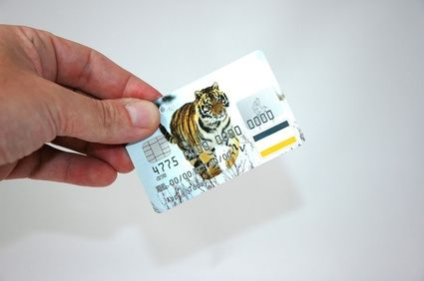
The benefits of owning a credit card may not be as great as the dangers.
Credit cards can seem like a great idea when an unexpected expense arises, but the benefits can quickly become outweighed by the disadvantages if the cards are misused. There are a number of dangers associated with credit card use if the owner of the account fails to use caution when charging purchases.

Minimum Payments And High Interest
What seems like an advantage of credit cards is actually one of its biggest dangers. Charging up a high balance and only having to come up with a minimum payment each month is an attractive idea. However, people who charge more than they can afford to pay off in a month are hit with high interest charges that can make it more difficult to get out of debt.
It is common for credit card companies to charge nearly 30 percent interest on purchases. Buying items on a credit card account that cannot be paid off by the end of the next billing cycle is a big mistake often made by consumers. This misuse of credit cards will result in ever-increasing debt as long as the minimum payment is all that is applied to the balance each month. Eventually, an item that was bought for a few hundred dollars may end up costing a few thousand.

Multiple Accounts
Obtaining a credit card isn't always a bad idea, but having too many is. Credit card companies make good money on people who cannot afford to completely pay off their balances. Eventually this leads to a maxed out card that earns a hefty minimum payment each month. When other credit card companies see consumers in this bad position, they will offer them more credit cards.
The consumer may see the additional offers as financial breathing room. The new cards present an opportunity for more purchasing power to a person who is sick of being broke. Eventually, these cards get maxed out too and the situation becomes twice as bad. Those having trouble paying off one credit card should ignore all offers for additional lines of credit.

Credit Damage
The only way to significantly improve a credit history with a credit card is to use it on occasion, then pay it off regularly. Carrying a constant balance will not do much to help a credit score, and carrying too much will only lower it. Unfortunately, most people use their credit cards in a way that hurts their credit scores.
If a consumer carries heavy balances on his credit card accounts, has missed or made late payments or simply has too many open accounts, it can make it more difficult for the person to do the kind of borrowing that really matters. If someone wishes to borrow money for a mortgage or a personal business loan, it is a good idea to get the credit cards paid off first, and do it a few months in advance.

Stations Activity:

Affordability
Credit card troubles typically start with uncontrolled spending or using cards for instant gratification. Wisely using credit cards will require limiting your spending and only buying things that are within your means. There's nothing wrong with using credit to pay for items. But before relying on plastic to make a purchase, check your finances to see if you can pay off the item in full when you receive the statement in the mail. Starting a habit of carrying a balance from month-to-month can create a cycle of debt, and the more debt you have, the hard it is to pay off the balance.

Credit Utilization
Pay attention to the utilization ratio on your credit cards. This is your percentage of debt in comparison to your credit limit. For example, if you have a credit limit of $1,000 and a balance of $500, you're utilizing 50 percent of your credit limit. MSN Money recommends a utilization ratio of about 30 percent. Keeping low balances helps you maintain a good credit rating and prevent huge balances. Give yourself a spending limit that's much lower than your actual limit and stay below that level.

Safe Online Shopping
Many consumers rely on online shopping for convenience. However, online shopping can present trouble if someone gets your information. Be cautious when using your credit cards online. Before entering your card information online, quickly scan the website for symbols such as a padlock, which indicates that your information is secured. You can also protect yourself by ignoring emails that request your credit card account number and expiration date.

Consideration
When paying your credit card bills each month, take a few moments to read your card statement. Check the account statement for accuracy. A retailer or merchant may charge a different amount to your card or accidentally submit a double payment; or someone could gain access to your credit card number and go on a shopping spree. Immediately report inaccuracies or unfamiliar account activity to your credit card company.

