AP Physics Multiple Choice Practice – Circuits

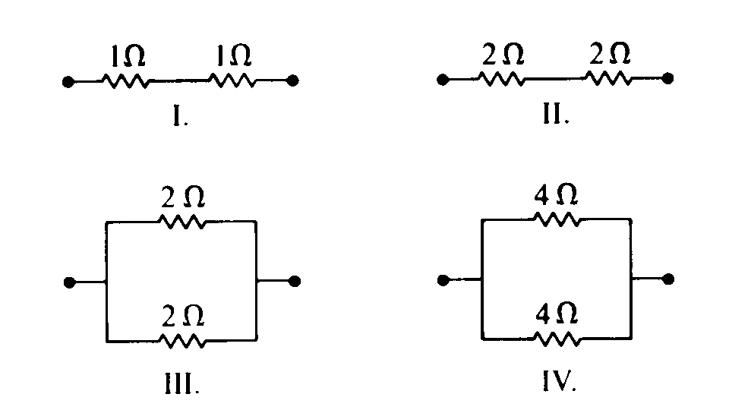

1. Which two arrangements of resistors shown above have the same resistance between the terminals?

(A) I and II (B) I and IV (C) II and III (D) II and IV (E) III and IV

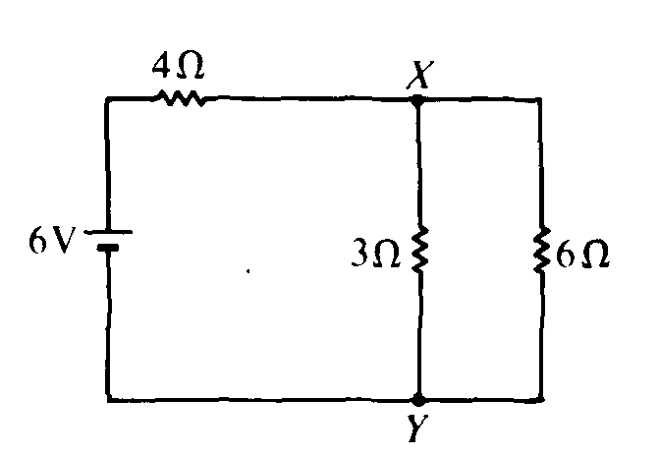

2. In the circuit shown above, what is the value of the potential difference between points X and Y if the 6–volt battery has no internal resistance?   
(A) 1 V (B) 2 V (C) 3 V (D) 4 V (E) 6V

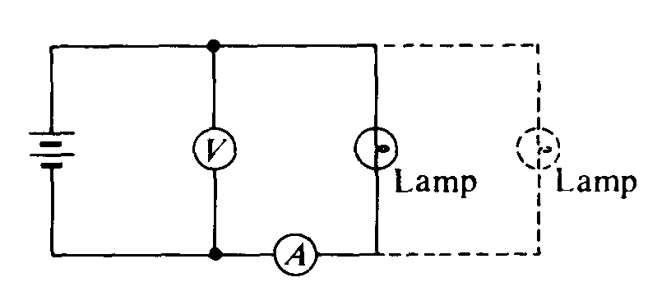

3. A lamp, a voltmeter V, an ammeter A, and a battery with zero internal resistance are connected as shown above. Connecting another lamp in parallel with the first lamp as shown by the dashed lines would

(A) increase the ammeter reading (B) decrease the ammeter reading

(C) increase the voltmeter reading (D) decrease the voltmeter reading

(E) produce no change in either meter reading

4. The five resistors shown below have the lengths and cross–sectional areas indicated and are made of material with the same resistivity. Which has the greatest resistance?  
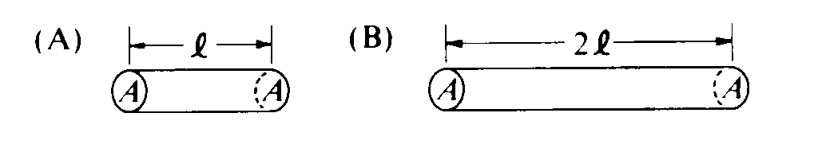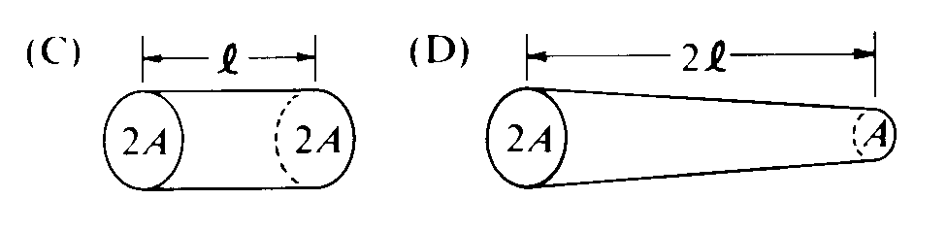 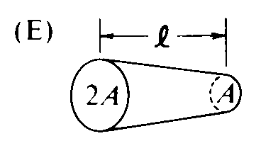

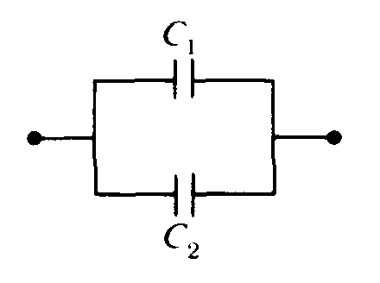

5. Two capacitors are connected in parallel as shown above. A voltage V is applied to the pair. What is the ratio of charge stored on C1 to the charge stored on C2, when C1 = 1.5C2 ?  
(A) 4/9 (B) 2/3 (C) 1 (D) 3/2 (E) 9/4

Questions 6 – 7

The five incomplete circuits below are composed of resistors R, all of equal resistance, and capacitors C, all of equal capacitance. A battery that can be used to complete any of the circuits is available.

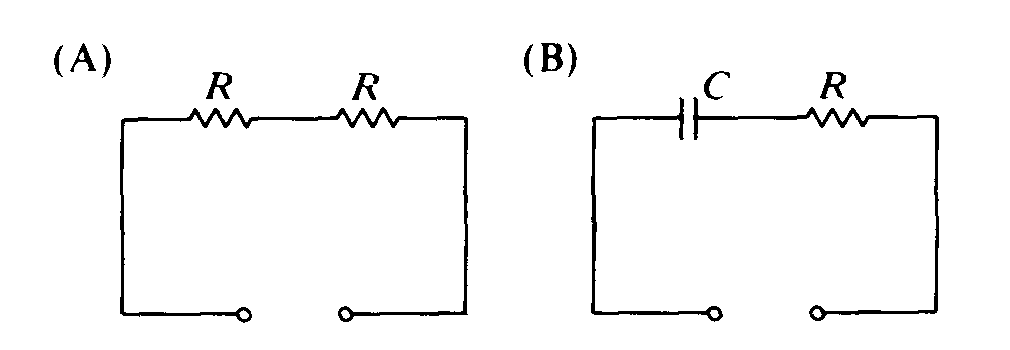 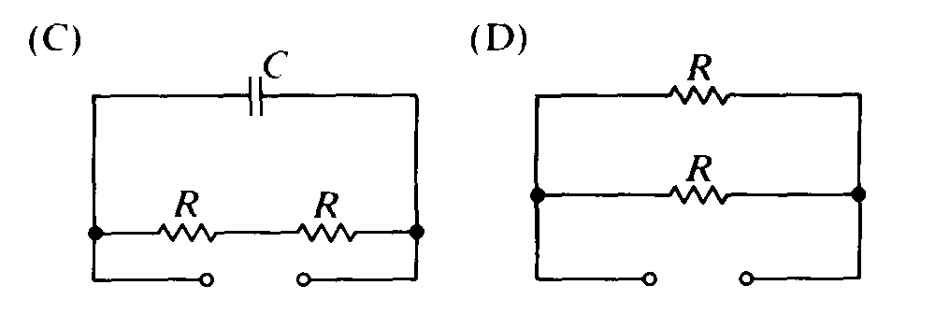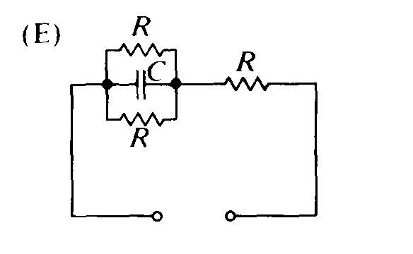

6. Into which circuit should the battery be connected to obtain the greatest steady power dissipation?

(A) A (B) B (C) C (D) D (E) E

7. Which circuit will retain stored energy if the battery is connected to it and then disconnected?

(A) A (B) B (C) C (D) D (E) E

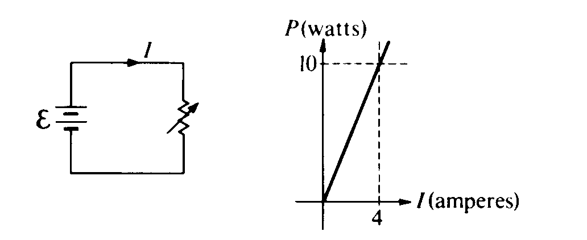

8. The circuit shown above left is made up of a variable resistor and a battery with negligible internal resistance. A graph of the power P dissipated in the resistor as a function of the current I supplied by the battery is given above right. What is the emf of the battery?  
(A) 0.025 V (B) 0.67 V (C) 2.5 V (D) 6.25 V (E) 40 V

9. An immersion heater of resistance R converts elec­trical energy into thermal energy that is transferred to the liquid in which the heater is immersed. If the current in the heater is I, the thermal energy trans­ferred to the liquid in time t is

(A) IRt (B) I2Rt (C) IR2t (D) IRt2 (E) IR/t

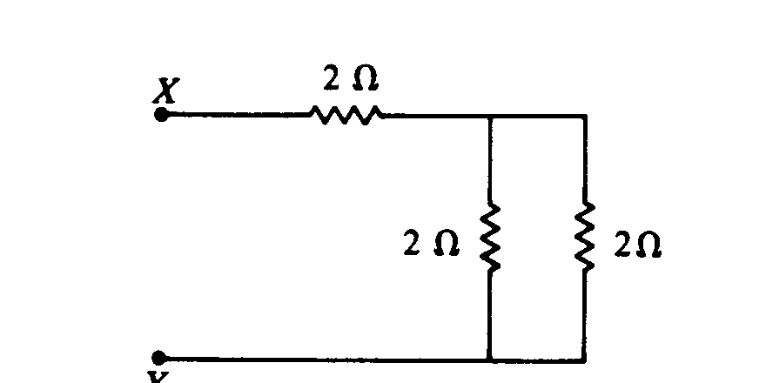

10. The total equivalent resistance between points X and Y in the circuit shown above is  
(A) 3 Ω (B) 4 Ω (C) 5 Ω (D) 6 Ω (E) 7 Ω

11. The five resistors shown below have the lengths and cross–sectional areas indicated and are made of material with the same resistivity. Which resistor has the least resistance?  
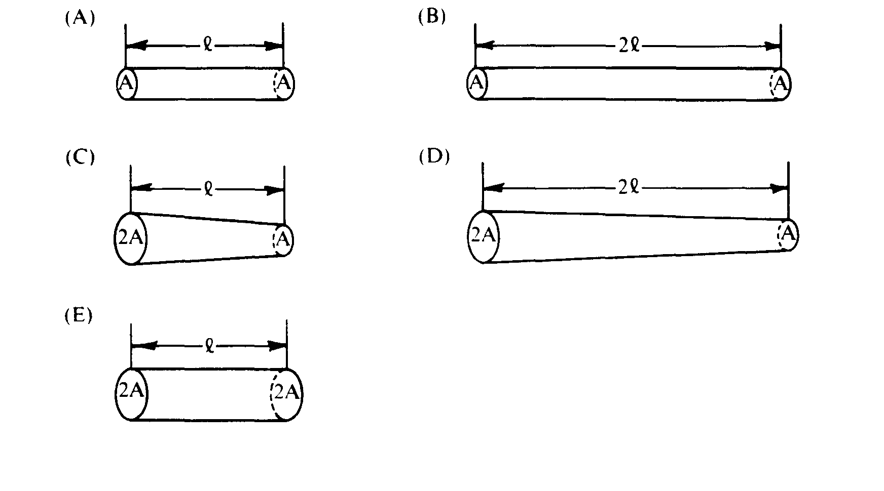

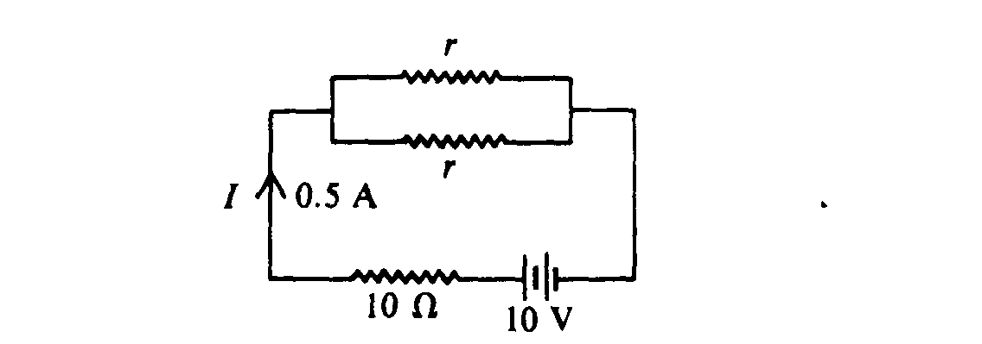

12. In the circuit shown above, the value of r for which the current I is 0.5 ampere is  
(A) 0 Ω (B) 1 Ω (C) 5 Ω (D) 10 Ω (E) 20 Ω

13. Which of the following will cause the electrical resistance of certain materials known as superconductors to suddenly decrease to essentially zero?  
(A) Increasing the voltage applied to the material beyond a certain threshold voltage  
(B) Increasing the pressure applied to the material beyond a certain threshold pressure  
(C) Cooling the material below a certain threshold temperature  
(D) Stretching the material to a wire of sufficiently small diameter  
(E) Placing the material in a sufficiently large magnetic field

14. Kirchhoff’s loop rule for circuit analysis is an expression of which of the following?  
(A) Conservation of charge (B) Conservation of energy (C) Ampere's law   
(D) Faraday's law (E) Ohm's law

Questions 15 – 16

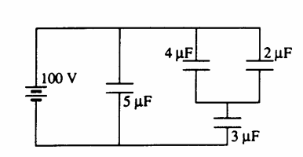

15. The equivalent capacitance for this network is most nearly  
(A) 10/7 μF (B) 3/2 μF (C) 7/3 μF (D) 7 μF (E) 14 μF

16. The charge stored in the 5–microfarad capacitor is most nearly

(A) 360 μC (B) 500 μC (C) 710 μC (D) 1,100 μC (E) 1,800 μC

Questions 17 – 19

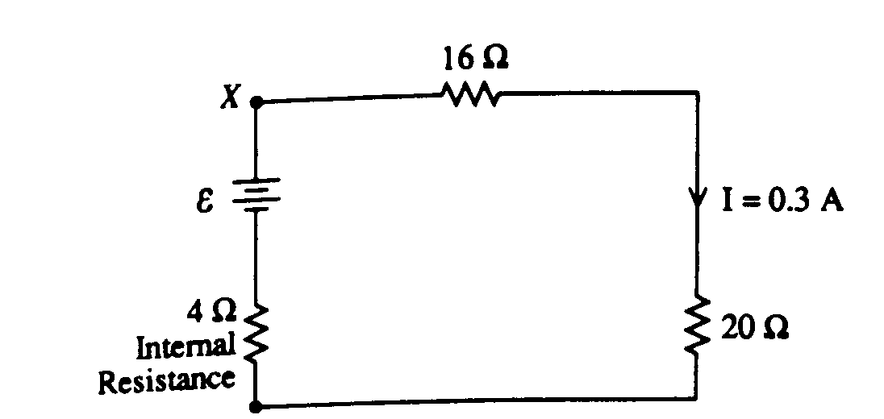

The above circuit diagram shows a battery with an internal resistance of 4.0 ohms connected to a 16–ohm and a 20–ohm resistor in series. The current in the 20–ohm resistor is 0.3 amperes

17. What is the emf of the battery?  
(A) 1.2 V (B) 6.0 V (C) 10.8 V (D) 12.0 V (E) 13.2 V

18. What is the potential difference across the terminals X and Y of the battery?  
(A) 1.2 V (B) 6.0 V (C) 10.8 V (D) 12.0 V (E) 13.2 V

19. What power is dissipated by the 4–ohm internal resistance of the battery?  
(A) 0.36 W (B) 1.2 W (C) 3.2 W (D) 3.6 W (E) 4.8 W

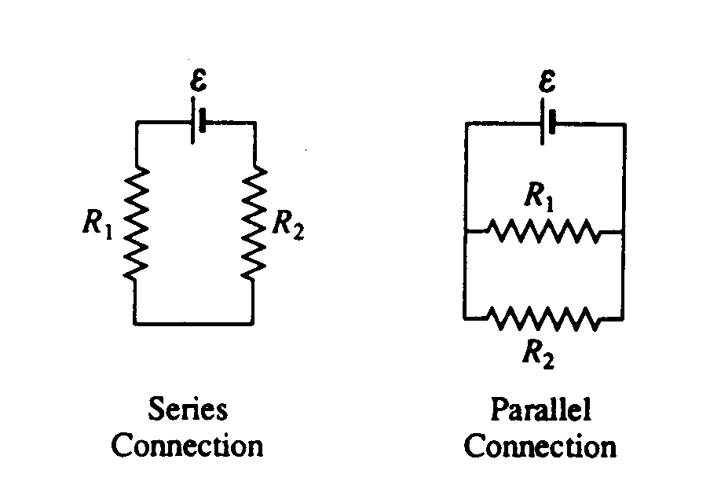

20. In the diagrams above, resistors R1 and R2 are shown in two different connections to the same source of emf ε that has no internal resistance. How does the power dissipated by the resistors in these two cases compare?  
(A) It is greater for the series connection.  
(B) It is greater for the parallel connection.  
(C) It is the same for both connections.  
(D) It is different for each connection, but one must know the values of R1 and R2 to know which is greater.  
(E) It is different for each connection, but one must know the value of ε to know which is greater.

21. The product (2 amperes × 2 volts × 2 seconds) is equal to   
(A) 8 coulombs (B) 8 newtons (C) 8 joules (D) 8 calories (E) 8 newton–amperes

Questions 22 – 23 refer to the following diagram that shows part of a closed electrical circuit.

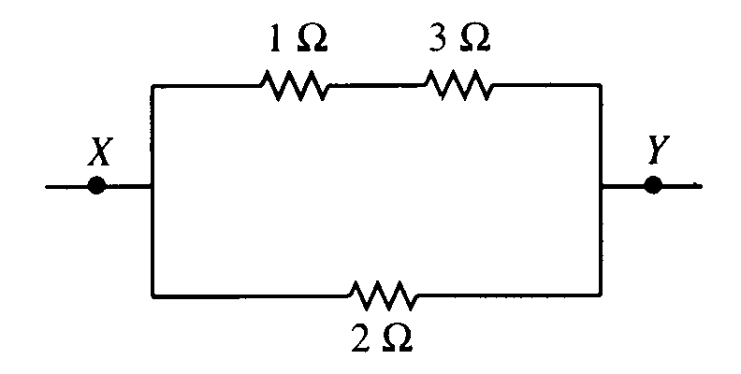

22. The electrical resistance of the part of the circuit shown between point X and point Y is

(A) 4/3 Ω (B) 2 Ω (C) 2.75 Ω (D) 4 Ω (E) 6 Ω

23. When there is a steady current in the circuit, the amount of charge passing a point per unit of time is

(A) the same everywhere in the circuit (D) greater at point X than at point Y

(B) greater in the 1 Ω resistor than in the 2 Ω resistor (E) greater in the 1 Ω resistor than in the 3 Ω resistor

(C) greater in the 2 Ω resistor than in the 3 Ω resistor

24. A certain coffeepot draws 4.0 A of current when it is operated on 120 V household lines. If electrical energy costs 10 cents per kilowatt–hour, how much does it cost to operate the coffeepot for 2 hours?

(A) 2.4 cents (B) 4.8 cents (C) 8.0 cents (D) 9.6 cents (E) 16 cents



*25. A battery having emf *E* and internal resistance r is connected to a load consisting of two parallel resistors each having resistance R. At what value of R will the power dissipated in the load be a maximum?

(A) 0 (B) r/2 (C) r (D) 2r (E) 4r

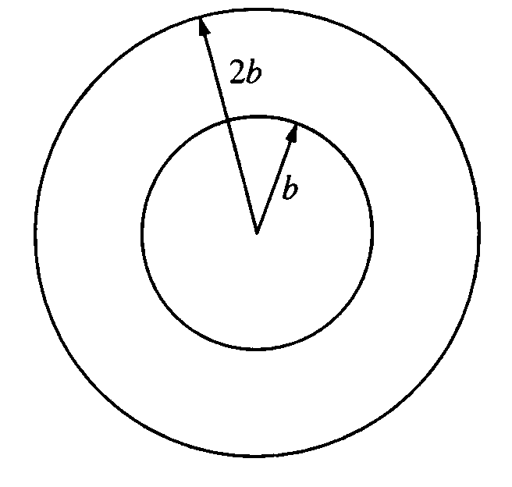

26. Two concentric circular loops of radii *b* and *2b*, made of the same type of wire, lie in the plane of the page, as shown above. The total resistance of the wire loop of radius *b* is *R*. What is the resistance of the wire loop of radius *2b*?

(A)  *R/4* (B) *R/2* (C) *R* (D) *2R* (E) *4R*

27. The total capacitance of several capacitors in parallel is the sum of the individual capacitances for which of the following reasons?

(A) The charge on each capacitor depends on its capacitance, but the potential difference across each is the same.

(B) The charge is the same on each capacitor, but the potential difference across each capac­itor depends on its capacitance.

(C) Equivalent capacitance is always greater than the largest capacitance.

(D) Capacitors in a circuit always combine like resistors in series.

(E) The parallel combination increases the effec­tive separation of the plates.

28. A wire of length *L* and radius *r* has a resistance *R*. What is the resistance of a second wire made from the same material that has a length *L/2* and a radius *r/2*?

(A)  *4R* (B) *2R* (C) *R* (D)  *R/2* (E)  *R/4*

29. The operating efficiency of a 0.5 A, 120 V electric motor that lifts a 9 kg mass against gravity at an average velocity of 0.5 m/s is most nearly

(A) 7% (B) 13% (C) 25% (D) 53% (E) 75 %

Questions 30 – 31

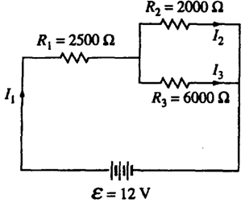

30. What is the current *I1*?

(A) 0.8 mA (B) 1.0 mA (C) 2.0 mA (D) 3.0 mA (E) 6.0 mA

31. How do the currents *I1, I2,* and *13* compare?

(A)  *I1 > I2 > I3* (B)  *I1 > I3 > I2* (C)  *I2 > I1 > I3* (D) *I3 > I1 > I2* (E)  *I3 > I2 > I1*

32. When lighted, a 100–watt light bulb operating on a 110–volt household circuit has a resistance closest to

(A) 10–2 Ω (B) 10–1 Ω (C) 1 Ω (D) 10 Ω (E) 100 Ω

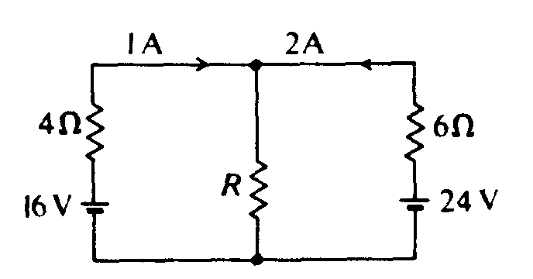

33. In the circuit shown above, what is the resistance R?

(A) 3 Ω (B) 4 Ω (C) 6 Ω (D) 12 Ω (E) 18 Ω



34. In the circuit shown above, the current in each battery is 0.04 ampere. What is the potential difference between the points x and y?

(A) 8 V (B) 2 V (C) 6 V (D) 0 V (E) 4 V

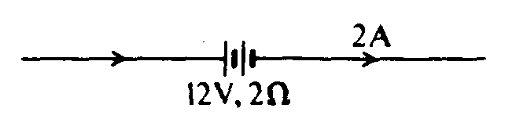

35. A 12–volt storage battery, with an internal resistance of 2Ω, is being charged by a current of 2 amperes as shown in the diagram above. Under these circumstances, a voltmeter connected across the terminals of the battery will read   
(A) 4 V (B) 8 V (C) 10 V (D) 12 V (E) 16 V

Questions 36 – 38

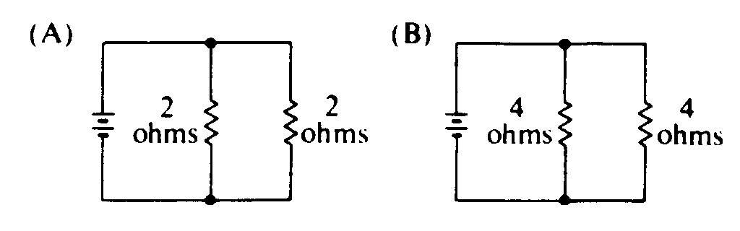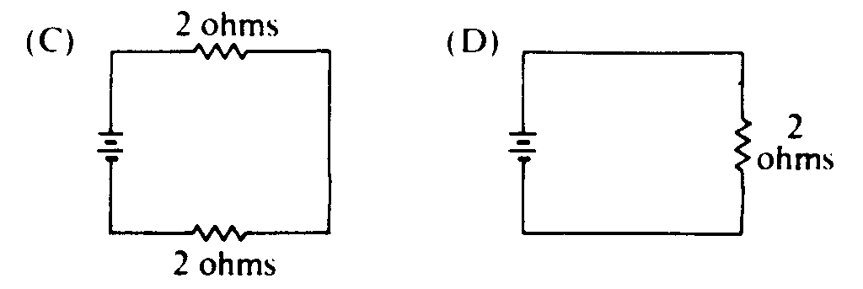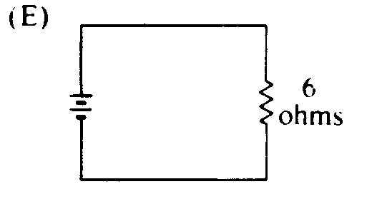

The batteries in each of the circuits shown above are identical and the wires have negligible resistance.

36. In which circuit is the current furnished by the battery the greatest?

(A) A (B) B (C) C (D) D (E) E

37. In which circuit is the equivalent resistance connected to the battery the greatest?

(A) A (B) B (C) C (D) D (E) E

38. Which circuit dissipates the least power?

(A) A (B) B (C) C (D) D (E) E

39. When two identical parallel–plate capacitors are connected in series, which of the following is true of the equivalent capacitance?

(A) It depends on the charge on each capacitor.

(B) It depends on the potential difference across both capacitors.

(C) It is larger than the capacitance of each capacitor.

(D) It is smaller than the capacitance of each capacitor.

(E) It is the same as the capacitance of each capacitor.

40. The emf of a battery is 12 volts. When the battery delivers a current of 0.5 ampere to a load, the potential difference between the terminals of the battery is 10 volts. The internal resistance of the battery is

(A) 1 Ω (B) 2 Ω (C) 4 Ω (D) 20 Ω (E) 24 Ω

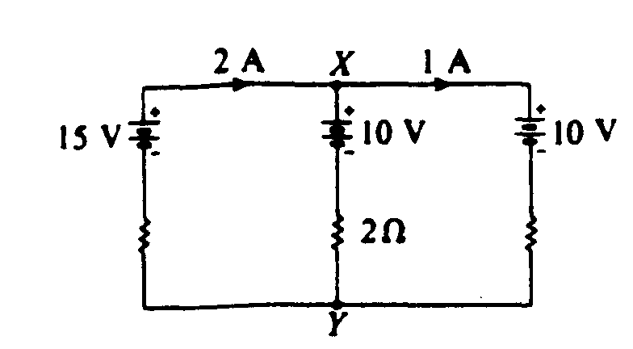

41. In the circuit shown above, the emf's of the batteries are given, as well as the currents in the outside branches and the resistance in the middle branch. What is the magnitude of the potential difference between X and Y?

(A) 4 V (B) 8 V (C) 10 V (D) 12 V (E) 16 V

Questions 42 – 44

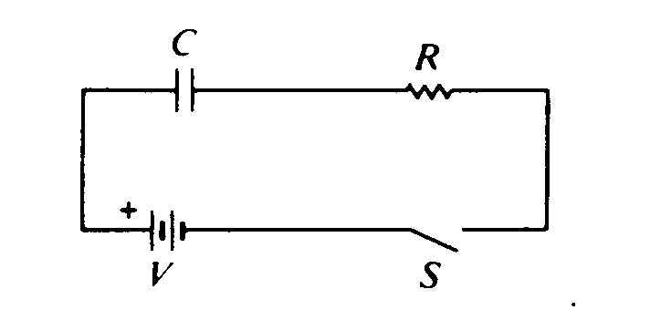

Assume the capacitor C is initially uncharged. The following graphs may represent different quantities related to the circuit as functions of time t after the switch S is closed

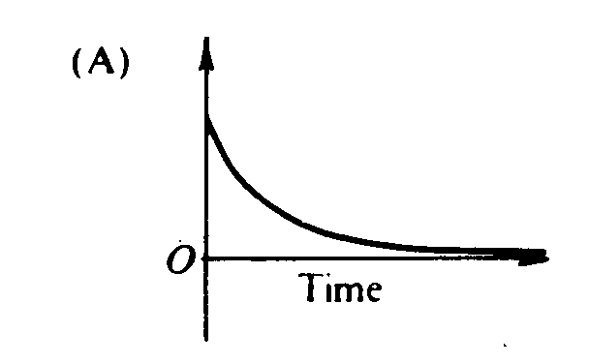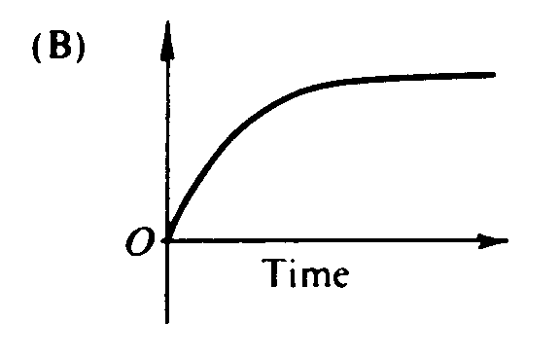 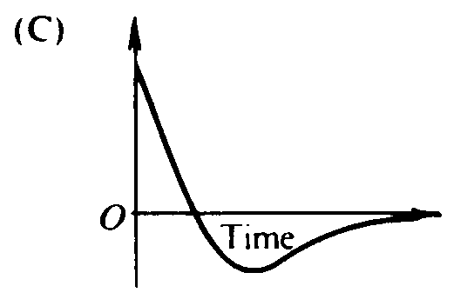 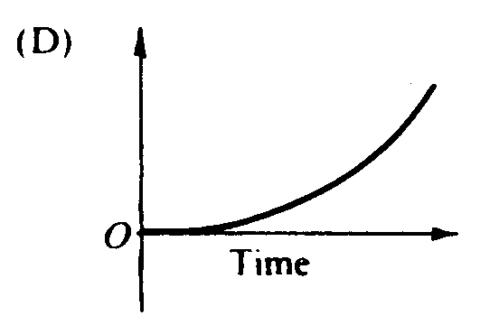 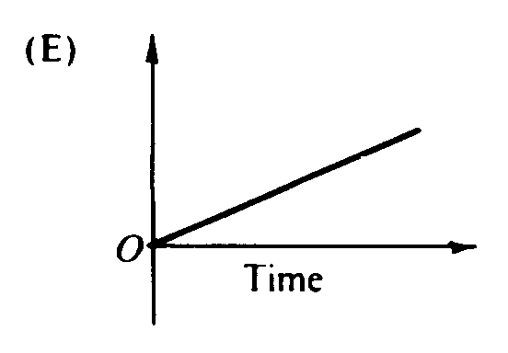

42. Which graph best represents the voltage versus time across the resistor R?

(A) A (B) B (C) C (D) D (E) E

43. Which graph best represents the current versus time in the circuit?

(A) A (B) B (C) C (D) D (E) E

44. Which graph best represents the voltage across the capacitor versus time?

(A) A (B) B (C) C (D) D (E) E

Questions 45 – 46

Three 6–microfarad capacitors are connected in series with a 6–volt battery.

45. The equivalent capacitance of the set of capacitors is

(A) 0.5 μF (B) 2 μF (C) 3 μF (D) 9 μF (E) 18 μF

46. The energy stored in each capacitor is

(A) 4 μJ (B) 6 μJ (C) 12 μJ (D) 18 μJ (E) 36 μJ

47. The power dissipated in a wire carrying a constant electric current I may be written as a function of the length *l* of the wire, the diameter d of the wire, and the resistivity ρ of the material in the wire. In this expression, the power dissipated is directly proportional to which of the following?

(A) *l* only (B) d only (C) *l* and ρ only (D) d and ρ only (E) *l*, d, and ρ

48. A wire of resistance *R* dissipates power *P* when a current *I* passes through it. The wire is replaced by another wire with resistance *3R*. The power dissipated by the new wire when the same current passes through it is

(A) P/9 (B) P/3 (C) P (D) 3P (E) 6P

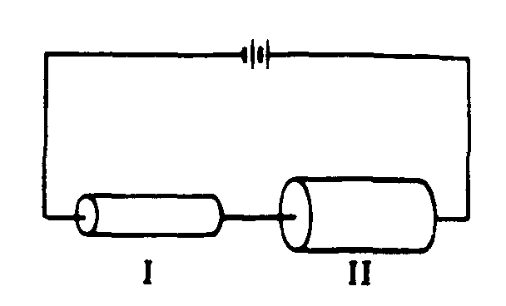

49. Two resistors of the same length, both made of the same material, are connected in a series to a battery as shown above. Resistor II has a greater cross. sectional area than resistor I. Which of the following quantities has the same value for each resistor?

(A) Potential difference between the two ends   
(B) Electric field strength within the resistor   
(C) Resistance   
(D) Current per unit area  
(E) Current

Questions 50 – 51

Below is a system of six 2–microfarad capacitors.

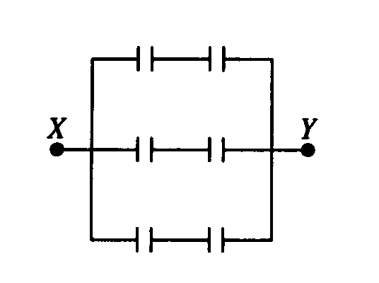

50. The equivalent capacitance of the system of capacitors is

(A) 2/3μF (B) 4/3 μF (C) 3 μF (D) 6 μF (E) 12 μF

51. What potential difference must be applied between points X and Y so that the charge on each plate of each capacitor will have magnitude 6 microcoulombs?

(A) 1.5 V (B) 3V (C) 6 V (D) 9 V (E) 18 V

# Questions 52 – 54

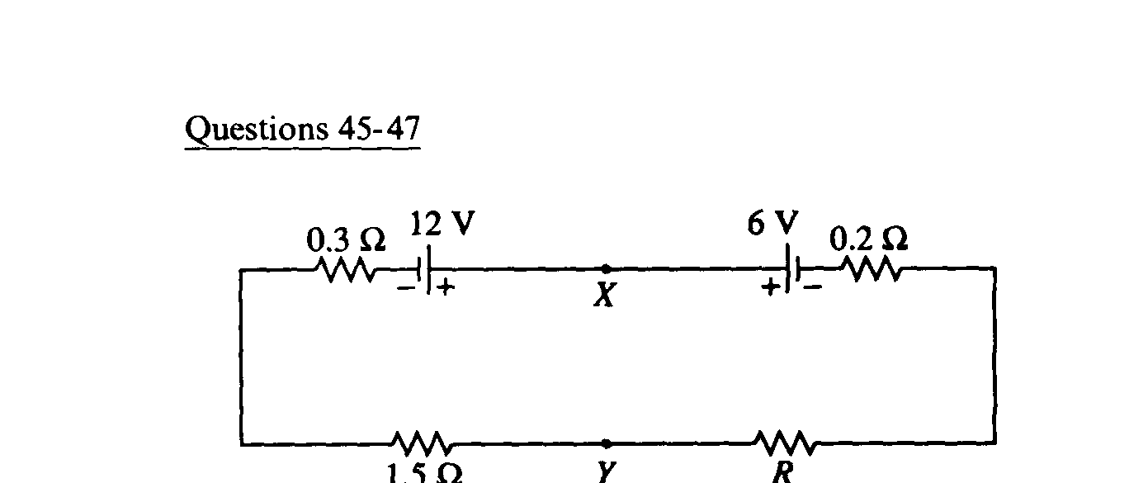

**1.5 Ω**

In the circuit above, the emf's and the resistances have the values shown. The current I in the circuit is 2 amperes.

52. The resistance R is

(A) 1 Ω (B) 2Ω (C) 3 Ω (D) 4 Ω (E) 6 Ω

53. The potential difference between points X and Y is

(A) 1.2 V (B) 6.0 V (C) 8.4 V (D) 10.8 V (E) 12.2 V

54. How much energy is dissipated by the 1.5–ohm resistor in 60 seconds?

(A) 6 J (B) 180 J (C) 360 J (D) 720 J (E) 1,440 J

# Questions 55 – 56

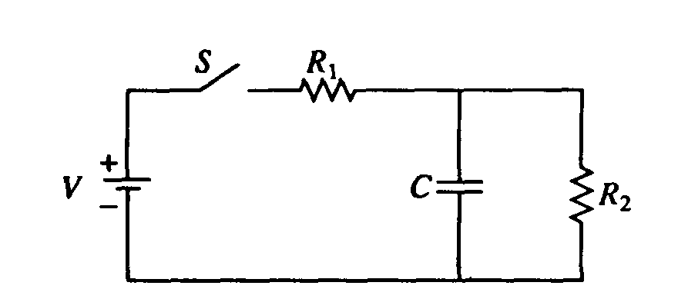

In the circuit shown above, the battery supplies a constant voltage V when the switch S is closed. The value of the capacitance is C, and the value of the resistances are R1 and R2.

55. Immediately after the switch is closed, the current supplied by the battery is

(A) V/(R1 + R2) (B) V/R1 (C) V/R2 (D) V(R1 + R2)/R1R2 (E) zero

56. A long time after the switch has been closed, the current supplied by the battery is

(A) V/(R1 + R2) (B) V/R1 (C) V/R2 (D) V(R1 + R2)/R1R2  (E) zero

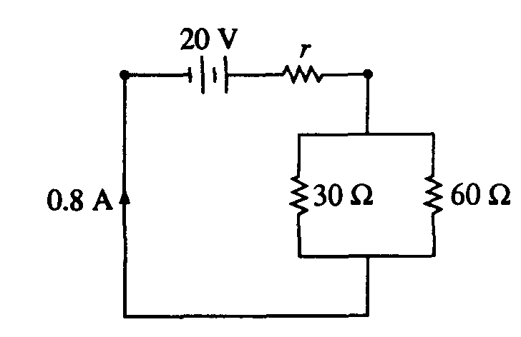

57. A 30–ohm resistor and a 60–ohm resistor are connected as shown above to a battery of emf 20 volts and internal resistance *r*. The current in the circuit is 0.8 ampere. What is the value of *r*?

(A) 0.22 Ω (B) 4.5 Ω (C) 5 Ω (D) 16Ω (E) 70 Ω

58. A variable resistor is connected across a constant voltage source. Which of the following graphs represents the power P dissipated by the resistor as a function of its resistance R?

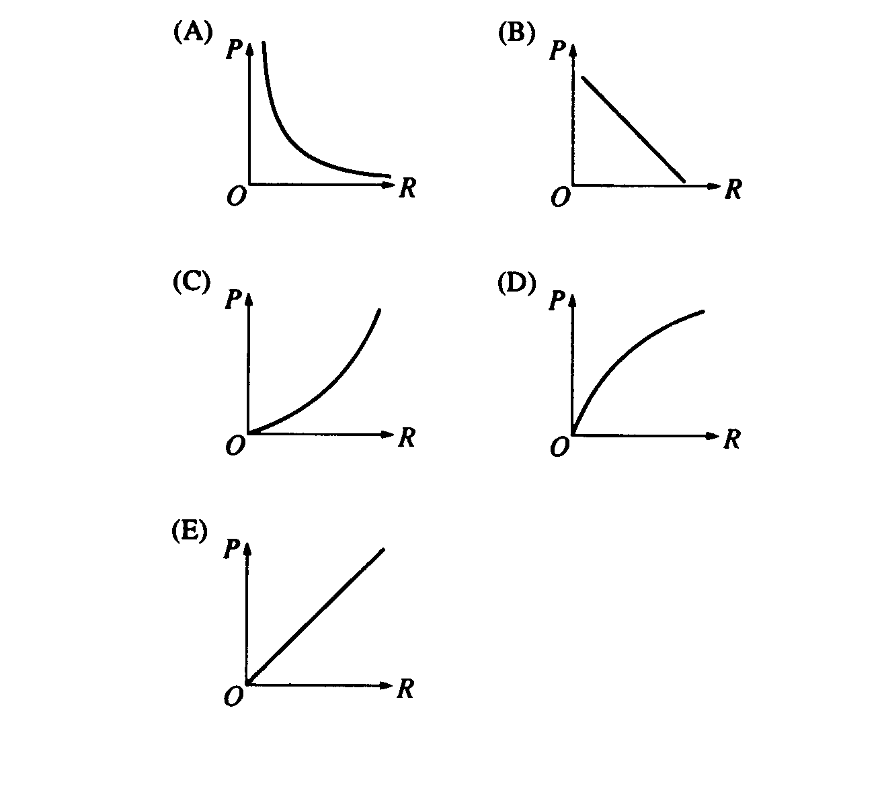

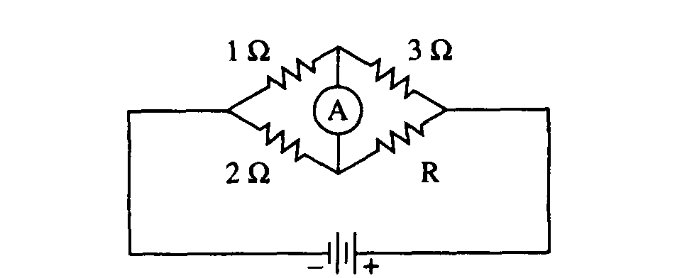

59. If the ammeter in the circuit above reads zero, what is the resistance R ?

(A) 1.5 Ω (B) 2Ω (C) 4 Ω (D) 5 Ω (E) 6Ω

60. A resistor R and a capacitor C are connected in series to a battery of terminal voltage V0. Which of the following equations relating the current I in the circuit and the charge Q on the capacitor describes this circuit?

(A) V0 + QC – I2R = 0 (B) V0 – Q/C – IR = 0 (C) V02 – Q2/2C – I2R = 0

(D) V0 – CI – I2R = 0 (E) Q/C – IR = 0

61 Which of the following combinations of 4Ω resis­tors would dissipate 24 W when connected to a 12 Volt battery?

 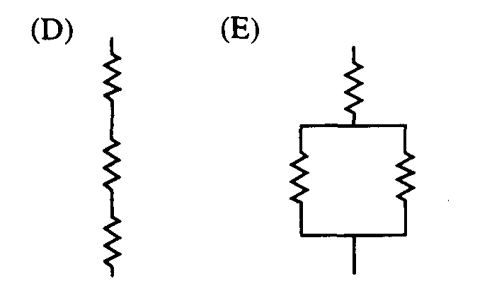

62. A narrow beam of protons produces a current of 1.6 × 10–3 A. There are 109 protons in each meter along the beam. Of the following, which is the best estimate of the average speed of the protons in the beam?

(A) 10–15 m/s (B) 10–12 m/s (C) 10–7 m/s (D) 107 m/s (E) 1012 m/s

Questions 63 – 64

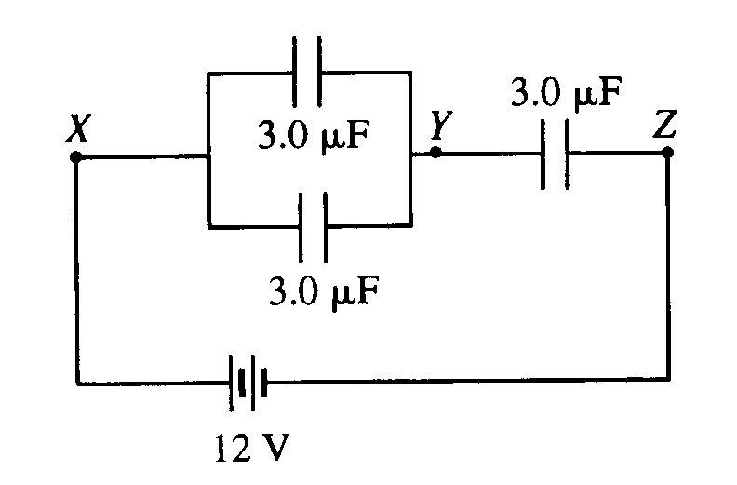

Three identical capacitors, each of capacitance 3.0 μF, are connected in a circuit with a 12 V battery as shown above.

63. The equivalent capacitance between points X and Z is

(A) 1.0 μF (B) 2.0 μF (C) 4.5 μF (D) 6.0 μF (E) 9.0 μF

64. The potential difference between points Y and Z is

(A) zero (B) 3 V (C) 4 V (D) 8 V (E) 9 V

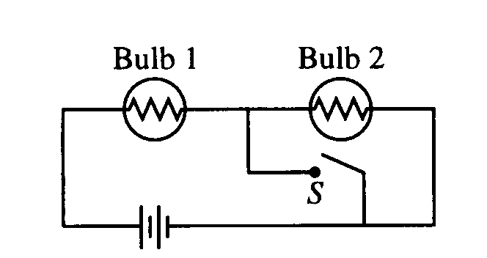

65. The circuit in the figure above contains two iden­tical lightbulbs in series with a battery. At first both bulbs glow with equal brightness. When switch S is closed, which of the following occurs to the bulbs?

Bulb I Bulb 2

(A) Goes out Gets brighter

(B) Gets brighter Goes out

(C) Gets brighter Gets slightly dimmer

(D) Gets slightly dimmer Gets brighter

(E) Nothing Goes out



66. Three 1/2 μF capacitors are connected in series as shown in the diagram above. The capacitance of the combination is   
(A) 0.1 μF (B) 1 μF (C) 2/3 μF (D) ½ μF (E) 1/6 μF

67. A hair dryer is rated as 1200 W, 120 V. Its effective internal resistance is

(A) 0.1 Ω (B) 10 Ω (C) 12 Ω (D) 120 Ω (E) 1440 Ω

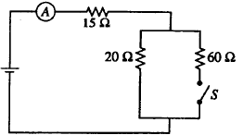

68. When the switch S is open in the circuit shown above, the reading on the ammeter A is 2.0 A. When the switch is closed, the reading on the ammeter is

(A) doubled  
(B) increased slightly but not doubled  
(C) the same   
(D) decreased slightly but not halved  
(E) halved

69. Two conducting cylindrical wires are made out of the same material. Wire X has twice the length and twice the diameter of wire Y. What is the ratio *Rx/Ry* of their resistances?

(A) 1/4 (B) ½ (C) 1 (D) 2 (E) 4

70. You are given three 1.0 Ω resistors. Which of the following equivalent resistances *CANNOT* be produced using all three resistors?

(A) 1/3 Ω (B) 2/3 Ω (C) 1.0 Ω (D) 1.5 Ω (E) 3.0 Ω

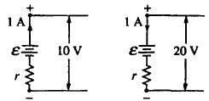

71. The figures above show parts of two circuits, each containing a battery of emf ε and internal resistance *r*. The current in each battery is 1 A, but the direction of the current in one battery is opposite to that in the other. If the potential differences across the batteries' terminals are 10 V and 20 V as shown, what are the values of ε and *r* ?   
(A) E = 5 V, r = 15 Ω  
(B) E =10 V, r = 100 Ω  
(C) E = 15 V, r = 5 Ω

(D) E = 20 V, r = 10 Ω  
(E) The values cannot be computed unless the complete circuits are shown.

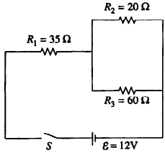

72. In the circuit shown above, the equivalent resistance of the three resistors is

(A) 10.5 Ω (B) 15Ω (C) 20 Ω (D) 50 Ω (E) 115 Ω



73. What is the current through the 6.0 Ω resistor shown in the accompanying circuit diagram? Assume all batteries have negligible resistance.

(A) 0 (B) 0.40 A (C) 0.50 A (D) 1.3 A (E) 1.5 A

Questions 74 – 77



Four identical light bulbs K, L, M, and N are connected in the electrical circuit shown above.

74. Rank the current through the bulbs.

(A) K > L > M > N

(B) L = M > K = N

(C) L > M > K > N

(D) N > K > L = M

(E) N > L = M > K

75. In order of decreasing brightness (starting with the brightest), the bulbs are:

(A) K = L > M > N

(B) K = L = M > N

(C) K > L = M > N

(D) N > K > L = M

(E) N > K = L = M

76. Bulb K burns out. Which of the following statements is true?

(A) All the light bulbs go out.

(B) Only bulb N goes out.

(C) Bulb N becomes brighter.

(D) The brightness of bulb N remains the same.

(E) Bulb N becomes dimmer but does not go out.

77. Bulb M burns out. Which of the following statements is true?

(A) All the light bulbs go out.

(B) Only bulb M goes out.

(C) Bulb N goes out but at least one other bulb remains lit.

(D) The brightness of bulb N remains the same.

(E) Bulb N becomes dimmer but does not go out.



78. The voltmeter in the accompanying circuit diagram has internal resistance 10.0 kΩ and the ammeter has internal resistance 25.0 Ω. The ammeter reading is 1.00 mA. The voltmeter reading is most nearly:

(A) 1.0 V (B) 2.0 V (C) 3.0 V (D) 4.0 V (E) 5.0 V

79. When two resistors, having resistance *R1* and *R2*, are connected in parallel, the equivalent resistance of the combination is 5 Ω. Which of the following statements about the resistances is correct?

(A) Both *R1* and *R2* are greater than 5 Ω.

(B) Both *R1* and *R2* are equal to 5 Ω.

(C) Both *R1* and *R2* are less than 5 Ω.

(D) The sum of *R1* and *R2* is 5 Ω.

(E) One of the resistances is greater than 5 Ω, one of the resistances is less than 5 Ω.



80. See the accompanying figure. What is the current through the 300 Ω resistor when the capacitor is fully charged?

(A) zero (B) 0.020 A (C) 0.025 A (D) 0.033 A (E) 0.100 A

81. Three resistors – *R*1, *R*2, and *R*3 – are connected in series to a battery. Suppose *R*1 carries a current of 2.0 A, *R*2 has a resistance of 3.0 , and *R*3 dissipates 6.0 W of power. What is the voltage across *R*3?

(A) 1.0 V (B) 2.0 V (C) 3.0 V (D) 6.0 V (E) 12 V

82. When a single resistor is connected to a battery, a total power *P* is dissipated in the circuit. How much total power is dissipated in a circuit if *n* identical resistors are connected in series using the same battery? Assume the internal resistance of the battery is zero.

(A) *n*2*P* (B) *nP* (C) *P* (D) *P*/*n* (E) *P*/*n*2



83. Consider the compound circuit shown above. The three bulbs 1, 2, and 3 – represented as resistors in the diagram – are identical. Which of the following statements are true?

I. Bulb 3 is brighter than bulb 1 or 2.

II. Bulb 3 has more current passing through it than bulb 1 or 2.

III. Bulb 3 has a greater voltage drop across it than bulb 1 or 2.

(A) I only (B) II only (C) I & II only (D) I & III only (E) I, II, & III

84. When any four resistors are connected in parallel, the _______ each resistor is the same.

(A) charge on (B) current through (C) power from (D) resistance of (E) voltage across

85. Wire I and wire II are made of the same material. Wire II has twice the diameter and twice the length of wire I. If wire I has resistance *R*, wire II has resistance

(A) *R*/8 (B) *R*/4 (C) *R*/2 (D) *R* (E) 2*R*

86. A heating coil is rated 1200 watts and 120 volts. What is the maximum value of the current under these conditions?

(A) 10.0 A (B) 12.0 A (C) 14.1 A (D) 0.100 A (E) 0.141 A



87. In the accompanying circuit diagram, the current through the 6.0–Ω resistor is 1.0 A. What is the power supply voltage *V*?

(A) 10 V (B) 18 V (C) 24 V (D) 30 V (E) 42 V



88. In the circuit diagrammed above, the 3.00–μF capacitor is fully charged at 18.0 μC. What is the value of the power supply voltage *V*?

(A) 4.40 V (B) 6.00 V (C) 8.00 V (D) 10.4 V (E) 11.0 V

89. What is the resistance of a 60 watt light bulb designed to operate at 120 volts?

(A) 0.5 Ω (B) 2     (C) 60  (D) 240  (E) 7200 



90. Given the simple electrical circuit above, if the current in all three resistors is equal, which of the following statements must be true?

(A) X, Y, and Z all have equal resistance

(B) X and Y have equal resistance

(C) X and Y added together have the same resistance as Z

(D) X and Y each have more resistance than Z

(D) none of the above must be true

91. Wire Y is made of the same material but has twice the diameter and half the length of wire X. If wire X has a resistance of *R* then wire Y would have a resistance of

(A) *R/*8 (B) *R/*2 (C) *R* (D) 2*R* (E) 8*R*



92. The diagram above represents a simple electric circuit composed of 5 identical light bulbs and 2 flashlight cells. Which bulb (or bulbs) would you expect to be the brightest?

(A) V only

(B) V and W only

(C) V and Z only

(D) V, W and Z only

(E) all five bulbs are the same brightness

93. Three different resistors *R*1, *R*2 and *R*3 are connected in parallel to a battery. Suppose *R*1 has 2 V across it, *R*2 = 4 , and *R*3 dissipates 6 W. What is the current in *R*3?

(A) 0.33 A (B) 0.5 A (C) 2 A (D) 3 A (E) 12 A



94. Which of the following statements is NOT true concerning the simple circuit shown where resistors R1, R2 and R3 all have equal resistances?

(A) the largest current will pass through R1

(B) the voltage across R2 is 5 volts

(C) the power dissipated in R3 could be 10 watts

(D) if R2 were to burn out, current would still flow through both R1 and R3

(E) the net resistance of the circuit is less than R1



95. If all of the resistors in the above simple circuit have the same resistance, which would dissipate the greatest power?

(A) resistor A

(B) resistor B

(C) resistor C

(D) resistor D

(E) they would all dissipate the same power



96. The following diagram represents an electrical circuit containing two uniform resistance wires connected to a single flashlight cell. Both wires have the same length, but the thickness of wire X is twice that of wire Y. Which of the following would best represent the dependence of electric potential on position along the length of the two wires?



97. Each member of a family of six owns a computer rated at 500 watts in a 120 V circuit. If all computers are plugged into a single circuit protected by a 20 ampere fuse, what is the maximum number of the computers can be operating at the same time?

(A) 1 (B) 2 (C) 3 (D) 4 (E) 5 or more

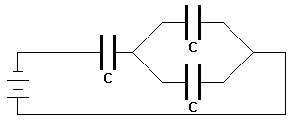

98. Three identical capacitors each with a capacitance of *C* are connected as shown in the following diagram. What would be the total equivalent capacitance of the circuit?

(A) 0.33 *C* (B) 0.67 *C* (C) 1.0 *C* (D) 1.5 *C* (E) 3.0 *C*

99. An electric heater draws 13 amperes of current when connected to 120 volts. If the price of electricity is $0.10/kWh, what would be the approximate cost of running the heater for 8 hours?

(A) $0.19 (B) $0.29 (C) $0.75 (D) $1.25 (E) $1.55

Questions 100 – 101

Five identical light bulbs, each with a resistance of 10 ohms, are connected in a simple electrical circuit with a switch and a 10 volt battery as shown in the diagram below.

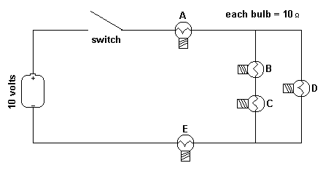

100. The steady current in the above circuit would be closest to which of the following values?

(A) 0.2 amp (B) 0.37 amp (C) 0.5 amp (D) 2.0 amp (E) 5.0 amp

101. Which bulb (or bulbs) could burn out without causing other bulbs in the circuit to also go out?

(A) only bulb D (D) only bulbs C or D

(B) only bulb E (E) bulbs B, C, or D

(C) only bulbs A or E

Questions 102 – 104

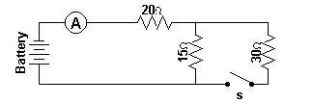

An ideal battery, an ideal ammeter, a switch and three resistors are connected as shown. With the switch open as shown in the diagram the ammeter reads 2.0 amperes.

102. With the switch open, what would be the potential difference across the 15 ohm resistor?

(A) 30 V (B) 40 V (C) 60 V (D) 70 V (E) 110V

103. With the switch open, what must be the voltage supplied by the battery?

(A) 30 V (B) 40 V (C) 60 V (D) 70 V (E) 110 V

104. When the switch is closed, what would be the current in the circuit?

(A) 1.1 A (B) 1.7 A (C) 2.0 A (D) 2.3 A (E) 3.0 A

105. How much current flows through a 4 ohm resistor that is dissipating 36 watts of power?

(A) 2.25 amps (B) 3.0 amps (C) 4.24 amps (D) 9.0 amps (E) 144 amps

Questions 106 – 107

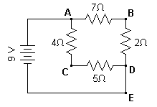

A 9–volt battery is connected to four resistors to form a simple circuit as shown above.

106. How would the current through the 2 ohm resistor compare to the current through the 4 ohm resistor?

(A) one–forth as large (D) twice as large

(B) one–half as large (E) equally as large

(C) four times as large

107. What would be the potential at point B with respect to point C in the above circuit?

(A) +7 V (B) +3 V (C) 0 V (D) –3 V (E) –7 V

108. A cylindrical resistor has length *L* and radius *r*. This piece of material is then drawn so that it is a cylinder with new length 2*L*. What happens to the resistance of this material because of this process?

(A) the resistance is quartered.

(B) the resistance is halved.

(C) the resistance is unchanged.

(D) the resistance is doubled.

(E) the resistance is quadrupled.

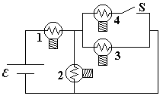

109. A circuit is connected as shown. All light bulbs are identical. When the switch in the circuit is closed illuminating bulb #4, which other bulb(s) also become brighter?

(A) Bulb #1 only (B) Bulb #2 only (C) Bulbs #2 and #3 only (D) Bulbs #1, #2, and #3

(E) None of the bulbs.

1. 110. A cylindrical graphite resistor has length L and cross–sectional area A. It is to be placed into a circuit, but it first must be cut in half so that the new length is ½ L. What is the ratio of the new resistivity to the old resistivity of the cylindrical resistor?

(A) 4 (B) 2 (C) 1 (D) ½ (E) ¼

Questions 111 – 112

The diagram below shows five identical resistors connected in a combination series and parallel circuit to a voltage source.

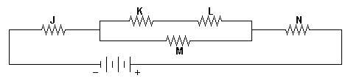

111. Through which resistor(s) would there be the greatest current?

(A) J only (B) M only (C) N only (D) J&N only (E) K&L only

112. Which resistor(s) have the greatest rate of energy dissipation?

(A) J only (B) M only (C) N only (D) J&N only (E) K&L only

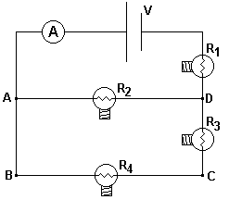

113. The circuit shown has an ideal ammeter with zero resistance and four identical resistance light bulbs which are initially illuminated. A person removes the bulb R4 from its socket thereby permanently breaking the electrical circuit at that point. Which statement is true of the circuit after removing the bulb?

(A) The voltage from B → C increases.

(B) The power supplied by the battery increases

(C) The voltage across R1 increases.

(D) The ammeter reading is unchanged.

(E) The bulb R2 maintains the same brightness.

1. 114. A current through the thin filament wire of a light bulb causes the filament to become white hot, while the larger wires connected to the light bulb remain much cooler. This happens because
2. (A) the larger connecting wires have more resistance than the filament.
3. (B) the thin filament has more resistance than the larger connecting wires.
4. (C) the filament wire is not insulated.
5. (D) the current in the filament is greater than that through the connecting wires.
6. (E) the current in the filament is less than that through the connecting wires.
7. 
8. 115. In the circuit above the voltmeter V draws negligible current and the internal resistance of the battery is 1.0 ohm. The reading of the voltmeter is
9. (A) 10.5 V (B) 12.0 V (C) 10.8 V (D) 13.0 V (E) 11.6 V
10. 
11. 116. Suppose you are given a constant voltage source V0 and three resistors R1, R2, and R3 with R1 > R2 > R3. If you wish to heat water in a pail which of the following combinations of resistors will give the most rapid heating?
12. 
13. 117. A household iron used to press clothes is marked “120 volt, 600 watt.” In normal use, the current in it is

(A) 0.2 A (B) 2 A (C) 4 A (D) 5 A (E) 7.2 A

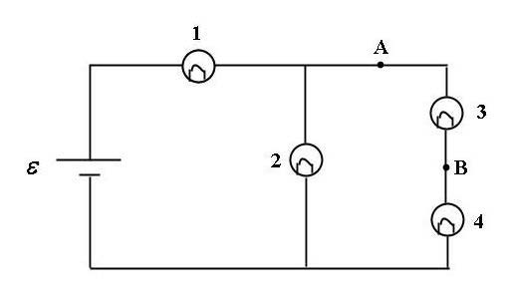

118. For the circuit shown, a shorting wire of negligible resistance is added to the circuit between points A and B. When this shorting wire is added, bulb #3 goes out. Which bulbs (all identical) in the circuit brighten?

(A) Only Bulb 2 (B) Only Bulb 4 (C) Only Bulbs 1 and 4 (D) Only Bulbs 2 and 4 (E) Bulbs 1, 2 and 4

1. 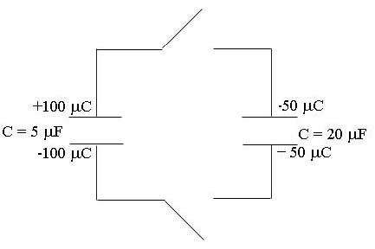
2. 119. For the configuration of capacitors shown, both switches are closed simultaneously. After equilibrium is established, what is the charge on the top plate of the 5 µF capacitor?
3. (A) 100 µC (B) 50 µC (C) 30 µC (D) 25 µC (E) 10 µC

This resistor

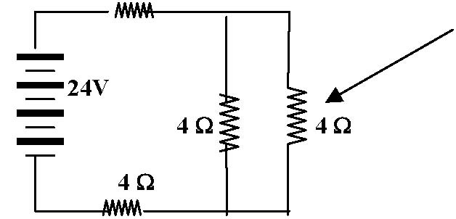

**4 Ω**

1. 120. How many coulombs will pass through the identified resistor in 5 seconds once the circuit was closed?

(A) 1.2 (B) 12 (C) 2.4 (D) 24 (E) 6

1. 121. A junior Thomas Edison wants to make a brighter light bulb. He decides to modify the filament. How should the filament of a light bulb be modified in order to make the light bulb produce more light at a given voltage?
2. (A) Increase the resistivity only.
3. (B) Increase the diameter only.
4. (C) Decrease the diameter only.
5. (D) Decrease the diameter and increase the resistivity.
6. (E) Increase the length only.
7. 

C

1. 122. In the circuit diagram above, all of the bulbs are identical. Which bulb will be the brightest?
2. (A) A (B) B (C) C (D) D (E) The bulbs all have the same brightness.



123. For the circuit shown, the ammeter reading is initially *I.* The switch in the circuit then is closed. Consequently:

(A) The ammeter reading decreases.

(B) The potential difference between *E* and *F* increases.

(C) The potential difference between *E* and *F* stays the same.

(D) Bulb #3 lights up more brightly.

(E) The power supplied by the battery decreases.

124. Approximately how much would it cost to keep a 100 W light bulb lit continuously for 1 year at a rate of $0.10 per kW ⋅ hr?

(A) $1 (B) $10 (C) $100 (D) $1000 (E) $100000



125. In the circuit shown above, the potential difference between points a and b is zero for a value of capacitance C of

(A) 1/3 microfarad (B) 2/3 microfarad (C) 2 microfarads (D) 3 microfarads (E) 9 microfarads



126. The equivalent resistance of the circuit shown to the right with resistances R1 = 4.00 Ω, R2 = 3.00 Ω, and R3 = 2.00 Ω is

(A) 0.111 Ω (B) 0.923 Ω (C) 1.08 Ω (D) 3.00 Ω (E) 9.00 Ω



127. For the circuit shown, when a shorting wire (no resistance) connects the points labeled A and B, which of the numbered light bulbs become brighter? Assume that all four bulbs are identical and have resistance R .

(A) Bulb 1 only (B) Bulb 2 only (C) Bulb 3 only (D) Bulbs 1 and 3 only (E) Bulbs 1, 2, and 3

128. In terms of the seven fundamental SI units in the MKS system, the Ohm is written as

(A) (B) (C) (D) (E)

129. Consider a simple circuit containing a battery and three light bulbs. Bulb *A* is wired in parallel with bulb *B* and this combination is wired in series with bulb *C*. What would happen to the brightness of the other two bulbs if bulb *A* were to burn out?

(A) There would be no change in the brightness of either bulb *B* or bulb *C*.   
(B) Both would get brighter.       
(C) Bulb *B* would get brighter and bulb *C* would get dimmer.   
(D) Bulb *B* would get dimmer and bulb *C* would get brighter.   
(E) Only bulb *B* would get brighter



130. For the RC circuit shown, the resistance is R = 10.0 Ω, the capacitance is C = 5.0 F and the battery has voltage ξ = 12 volts . The capacitor is initially uncharged when the switch S is closed at time t = 0. At some time later, the current in the circuit is 0.50 A. What is the magnitude of the voltage across the capacitor at that moment?

(A) 0 volts (B) 5 volts (C) 6 volts (D) 7 volts (E) 12 volts



131. In the circuit shown above, the 10 μF capacitor is initially uncharged. After the switch *S* has been closed for a long time, how much energy is stored in the capacitor?

(A) 0 μJ (B) 100 μJ (C) 250 μJ (D) 500 μJ (E) 1000 μJ

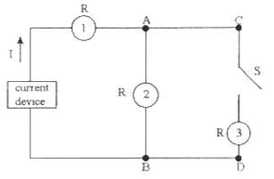

132. In the circuit shown above, a constant current device is connected to some identical light bulbs. After the switch S in the circuit is closed, which statement is correct about the circuit?

(A) Bulb #2 becomes brighter. (B) Bulb #1 becomes dimmer.       
(C) All three bulbs become equally brighter. (D) The voltage between points C and D is decreased.   
(E) The power from the current device is increased.

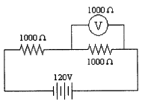

133. Two 1000 Ω resistors are connected in series to a 120–volt electrical source. A voltmeter with a resistance of 1000 Ω is connected across the last resistor as shown. What would be the reading on the voltmeter?

(A) 120 V (B) 80 V (C) 60 V (D) 40 V (E) 30 V

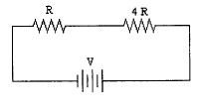

134. Two resistors, one with resistance *R* and the second with resistance 4*R* are placed in a circuit with a voltage *V*. If resistance *R* dissipates power *P*, what would be the power dissipated by the 4*R* resistance?

(A) 4 *P* (B) 2 *P*  (C) *P* (D) 1/2 *P* (E) 1/4 *P*

Questions 135 – 136

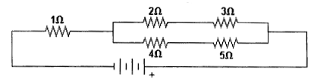

The diagram above shows five resistors connected to a voltage source.

135. Which resistor has the greatest electric current through it?

(A) 1 Ω (B) 2 Ω (C) 3 Ω (D) 4 Ω (E) 5 Ω

136. Which resistor has the greatest potential difference across it?

(A) 1 Ω (B) 2 Ω (C) 3 Ω (D) 4 Ω (E) 5 Ω

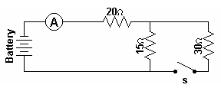

137. A battery, an ammeter, three resistors, and a switch are connected to form the simple circuit shown above. When the switch is closed what would happen to the potential difference across the 15 ohm resistor?

(A) it would equal the potential difference across the 20 ohm resistor   
(B) it would be twice the potential difference across the 30 ohm resistor  
(C) it would equal the potential difference across the 30 ohm resistor   
(D) it would be half the potential difference across the 30 ohm resistor   
(E) none of the above

Questions 138 – 139

A 9–volt battery is connected to four resistors to form a simple circuit as shown below.

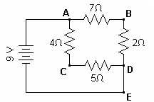

138. What would be the current at point E in the circuit?

(A) 2 amp (B) 4 amp (C) 5 amp (D) 7 amp (E) 9 amp

139. What would be the potential at point B with respect to point D?

(A) +2 V (B) +4 V (C) +5 V (D) +7 V (E) +9 V

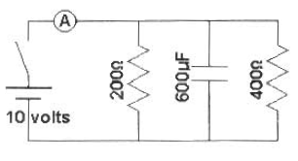

140. Two resistors and a capacitor are connected with a 10 volt battery, a switch and an ideal ammeter to form the simple electrical circuit shown. After the switch is closed and the current in the circuit reaches a constant value, what is the reading on the ammeter in the circuit?

(A) 9.2 × 10–2A (B) 8.1 × 10–2A (C) 7.5 × 10–2A (D) 6.9 × 10–2A (E) zero

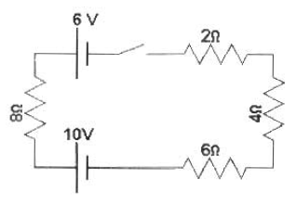

141. When the switch is closed, what would be the current in the circuit shown in the diagram above if the two batteries are opposing one another?

(A) 1.25 A (B) 0.75 A (C) 0.5 A (D) 0.3 A (E) 0.2 A

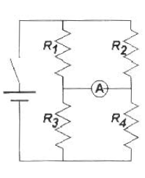

142. Four resistors, *R*1, *R*2, *R*3, and *R*4, are connected in the circuit diagram above. When the switch is closed, current flows in the circuit. If no current flows through the ammeter when it is connected as shown, what would be the value of *R*3?

(A) (B) (C) (D) (E) *R*1

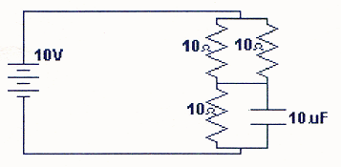

143. The diagram above shows an electrical circuit composed of 3 resistors and 1 capacitor. If each resistor has a resistance of 10 Ω and the capacitor has a value of 10 µF, what would be the charge stored in the capacitor when an EMF of 10 V is maintained in the circuit for a sufficient time to fully charge the capacitor?

(A) 23 µC (B) 40 µC (C) 67 µC (D) 100 µC (E) 150 µC

144. Given 4 identical resistors of resistance *R*, which of the following circuits would have an equivalent resistance of 4/3 *R*?

(A) four resistors in a circuit (B) four resistors in a circuit (C) four resistors in a circuit   
(D) four resistors in a circuit (E) None of the above



145. The three lightbulbs in the circuit above are identical, and the battery has zero internal resistance. When switch *S* is closed to cause bulb 1 to light, which of the other two bulbs increase(s) in brightness?

(A) Neither bulb

(B) Bulb 2 only

(C) Bulb 3 only

(D) Both bulbs

(E) It cannot be determined without knowing the emf of the battery.

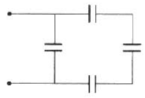

146. What would be the equivalent capacitance of the circuit shown if each capacitor has a capacitance of C?

(A) ¼ C (B) ¾ C (C) 4/3 C (D) 3C (E) 4C

147. Which of the following graphs would best represent the resistance versus temperature relationship for a superconductor?

(A) 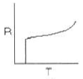 (B) 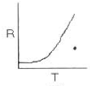 (C) 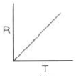  
(D) 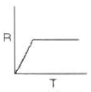 (E) 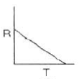

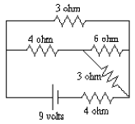

148. What would be the total current being supplied by the battery in the circuit shown above?

(A) 3.0 amperes (B) 2.25 amperes (C) 2.0 amperes (D) 1.5 amperes (E) 1.0 amperes

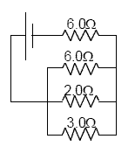

149. In the electric circuit shown above, the current through the 2.0 Ω resistor is 3.0 A. Approximately what is the emf of the battery?

(A) 51 V (B) 42 V (C) 36 V (D) 24 V (E) 21 V

150. Which of the following wiring diagrams could be used to experimentally determine *R* using Ohm's Law? Assume an ideal voltmeter and an ideal ammeter.

(A) 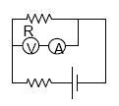 (B) 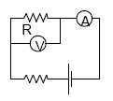 (C) 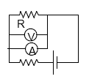  
(D) 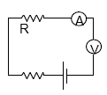 (E) 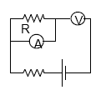

Questions 151 – 152

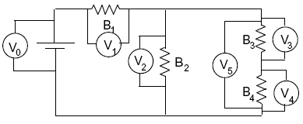

*B*1, *B*2, *B*3, and *B*4 are identical light bulbs. There are six voltmeters connected to the circuit as shown. All voltmeters are connected so that they display positive voltages. Assume that the voltmeters do not affect the circuit.

151. If *B*2 were to burn out, opening the circuit, which voltmeter(s) would read zero volts?

(A) none would read zero (B) only *V*2 (C) only *V*3 and *V*4 (D) only *V*2, *V*4, and *V*5 (E) they would all read zero

152. If *B*2 were to burn out, opening the circuit, what would happen to the reading of *V*1? Let *V* be its original reading when all bulbs are functioning and let *V* be its reading when *B*2 is burnt out.

(A) *V* > 2*V* (B) 2*V* > *V* > *V* (C) *V* = *V* (D) *V* > *V* > *V/2* (E) *V/2* > *V*

Questions 153 – 155



In the circuit above, the resistors all have the same resistance. The battery, wires, and ammeter have negligible resistance. A closed switch also has negligible resistance.

153. Closing which of the switches will produce the greatest power dissipation in *R*2?

(A) *S*1 only (B) *S*2 only (C) *S*1 and *S*2 only (D) *S*1 and *S*3 only (E) *S*1, *S*2, and *S*3

154. Closing which of the switches will produce the greatest reading on the ammeter?

(A) *S*1 only (B) *S*2 only (C) *S*3 only (D) *S*1 and *S*2 (E) *S*1 and *S*3

155. Closing which of the switches will produce the greatest voltage across *R*3?

(A) *S*1 only (B) *S*2 only (C) *S*1 and *S*2 only (D) *S*1 and *S*3 only (E) *S*1, *S*2, and *S*3

156. Two cables can be used to wire a circuit. Cable *A* has a lower resistivity, a larger diameter, and a different length than cable *B*. Which cable should be used to minimize heat loss if the same current is maintained in either cable?

(A) Cable *A*

(B) Cable *B*

(C) The heat loss is the same for both.

(D) It cannot be determined without knowing the length of each cable.

(E) It cannot be determined without knowing the materials contained in each cable

Questions 157 – 158



An electric circuit consists of a 12 V battery, an ideal 10 A fuse, and three 2 Ω resistors connected as shown above.

157. What would be the reading on a voltmeter connected across points *A* and *C* ?

(A) 12 V (B) 6 V (C) 3 V (D) 2 V (E) 0 V, since the fuse would break the circuit

158. What would be the reading on an ammeter inserted at point *B* ?

(A) 9 A (B) 6 A (C) 3 A (D) 2 A (E) 0 A, since the fuse would break the circuit

Questions 159 – 160



Three capacitors are connected to a 5 V source, as shown in the circuit diagram above.

159. The equivalent capacitance for the circuit is

(A) 1/11 μF (B) 11/18 μF (C) 1 μF (D) 4 μF (E) 11 μF

160. How do the charge *Q*3 stored in the 3 μF capacitor and the voltage *V*3 across it compare with those of the 6 μF capacitor?

Charge Voltage

(A) *Q*3 < *Q*6 *V*3 = *V*6

(B) *Q*3 = *Q*6 *V*3 < *V*6

(C) *Q*3 = *Q*6 *V*3 > *V*6

(D) *Q*3 > *Q*6 *V*3 = *V*6

(E) *Q*3 > *Q*6 *V*3 > *V*6

161. A length of wire of resistance *R* is connected across a battery with zero internal resistance. The wire is then cut in half and the two halves are connected in parallel. When the combination is reconnected across the battery, what happens to the resultant power dissipated and the current drawn from the battery?

Power Current

(A) No change No change

(B) Doubles Doubles

(C) Quadruples Doubles

(D) Doubles Quadruples

(E) Quadruples Quadruples

162. A fixed voltage is applied across the length of a tungsten wire. An increase in the power dissipated by the wire would result if which of the following could be increased?

(A) The resistivity of the tungsten

(B) The cross-sectional area of the wire

(C) The length of the wire

(D) The temperature of the wire

(E) The temperature of the wire’s surroundings

163. In a 30-minute interval, one kilowatt-hour of electrical energy is dissipated in a resistance of 20 ohms by a current of

(A) 10 amp. (B) 20 amp. (C) 14.1 amp. (D) 36 amp. (E) 18 amp.