Analyzing Budget’s Worksheet Name: _______________________

- Patrice has budgeted to put $35.00 a week into savings. This accounts for 10% of her income.
- What is Patrice’s weekly income?

- If she follows her budget, how much will she have saved in one year?

- If her salary increases by 5% and she continues to put 10% of her income into savings, how much will she save in a year?

- Sukh works full-time but is saving up for a part-time college course. He estimates that he will need $6000.00 in savings to cover extra expenses while he studies.
- He budgets to save 15% of his salary each month. If he earns $2865.00 a month, how much will he put away each month?

- How many months will he have to work in order save enough money? (Hint: Find how much he saves per month)

- The course starts 12 months from now. What percentage of his salary will Sukh have to save per month in order to be able to afford the course?

- Juliet’s monthly entertainment expenses are $275.00 and account for 12% of her income. She would like to reduce her entertainment spending to 8% of her income.
- Calculate Juliet’s total monthly income.

- Calculate her new monthly entertainment budget.

- Sammy earns about $1500.00 per month and has the following expenses. To the right are the suggested spending guidelines
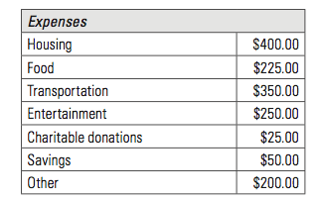 | 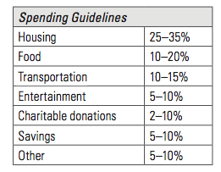

  - How does his spending compare to the guidelines? In what categories does he need to adjust his spending?

  - If Sammy does not make any changes to his spending, how much money will he save in one year?

  - Make a new budget for Sammy that falls within the spending guidelines.

Expenses
Housing
Food
Transportation
Entertainment
Charitable Donations
Savings
Other

  - Construct a circle graph that shows his new budget.

- Manjeet earns $550.00 per week.
  - If he saves 14% of his salary, how much will he save in one year?

  - If Manjeet’s salary increases by 5% and he continues to save 14%, how much more will he save in one year?

