Name: ____________
LEARNING INTENTIONS: Solve problems that involve creating and interpreting a broken line, bar and circle graph.
- Determine the possible graphs that can be used to represent a given data set, and explain the
advantages and disadvantages of each.
- Create, with and without technology, a graph to represent a given data set.
- Explain, using examples, how the same graph can be used to justify more than one
- conclusion.
- Explain, using examples, how different graphic representations of the same data set can be
used to emphasize a point of view.
- Solve a contextual problem that involves the interpretation of a graph.

QUESTION: Am I balanced?

TASK: Working on your own, you will keep track of the minutes in one week and how you spend your time. You will analysis your data and represent your findings in a bar graph and a circle graph. After you create the graphs you will analyze them and reflect on how you spend your time.

CONTENT: You will create a report that includes the following items:

- Getting Started – Complete handout
  - Due Date: ______________

- Data Collection – A table that contains a list of weekly activities and the time spent doing each. Either hard copy or digital.
  - Due Date: ______________

- Data Analysis – A table the reorganizes minutes into larger categories and calculates the percent of each category.
  - Due Date: ______________

- Bar Graph – A bar graph complete by hand representing time spent in large categories on a half sheet of poster board with pictures of activities.
  - Due Date: _____________

- Circle Graph – A circle graph created in Excel that displays an accurate representation of how you spend your time.
  - Due Date: ______________

- A Broken Line Graph – A circle graph created in Excel that displays the amount of sleep you get each day of the week
  - Due Date: ______________

- Conclusion and Reflection - Complete questions in the handout.
  - Due Date: ______________

- Final Product – All documents put in order according to the table of contents in a duo-tang and poster with bar and circle graphs.
  - Due Date: ______________

Getting Started:

“There’s no secret to balance. You just have to feel the waves” – Frank Herbert

In one week there are 10 080 minutes. This week you are going to keep a log on how those minutes are spent. How long do you sleep? What about the time spent in the bathroom? How much of your day is in a classroom? You might be surprised.

You are going to create a report all about your week. Follow the format outlined here.

What are you going to do? _______________________________________________________________________________________
_______________________________________________________________________________________

Why are you going to do it? _______________________________________________________________________________________
_______________________________________________________________________________________
_______________________________________________________________________________________
_______________________________________________________________________________________

What are you hoping to achieve? _______________________________________________________________________________________
_______________________________________________________________________________________
_______________________________________________________________________________________
_______________________________________________________________________________________

Data Collection:

You are going to diligently record how many minutes you spend doing various activities in your week. The more accurate data you collect, the more valuable your results will be. You can record your minutes on paper, in an excel sheet or on your phone (print it out) and attach it in the data section of your report (see chart).

Data Analysis:

Look at the minutes you spent over the week. Put your minutes into the following categories using an excel spreadsheet:

Categories | Total Minutes
Spirituality
Physical Activity
Sleep
Physical Appearance
Environmental Impact
Intellectuality
Employment
Socializing
Family
Recreational Technology

Defining the Categories:

Spirituality - manage stress, reflect on values and beliefs, respect the beliefs and values of others
Examples: yoga, listening to music, church, gardening, volunteering, meditation, drawing, spending time in nature

Physical Activity –any bodily activity that enhances or maintains physics fitness and overall health
Examples: being active, sports, walking, dance

Sleep – a natural periodic state of rest for the mind and body

Physical Appearance – self-care practices
Examples: going to the doctor/dentist, personal hygiene, showering, make up, picking out clothes

Environmental Impact – creating a safe and sustainable community that recognizes the impact of personal and social environmental decisions
Examples: walking or taking the bus, reduce your waste, eat locally, re-use materials, toxic free personal care products

Intellectuality – expanding knowledge and seeking mental stimulation
Examples: in class learning, homework, studying, research, personal inquiry

Employment – condition of having paid work
Examples: part-time job, baby sitting, chores

Socializing – developing and maintaining healthy relationships with those around you
Examples: spending time with people, hanging out with friends, communicating and resolving conflicts

Family – a network of people you can rely on
Examples: parents, siblings, neighbours, grandparents, godparents, aunts and uncles

Recreational Technology – refreshing of one’s mind or body through different technologies
Examples: watching TV, texting, gaming, Facebook, talking on the phone, Twitter, YouTube

Bar Graph: Create by hand on paper no bigger than half the size of a poster board.

Steps:

- Decide on a title for your graph
- Draw the vertical and horizontal axes.
- Label the horizontal axes
- Write the names of the categories where the bars will be
- Label the vertical axes
- Decide on an appropriate scale.
- Draw a bar to show the total for each category
- Fill bars with pictures that relate to each category

Broken line graph: Use the amount of sleep you receive each night of the week to create a broken line graph… We will do this together in the computer lab

Circle Graph:

Use the totals for each category listed above to create a circle graph in Excel. Highlight the data, click on charts and choose the circle graph. Use the formatting palette to add a title and percentages. Copy and paste your circle graph into a word document and enlarge it to half a page. Print your circle graph. Use coloured pencils to identify the sectors with the legend. Attach your circle graph to the larger bar graph poster.
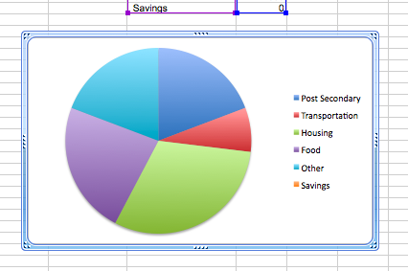

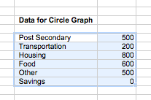
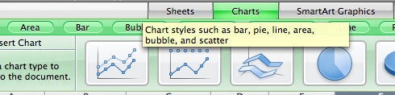

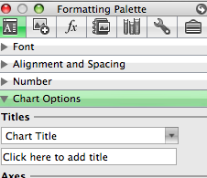
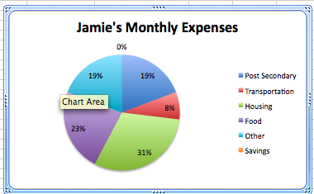
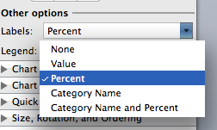

Conclusion and Reflection

Summary of results and what they mean, compare the categories of time spent

Discuss interesting findings – what surprised you and why? Do you feel like you have a good balance between the different activities in your life?

List all sources of error or mistakes you may have made without realizing – be thorough. Do the graphs accurately represent that data? Why or why not?

Make a connection to the big picture (relevance) – why is it important?

Compare the bar graph and the circle graph – which one is the most effective to represent the data and why?

Why is the broken line graph a good choice when tracking a single data set over time?

Ask new questions on this topic – that you could study in the future

Evaluation:

Content |  | Beginning | Developing | Accomplished | Exemplary
Knowledge & Understanding
Bar Graph | The student generally makes appropriate calculations when creating a bar graph.  Missing two of the following:  Title  Axes labeled including units  Appropriate scale that reflects an accurate representation of data  Crisp and neat bar graph that represents the data accurately |  | The student generally makes appropriate calculations when creating a bar graph.  Two of the following has errors and/or one is incomplete:  Title  Axes labeled including units  Appropriate scale that reflects an accurate representation of data  Crisp and neat bar graph that represents the data accurately | The student generally makes appropriate calculations when creating a bar graph.  One of the following has errors or is incomplete:  Title  Axes labeled including units  Appropriate scale that reflects an accurate representation of data  Crisp and neat bar graph that represents the data accurately | The student consistently makes appropriate calculations when creating a bar graph.  No errors and all the following are complete:  Title  Axes labeled including units  Appropriate scale that reflects an accurate representation of data  Crisp and neat bar graph that represents the data accurately
Circle Graph | The student generally makes appropriate calculations when creating a circle graph.  Missing two or more of the following:  Title  Colour Coded Legend  Percentages Labeled  Crisp and neat bar graph that represents the data accurately |  | The student generally makes appropriate calculations when creating a circle graph.  Two of the following has errors and maximum one is incomplete:  Title  Colour Coded Legend  Percentages Labeled  Crisp and neat bar graph that represents the data accurately | The student generally makes appropriate calculations when creating a circle graph.  One of the following has errors or is incomplete:  Title  Colour Coded Legend  Percentages Labeled  Crisp and neat bar graph that represents the data accurately | The student consistently makes appropriate calculations when creating a circle graph.  No errors and all the following are complete:  Title  Colour Coded Legend  Percentages Labeled  Crisp and neat bar graph that represents the data accurately
Broken Line Graph | The student generally makes appropriate calculations when creating a bar graph.  Missing two of the following:  Title  Axes labeled including units  Appropriate scale that reflects an accurate representation of data  Crisp and neat bar graph that represents the data accurately |  | The student generally makes appropriate calculations when creating a bar graph.  Two of the following has errors and/or one is incomplete:  Title  Axes labeled including units  Appropriate scale that reflects an accurate representation of data  Crisp and neat bar graph that represents the data accurately | The student generally makes appropriate calculations when creating a bar graph.  One of the following has errors or is incomplete:  Title  Axes labeled including units  Appropriate scale that reflects an accurate representation of data  Crisp and neat bar graph that represents the data accurately | The student consistently makes appropriate calculations when creating a bar graph.  No errors and all the following are complete:  Title  Axes labeled including units  Appropriate scale that reflects an accurate representation of data  Crisp and neat bar graph that represents the data accurately

Reflection
Conclusion | The student attempts to explain whether his or her results make sense in the context of the problem, but leaves some gaps having to do with the following:  Purpose and Summary of Results  Interesting Findings  Sources of Error  Relevance to the Real World  Comparing graphs  Extension and Further Study  Brainstorm – has some errors in understanding or is incomplete | The student attempts to explain whether his or her results make sense in the context of the problem, but leaves some gaps having to do with the following:  Purpose and Summary of Results  Interesting Findings  Sources of Error  Relevance to the Real World  Comparing graphs  Extension and Further Study  Brainstorm – has some errors in understanding or is incomplete | The student correctly but briefly explains whether business idea makes sense in the context of the scenario:  Purpose and Summary of Results  Interesting Findings  Sources of Error  Relevance to the Real World  Comparing graphs  Extension and Further Study  Brainstorm – completed but does not provide many details | The student critically explains whether business idea makes sense in the context of the scenario.  Purpose and Summary of Results  Interesting Findings  Sources of Error  Relevance to the Real World  Comparing graphs  Extension and Further Study  Brainstorm – thorough and thoughtful

