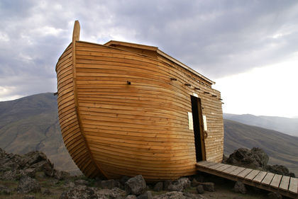
Noah’s Ark… For Real?
By O. Youle, K. Raymer, B Jordan, T. Morris

Abstract
God commands Noah to build an ark, and to do so God provides exact dimensions. Ultimately the ark will home at least two of all the Earth’s animals.

In ‘The Book of Genesis’, chapter 6:13 - 22, God commands Noah to build an ark as he promises to ‘bring the floodwaters down on Earth’ and rid the Earth of all its sinners. This would unfortunately mean that the animal kingdom would perish also, however as most primary school children could tell you, the ark was to accommodate at least two of every animal on Earth to ensure the survival of each species. God gives Noah exact instructions, describing the dimensions of the ark, ‘the length of the ark should be 300 cubits, its width 50 cubits, and its height 30 cubits’ (1 cubit = 48.2 cm). Now, whilst God is often regarded as infinitely wise, I wonder whether God paused to consider the physics behind such a request. Use Archimedes principle to determine if the Ark will provide sufficient to safely support the mass of the animals and the Ark.

God states that the ark should have a roof, and it should be made out of Gopher wood. Such wood doesn’t actually exist today. Many articles speculate over the exact translation of the word ‘gopher’, comparing it to pine or cedar, each of which are also mentioned in the bible. Let’s assume ‘gopher wood’ is most similar to cypress wood, as most English versions of the bible use this translation. Let’s also assume that each plank of cypress is 0.20 m thick. Cypress has a density of 510 kg/m³.

An Empty Ark.
- Calculate the volume occupied be Noah’s Ark. | - Create a FBD for an empty Ark in the space to the below.

- From your FBD create a F_{net} for the balanced forces assuming the Ark has no cargo. | - Find the depth of water the Ark would sit with no cargo. (Total Volume of Cypress used = 2369.7m³). Assume the flood brought fresh water.
- Determine the buoyant force for the Ark if we took depth to the extreme (30 cubits).

A previous investigation conducted into the feasibility of Noah’s ark suggests that an average mass of all the animals aboard the ark is approximately equal to the mass of a sheep. As such, assuming the average mass of a sheep is 23.47 kg.

- Create a new FBD for an Ark that contains “sheep” in the space to the below. | - How many total sheep could the Ark hold?

In The Genesis Flood, Doctors Morris and Whitcomb claim that only 35,000 individual animals needed to go on the ark.

- Would it be possible for the Ark to support it’s own mass and that of 35,000 sheep?

