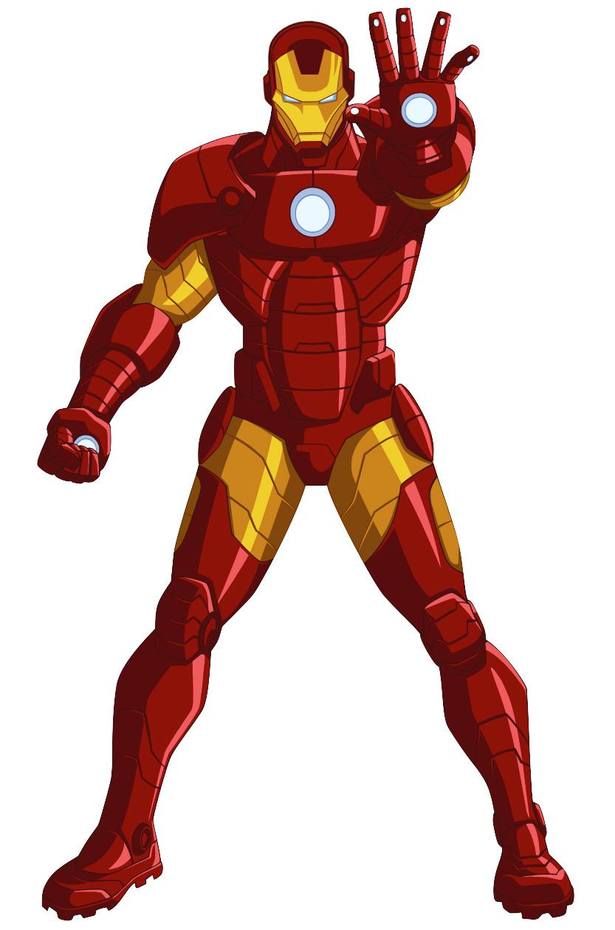
Iron Armor
E. I. Spender, L. J. Holdsworth, A. L. Bentley, A. R. Fogg

Abstract
Iron Man is a popular character from the Marvel Comics and Cinematic Universe, he possesses an armored suit that, among other fictional technological powers, has the ability to withstand large amounts of trauma without any damage to the occupant. Let’s explore the feasibility of the suit taking a direct hit from a tank shell and the wearer surviving, as seen in the film Iron Man (2008). The suit seems to work by absorbing the energy released from impact through internal dampers, reducing the impact by decelerating an object over a longer time to reduce the force applied.

A commonly used tank shell is the HESH L31 (High Explosive Squash Head) and when fired from a Challenger 2 tank has a muzzle velocity of 670 m/s. The shell is modeled as staying intact and upon striking the suit accelerates the suit, initially moving as one body, as shown in the figure below. The mass of a HESH L31 shell is about 17.1 kg and the mass of Iron Man’s suit, with him inside is 425lb (192.77 kg).

- Find the velocity (v₃) after collision. | 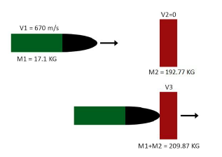

Upon colliding the acceleration of Iron Man would be enormous. To prevent the sudden acceleration from killing the user, the suit needs to decelerate the projectile sufficiently to prevent harm. Research has already been done on the relationship of g force to brain trauma, the main cause of trauma deaths in motorsport crashes. G force is a method of describing acceleration in terms of the Earth’s gravitational acceleration (2 g = 2 x 9.81 m/s² = 19.62 m/s²). The maximum g force a person can experience in an impact without significant risk of brain trauma is 50 g.

- Calculate the minimum distance it would take Ironman to bring the tank shell to a stop without causing brain trauma. (Note: this would be the minimum width of his armour).

