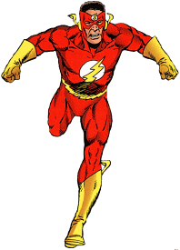**Flash’s Sole Problem**

H. Samaratunga, H. S. Ahmed, L. Tonks and M. Sadhra

Abstract

The comic book hero The Flash (Barry Allen) is capable of running at extremely fast speeds while wearing what appear to be “normal shoes”. While The Flash may not be susceptible to the consequences of physics ***his shoes are***! *Let’s find out how fast he would need to run before his shoes catch on fire*.

Data

The Flash is approximately 70 kg and wear’s size 11 shoes (weight of 2.5 lbs with a Surface Area of approximately 0.020 m2).

The **heat flux** due to friction can be found using the following equation. Where H is Heat Flux due to friction (W/m2), Q is heat, P is pressure exerted on the ground, v is velocity, t is time and A is area.



Heat transfer can found using the equations explored in AP Physics 2! Where Q is heat, m is mass, c is the specific heat capacity (1.13 x 103 J/(kg•K) for natural rubber, and ΔT is temperature.



The temperature that rubber starts to burn at 260oC and if we assume he is running at room temperature (20oC) ***find the Flash’s maximum velocity before he starts to literally “burn rubber”***. *Let’s assume the shoe is in contact with the ground for a total of 5.0 seconds and the coefficient of friction between the ground and The Flash is 0.80.*

|  |
| --- |
|  |