Efficiency of a Gasoline Powered Car

Purpose: Determine the efficiency of a car powered by gasoline.

Background: Without external forces a car would continue at a constant speed indefinitely. This is why on a flat surface we must continue to apply a force (F_{app}) if we hope to maintain a constant force. When traveling at 100 km/hr and above, must of the force opposing the motion of the car is due to drag forces due to air (see the Pagani Zonda below).
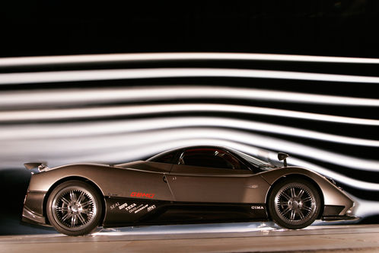
The Pagani Zonda is a mid-engine sports car car with a 550 hp engine and a drag coefficient of 0.40. The area of the front of the car is 2.35 m². The Zonga gets about 10.5 km/L driving at 100 km/hr.

Suppose the car is driven for 50 km at 100 km/hr. Gasoline contains 3.45 x 10⁷ J/L of energy. Calculate the efficiency for this trip. Find the fraction of the engines 800 horsepower that goes to keeping the car moving on the highway.
Efficiency of an Electrically Powered Car

Purpose: Determine the drag coefficient of a car powered by electricity.

Background: Electric cars use energy stored in batteries in order to generate mechanical motion. One of the earliest production cars is the Tesla Model S, first hitting the market in June of 2012.
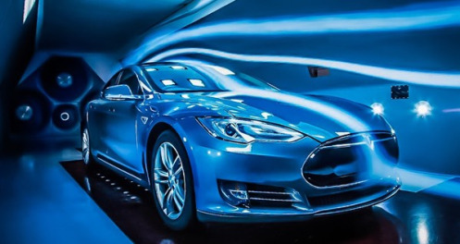

It is the third fastest accelerating production car ever produced and the quickest currently on the market. Its 310 MJ battery can travel 426 km when traveling at 100 km/hr and is said to be 59% efficient. Find the drag (D) for the Tesla Model S.

