Observations vs. Inferences vs. Predictions

Observation: recognizing or noting a fact or occurrence
Inference: a conclusion based on observations
Prediction: an educated guess about a future event.

Use the picture of the boy in the water to determine if the following statements are observations or if the statements are inferences. Place an “I” in the blank for inference, an “O” in the blank for observation, and “P” in the blank for prediction.
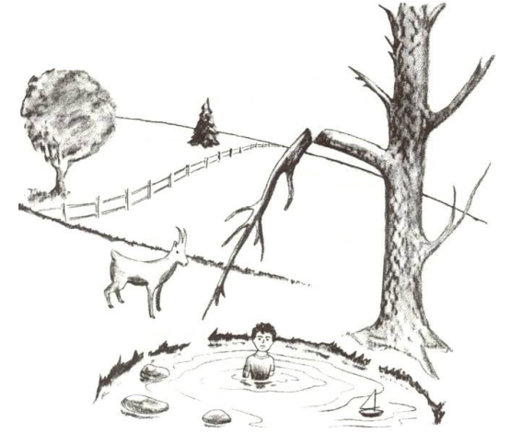

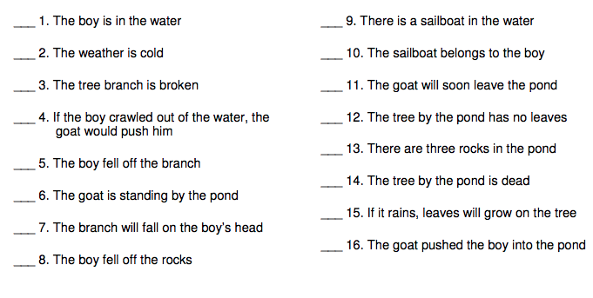
“Boy in the Water” Worksheet answers:

Observation: 1, 3, 6, 9, 12, 13

Inference: 2, 4, 5, 8, 10, 14 16

Prediction: 7, 11, 15

