AP Physics Free Response Practice – Thermodynamics

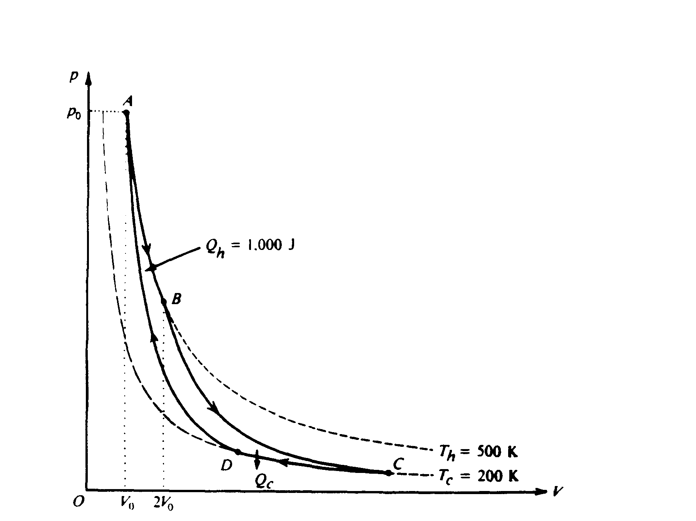

1983B4. The pV‑diagram above represents the states of an ideal gas during one cycle of operation of a reversible heat engine. The cycle consists of the following four processes.

**Process** **Nature of Process**

AB Constant temperature ( Th = 500 K)

BC Adiabatic

CD Constant temperature ( Tc = 200 K)

DA Adiabatic

During process A B, the volume of the gas increases from Vo to 2Vo and the gas absorbs 1,000 joules of heat.

a. The pressure at A is po.  Determine the pressure at B.

b. Using the first law of thermodynamics, determine the work performed on the gas during the process AB.

c. During the process AB, does the entropy of the gas increase, decrease, or remain unchanged? Justify your answer.

d. Calculate the heat Qc given off by the gas in the process CD.

e. During the full cycle ABCDA is the total work the performed on the gas by its surroundings positive, negative, or zero? Justify your answer.



1996B7 The inside of the cylindrical can shown above has cross-sectional area 0.005 m2 and length 0.15 m. The can is filled with an ideal gas and covered with a loose cap. The gas is heated to 363 K and some is allowed to escape from the can so that the remaining gas reaches atmospheric pressure (1.0 × 105 Pa). The cap is now tightened, and the gas is cooled to 298 K.

a. What is the pressure of the cooled gas?

b. Determine the upward force exerted on the cap by the cooled gas inside the can.

c. If the cap develops a leak, how many moles of air would enter the can as it reaches a final equilibrium at 298 K and atmospheric pressure? (Assume that air is an ideal gas.)

1986B5 (modified) A proposed ocean power plant will utilize the temperature difference between surface seawater and seawater at a depth of 100 meters. Assume the surface temperature is 25° Celsius and the temperature at the 100‑meter depth is 3° Celsius.

a. What is the ideal (Carnot) efficiency of the plant?

b. If the plant generates useful energy at the rate of 100 megawatts while operating with the efficiency found in part (a), at what rate is heat given off to the surroundings?

The diagram below represents the Carnot cycle for a simple reversible (Carnot) engine in which a fixed amount of gas, originally at pressure po and volume Vo follows the path ABCDA*.*

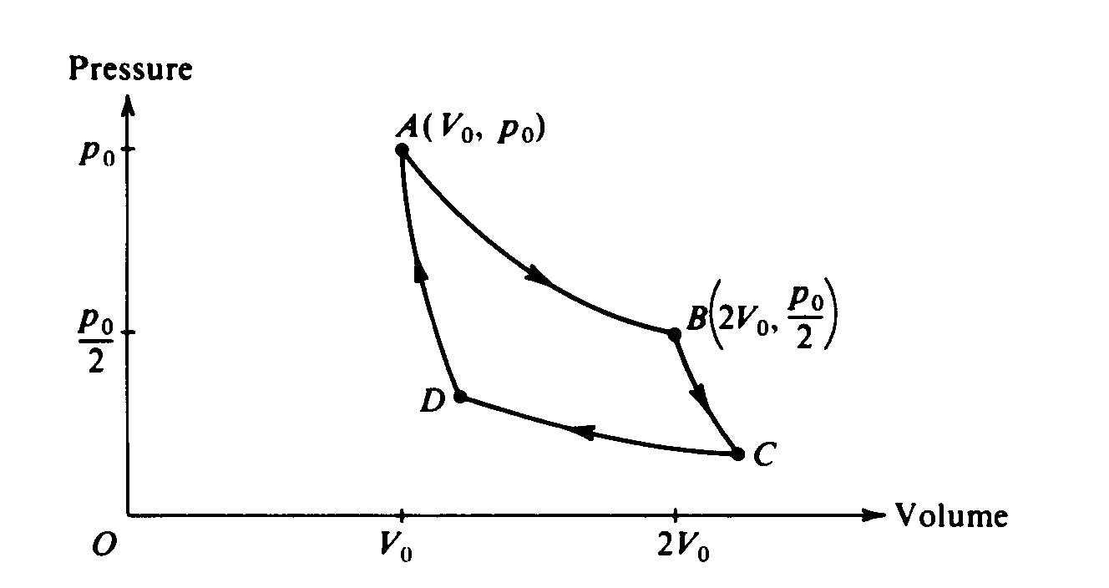

c. In the chart below, for each part of the cycle indicate with +, ‑, or 0 whether the heat transferred Q and temperature change ΔT are positive, negative, or zero, respectively. (Q is positive when heat is added to the gas, and ΔT is positive when the temperature of the gas increases.)

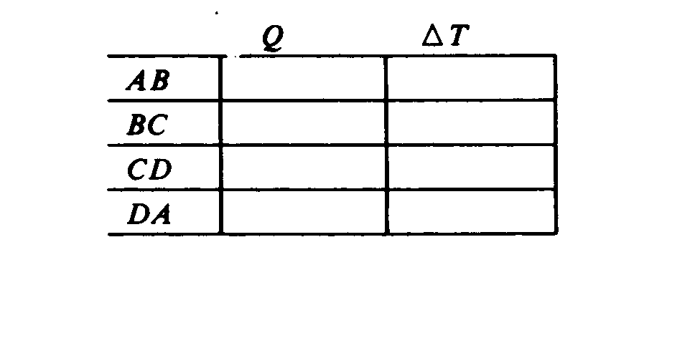

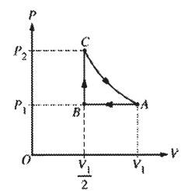

2004Bb5 One mole of an ideal gas is initially at pressure *P*1, volume *V*1, and temperature *T*1, represented by point *A* on the *PV* diagram above. The gas is taken around cycle *ABCA* shown. Process *AB* is isobaric, process *BC* is isochoric, and process *CA* is isothermal.

a. Calculate the temperature *T2* at the end of process *AB* in terms of temperature T1.

b. Calculate the pressure *P2* at the end of process *BC* in terms of pressure *P*1.

c. Calculate the net work done on the gas when it is taken from *A* to *B* to *C*. Express your answer in terms of *P*1 and *V*1.

d. Indicate below all of the processes that result in heat being added to the gas.

____ *AB ____ BC ____CA*

Justify your answer.

1989B4 (modified) An ideal gas initially has pressure po, volume Vo, and absolute temperature To. It then undergoes the following series of processes:

I. It is heated, at constant volume, until it reaches a pressure 2po.

II. It is heated, at constant pressure, until it reaches a volume 3 Vo.

III. It is cooled, at constant volume, until it reaches a pressure po.

IV. It is cooled, at constant pressure, until it reaches a volume Vo.

a. On the axes below

i. draw the p-V diagram representing the series of processes;

ii. label each end point with the appropriate value of absolute temperature in terms of To.

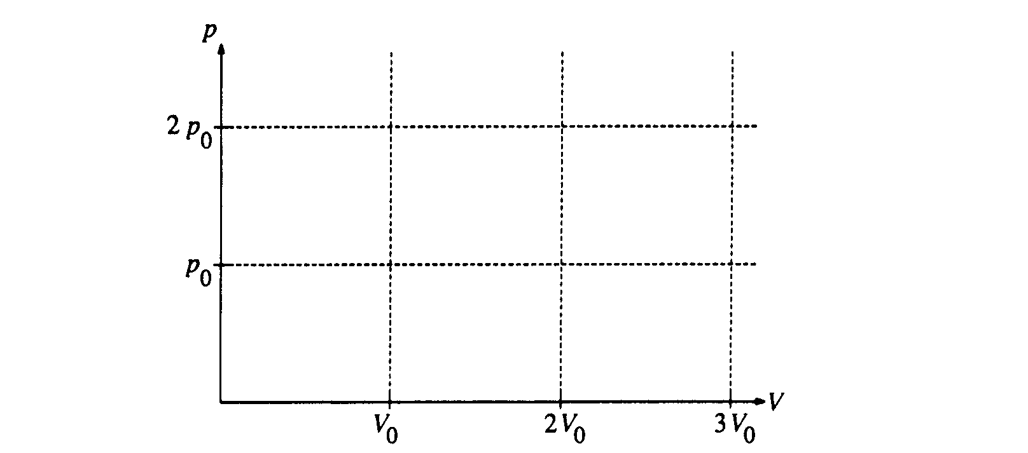

b. For this series of processes, determine the following in terms of po and Vo.

i. The net work done on the gas

ii. The net change in internal energy

iii. The net heat absorbed

c. Determine the heat transferred during process 2 in terms of po and Vo.

1999B7. A cylinder contains 2 moles of an ideal monatomic gas that is initially at state A with a volume of 1.0 × 10–2 m3 and a pressure of 4.0 × 105 Pa. The gas is brought isobarically to state B. where the volume is 2.0 × 10–2 m3. The gas is then brought at constant volume to state C, where its temperature is the same as at state A. The gas is then brought isothermally back to state A.

a. Determine the pressure of the gas at state C.

b. On the axes below, state B is represented by the point B. Sketch a graph of the complete cycle. Label points A and C to represent states A and C, respectively.

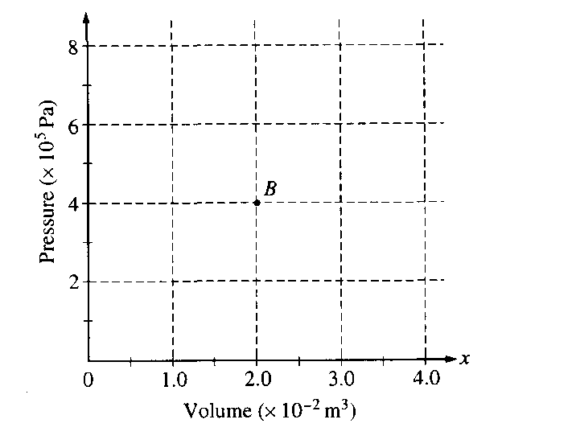

c. State whether the net work done on the gas during the complete cycle is positive, negative, or zero. Justify your answer.

d. State whether this device is a refrigerator or a heat engine. Justify your answer.

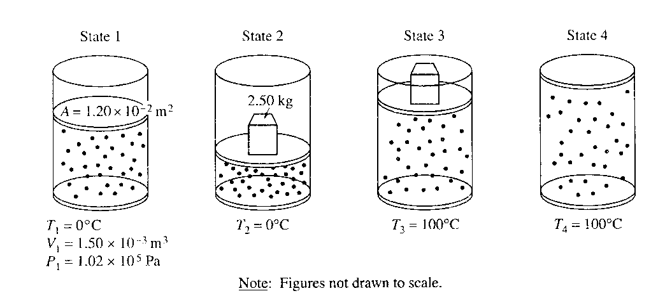

2001B6. A cylinder is fitted with a freely moveable piston of area 1.20 × 10–2 m2 and negligible mass. The cylinder below the piston is filled with a gas. At state 1, the gas has volume 1.50 × 10–3 m3, pressure 1.02 × 105 Pa, and the cylinder is in contact with a water bath at a temperature of 0°C. The gas is then taken through the following four‑step process.

• A 2.50 kg metal block is placed on top of the piston, compressing the gas to state 2, with the gas still at 0°C.

• The cylinder is then brought in contact with a boiling water bath, raising the gas temperature to 100°C at state 3.

• The metal block is removed and the gas expands to state 4 still at 100°C.

• Finally, the cylinder is again placed in contact with the water bath at 0°C, returning the system to state 1.

a. Determine the pressure of the gas in state 2.

b. Determine the volume of the gas in state 2.

c. Indicate below whether the process from state 2 to state 3 is isothermal, isobaric, or adiabatic.

_____Isothermal _____Isobaric _____Adiabatic

Explain your reasoning.

d. Is the process from state 4 to state 1 isobaric? _____Yes _____No

Explain your reasoning.

e. Determine the volume of the gas in state 4.

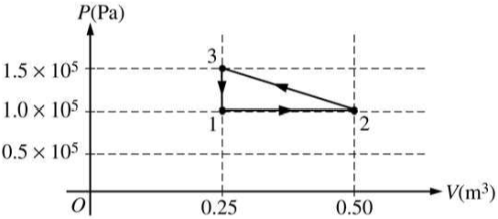

2006B5 A cylinder with a movable frictionless piston contains an ideal gas that is initially in state 1 at 1 × 105 Pa, 373 K, and 0.25 m3. The gas is taken through a reversible thermodynamic cycle as shown in the *PV* diagram above.

a. Calculate the temperature of the gas when it is in the following states.

i. State 2

ii. State 3

b. Calculate the net work done on the gas during the cycle.

c. Was heat added to or removed from the gas during the cycle?

Added _____ Removed _____ Neither added nor removed _____

Justify your answer.

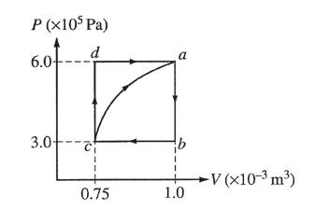

2003B5. A cylinder with a movable piston contains 0.1 mole of a monatomic ideal gas. The gas, initially at state *a,* can be taken through either of two cycles, *abca* or *abcda,* as shown on the PV diagram above. The following information is known about this system.

*Qc→a* = 685 J along the curved path

*Wc→a* = –120 J along the curved path

*Ua – Ub* = 450 J

*Wa→b→c* = 75 J

a. Determine the change in internal energy, *Ua – Uc*, between states *a* and *c*.

b. i. Is heat added to or removed from the gas when the gas is taken along the path *abc ?*

_____added to the gas _____removed from the gas

ii. Calculate the amount added or removed.

c. How much work is done on the gas in the process *cda?*

d. Is heat added to or removed from the gas when the gas is taken along the path *cda?*

_____added to the gas _____removed from the gas

Explain your reasoning.

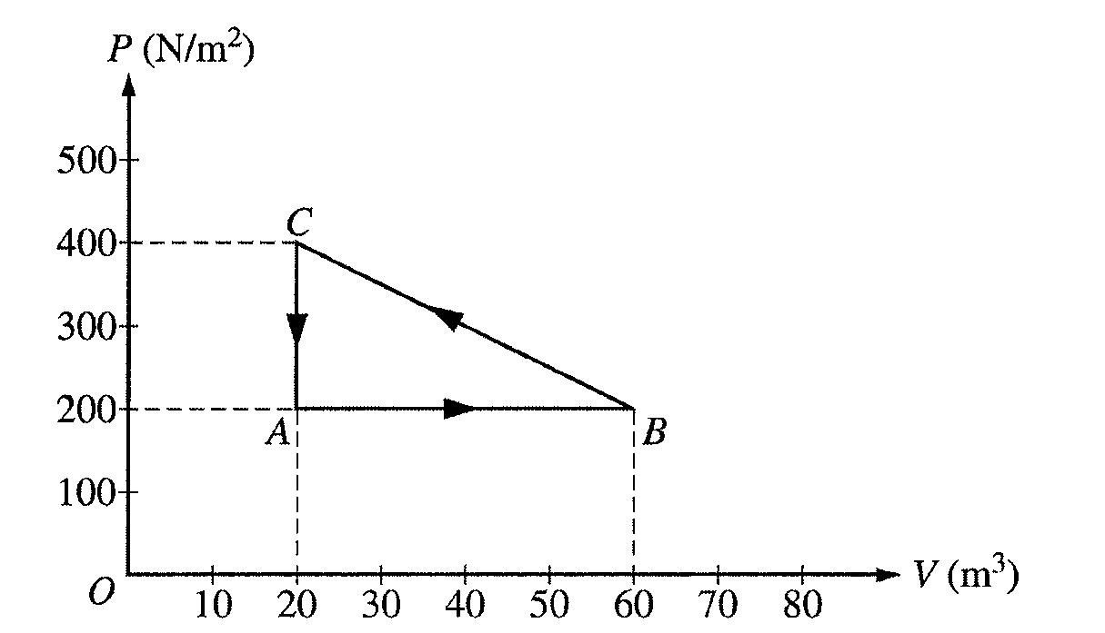

2003Bb5. One mole of an ideal gas is taken around the cycle *A→B→C→A* as shown on the PV diagram above.

a. Calculate the temperature of the gas at point *A*.

b. Calculate the net work done on the gas during one complete cycle.

c. i. Is heat added to or removed from the gas during one complete cycle?

_____added to the gas _____removed from the gas

ii. Calculate the heat added to or removed from the gas during one complete cycle.

d. After one complete cycle, is the internal energy of the gas greater, less, or the same as before?

_____greater _____less _____the same

Justify your answer.

e. After one complete cycle, is the entropy of the gas greater, less, or the same as before?

_____greater _____less _____the same

Justify your answer.

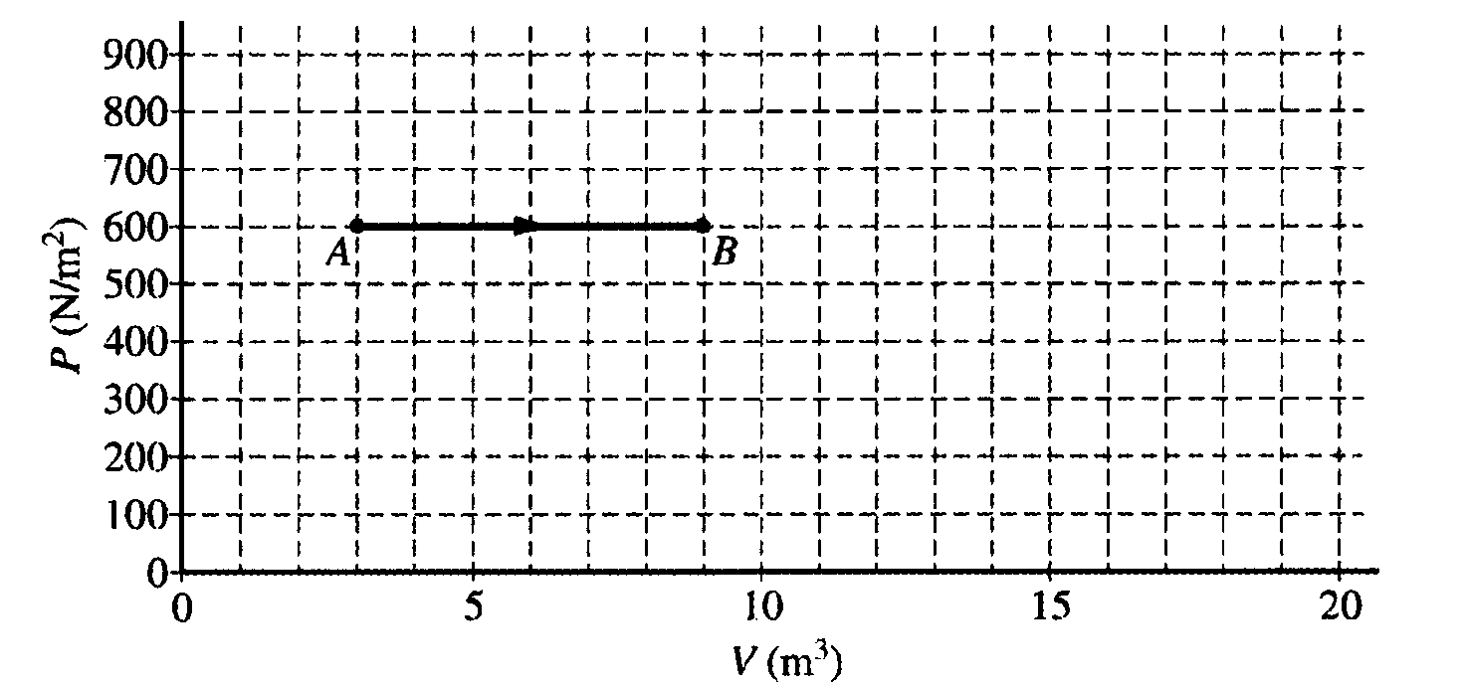

2004B5. The diagram above of pressure *P* versus volume *V* shows the expansion of 2.0 moles of a monatomic ideal gas from state *A* to state *B. As* shown in the diagram, *PA = PB = 600* N/m2, *V*A *=* 3.0m3, and *V*B*=*9.0 m3.

a. i. Calculate the work done by the gas as it expands.   
ii. Calculate the change in internal energy of the gas as it expands.   
iii. Calculate the heat added to or removed from the gas during this expansion.

b. The pressure is then reduced to 200 N/m2 without changing the volume as the gas is taken from state *B* to state *C*. Label state *C* on the diagram and draw a line or curve to represent the process from state *B* to state *C*.

c. The gas is then compressed isothermally back to state *A*.

i. Draw a line or curve on the diagram to represent this process.

ii. Is heat added to or removed from the gas during this isothermal compression?

_______added to _______removed from

Justify your answer.

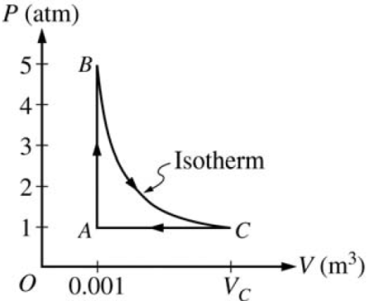

2008B5. A 0.03 mol sample of helium is taken through the cycle shown in the diagram above. The temperature of state *A* is 400 K.

a. For each process in this cycle, indicate in the table below whether the quantities *W*, *Q,* and *ΔU* are positive (+), negative (–), or zero (0). W is the work done on the helium sample.

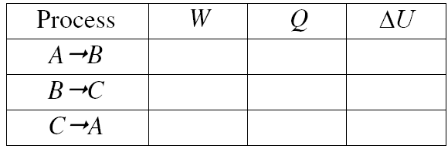

b. Explain your response for the signs of the quantities for process A⇨B.

c. Calculate *Vc*.

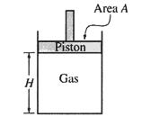

2005B6. An experiment is performed to determine the number *n* of moles of an ideal gas in the cylinder shown above. The cylinder is fitted with a movable, frictionless piston of area *A*. The piston is in equilibrium and is supported by the pressure of the gas. The gas is heated while its pressure P remains constant. Measurements are made of the temperature *T* of the gas and the height *H* of the bottom of the piston above the base of the cylinder and are recorded in the table below. Assume that the thermal expansion ofthe apparatus can be ignored.

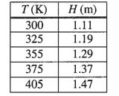

a. Write a relationship between the quantities *T* and *H,* in terms of the given quantities and fundamental constants, that will allow you to determine *n.*

b. Plot the data on the axes below so that you will be able to determine *n* from the relationship in part (a). Label the axes with appropriate numbers to show the scale.

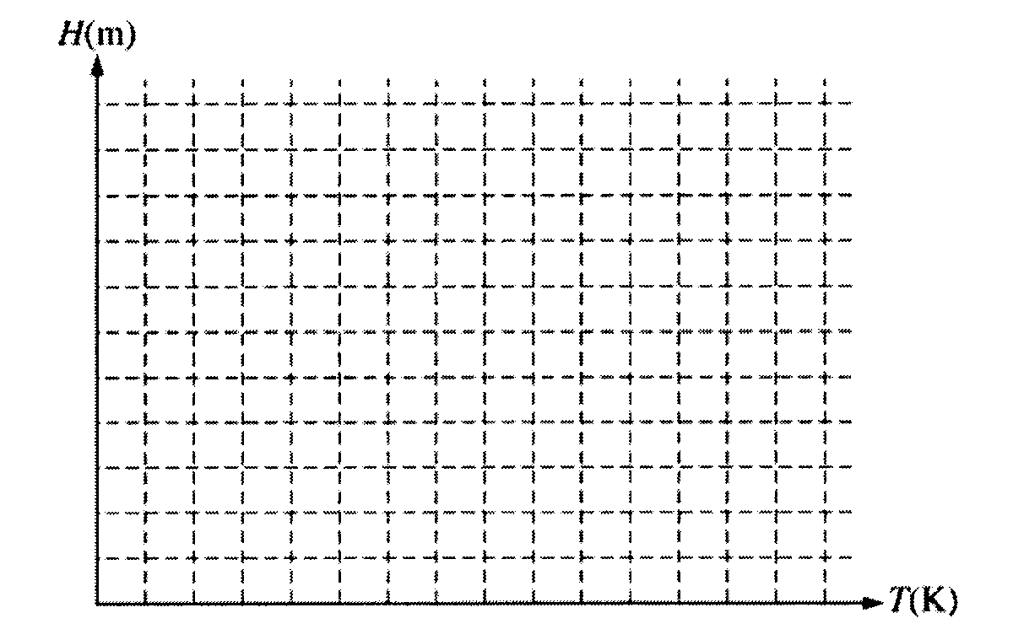

c. Using your graph and the values A = 0.027 m2 and P = 1.0 atmosphere, determine the experimental value of *n.*

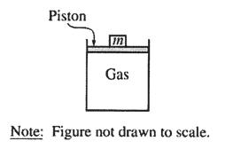

2005Bb6. You are given a cylinder of cross-sectional area *A* containing *n* moles of an ideal gas. A piston fitting closely in the cylinder is lightweight and frictionless, and objects of different mass *m* can be placed on top of it, as shown in the figure above. In order to determine *n*, you perform an experiment that consists of adding 1 kg masses one at a time on top of the piston, compressing the gas, and allowing the gas to return to room temperature *T* before measuring the new volume *V*. The data collected are given in the table below.

|  |  |  |  |
| --- | --- | --- | --- |
| m (kg) | *V* (m3) | 1/*V* (m–3) | *P* (Pa) |
| 0 | 6.0 × 10–5 | 1.7 × 104 |  |
| 1 | 4.5 × 10–5 | 2.2 × 104 |  |
| 2 | 3.6 × 10–5 | 2.8 × 104 |  |
| 3 | 3.0 × 10–5 | 3.3 × 104 |  |
| 4 | 2.6 × 10–5 | 3.8 × 104 |  |

a. Write a relationship between total pressure *P* and volume *V* in terms of the given quantities and fundamental constants that will allow you to determine *n*.

You also determine that *A* = 3.0 × 10–4 m2 and *T* = 300 K.

b. Calculate the value of *P* for each value of *m* and record your values in the data table above.

c. Plot the data on the graph below, labeling the axes with appropriate numbers to indicate the scale.

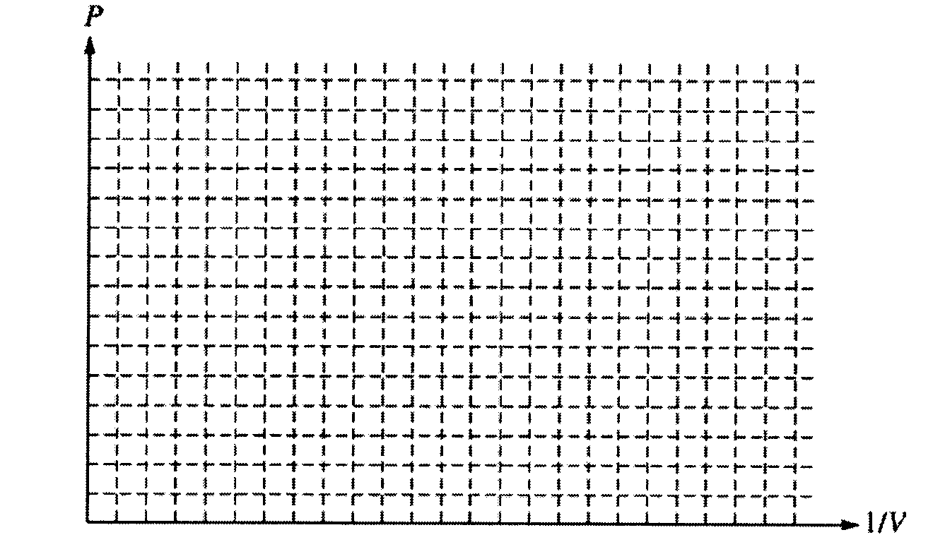

d. Using your graph in part (c), calculate the experimental value of *n*.

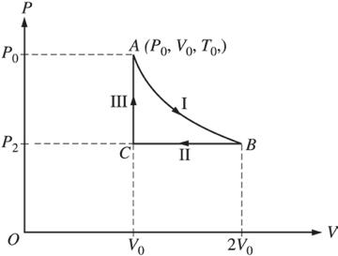

2006Bb5.A sample of ideal gas is taken through steps I, II, and III in a closed cycle, as shown on the pressure *P* versus volume *V* diagram above, so that the gas returns to its original state. The steps in the cycle are as follows.

I. An isothermal expansion occurs from point *A* to point *B,* and the volume of the gas doubles.

II. An isobaric compression occurs from point *B* to point *C,* and the gas returns to its original volume.

III. A constant volume addition of heat occurs from point *C* to point *A* and the gas returns to its original pressure.

a. Determine numerical values for the following ratios, justifying your answers in the spaces next to each ratio.

i. = ii. = iii. = iv. =

b. During step I, the change in internal energy is zero. Explain why.

c. During step III, the work done on the gas is zero. Explain why.

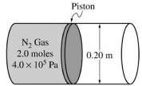

2007B5. The figure above shows a 0.20 m diameter cylinder fitted with a frictionless piston, initially fixed in place. The cylinder contains 2.0 moles of nitrogen gas at an absolute pressure of 4.0 × 105 Pa. Nitrogen gas has a molar mass of 28 g/mole and it behaves as an ideal gas.

a. Calculate the force that the nitrogen gas exerts on the piston.

b. Calculate the volume of the gas if the temperature of the gas is 300 K.

c. In a certain process, the piston is allowed to move, and the gas expands at constant pressure and pushes the piston out 0.15 m. Calculate how much work is done by the gas.

d. Which of the following is true of the heat energy transferred to or from the gas, if any, in the process in part (c)?  
  
_______Heat is transferred to the gas.  
  
_______Heat is transferred from the gas.  
  
_______No heat is transferred in the process.  
Justify your answer.

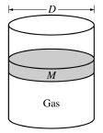

B2007b5. The cylinder above contains an ideal gas and has a movable, frictionless piston of diameter *D* and mass *M*. The cylinder is in a laboratory with atmospheric pressure *P*atm . Express all algebraic answers in terms of the given quantities and fundamental constants.

a. Initially, the piston is free to move but remains in equilibrium. Determine each of the following.

i. The force that the confined gas exerts on the piston

ii. The absolute pressure of the confined gas

b. If a net amount of heat is transferred to the confined gas when the piston is fixed, what happens to the pressure of the gas?

_______Pressure goes up. _______Pressure goes down. _______Pressure stays the same.   
Explain your reasoning.

c. In a certain process the absolute pressure of the confined gas remains constant as the piston moves up a distance *x*o. Calculate the work done by the confined gas during the process.

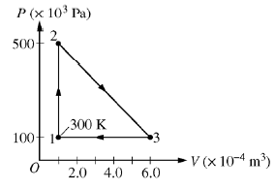

2008Bb6. A 0.0040 mol sample of a monatomic gas is taken through the cycle shown above. The temperature *T1* of state 1 is 300 K.

a. Calculate *T2* and *T3*.

b. Calculate the amount of work done on the gas in one cycle.

c. Is the net work done on the gas in one complete cycle positive, negative, or zero?

_____Positive _____Negative _____Zero

d. Calculate the heat added to the gas during process 1→2.



2009B4. The cylinder represented above contains 2.2 kg of water vapor initially at a volume of 2.0 m3 and an absolute pressure of 3.0 × 105 Pa. This state is represented by point *A* in the *PV* diagram below. The molar mass of water is 18 g, and the water vapor can be treated as an ideal gas.



a. Calculate the temperature of the water vapor at point *A*.

The absolute pressure of the water vapor is increased at constant volume to 4.0 × 105 Pa at point *B*, and then the volume of the water vapor is increased at constant pressure to 2.5 m3 at point *C*, as shown in the *PV* diagram.

b. Calculate the temperature of the water vapor at point *C*.

c. Does the internal energy of the water vapor for the process *A*→*B*→*C* increase, decrease, or remain the same?

____Increase ____Decrease ____Remain the same

Justify your answer.

d. Calculate the work done on the water vapor for the process *A*→*B*→*C*.

1974B6. One-tenth of a mole of an ideal monatomic gas undergoes a process described by the straight-line path AB shown in the p-V diagram below.

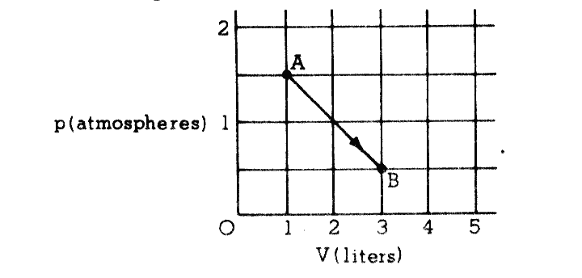

a. Show that the temperature of the gas is the same at points A and B.

b. How much heat must be added to the gas during the process described by A  B?

c. What is the highest temperature of the gas during the process described by A  B?

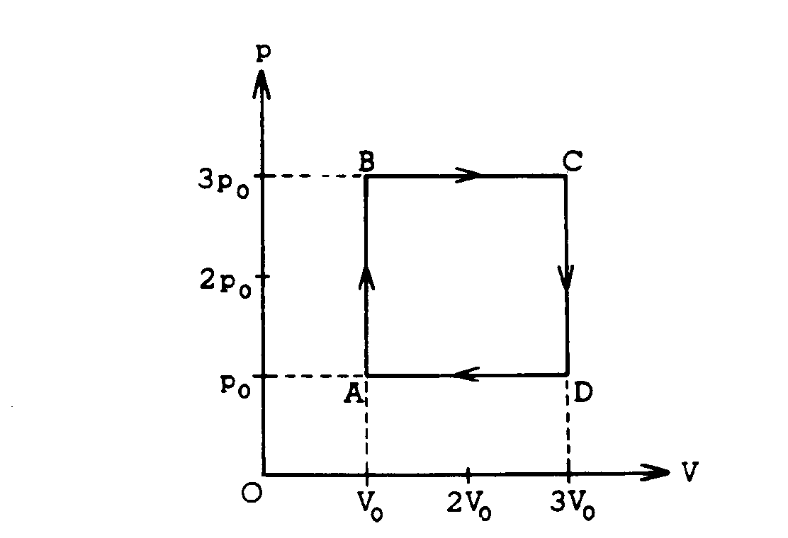

1975B3. One mole of a monatomic ideal gas enclosed in a cylinder with a movable piston undergoes the process ABCDA shown on the p‑V diagram above.

a. In terms of po and Vo calculate the work done on the gas in the process.

b. In terms of po and Vo calculate the net heat absorbed by the gas in the process.

c. At what two lettered points in the process are the temperatures equal? Explain your reasoning.

d. Consider the segments AB and BC. In which segment is the amount of heat added greater? Explain your reasoning.

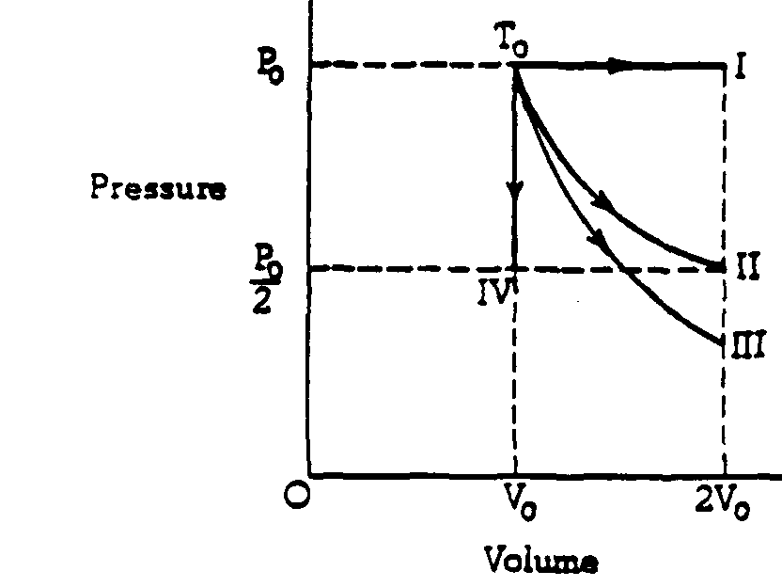

1979B5. Four samples of ideal gas are each initially at a pressure Po and volume Vo, and a temperature To as shown on the diagram above. The samples are taken in separate experiment from this initial state to the final states I, II, III, and IV along the processes shown on the diagram.

a. One of the processes is isothermal. Identify which one and explain.

b. One of the processes is adiabatic. Identify this one and explain.

c. In which process or processes does the gas do work? Explain.

d. In which process or processes is heat removed from the gas? Explain.

e. In which process or processes does the root‑mean‑square speed of the gas molecules increase? Explain.

1991B3 (modified) A heat engine consists of an oil‑fired steam turbine driving an electric power generator with a power output of 120 megawatts. The thermal efficiency of the heat engine is 40 percent.

a. Determine the time rate at which heat is supplied to the engine.

b. If the heat of combustion of oil is 4.4 x 107 joules per kilogram, determine the rate in kilograms per second at which oil is burned.

c. Determine the time rate at which heat is discarded by the engine.

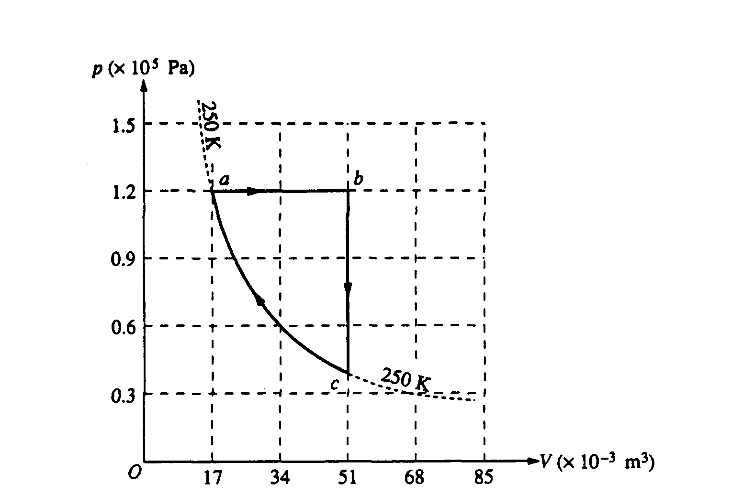

1993B5. One mole of an ideal monatomic gas is taken through the cycle abca shown on the diagram above. State a has volume Va = 17 × 10–3 cubic meter and pressure Pa = 1.2 × 105 pascals, and state c has volume Vc = 51 × 10–3 cubic meter. Process ca lies along the 250 K isotherm. Determine each of the following.

a. The temperature Tb of state b

b. The heat Qab added to the gas during process ab

c. The change in internal energy Ub ‑ Ua

d. The work Wbc done by the gas on its surroundings during process bc

The net heat added to the gas for the entire cycle 1,800 joules. Determine each of the following.

e. The net work done on the gas by its surroundings for the entire cycle

f. The efficiency of a Carnot engine that operates between the maximum and minimum temperatures in this cycle

1995B5. A heat engine operating between temperatures of 500 K and 300 K is used to lift a 10‑kilogram mass vertically at a constant speed of 4 meters per second.

a. Determine the power that the engine must supply to lift the mass.

b. Determine the maximum possible efficiency at which the engine can operate.

c. If the engine were to operate at the maximum possible efficiency, determine the following.

i. The rate at which the hot reservoir supplies heat to the engine

ii. The rate at which heat is exhausted to the cold reservoir