Similar Polygons
Name: _______________
Block: _________ Date: __________
Introduction: In the previous session, we learned about “similar triangles” and we found that two triangles are similar if…
- Their corresponding angles are equal
OR
- If all the triangles corresponding sides are reduced or enlarged by the same scale factor.
Today we will learn about polygons and how to identify similar polygons.
What are polygons? A 2-D closed figure made of three or more line segments. (poly = many)
The followings are examples of polygons.

Warm-up: from the following polygons, which one looks similar to the rectangle on the far left? Why?
4cm 8 cm 8 cm
2cm 4 cm 4 cm

Discovery: What conditions do you think are necessary in order for two POLYGONS to be SIMILAR?
Key Ideas:
Polygons are similar if BOTH of these conditions hold true:
- Corresponding angles are equal in measure
- Corresponding side lengths are proportional
Please note that we need both conditions above to prove that two polygons are similar whereas for triangles we needed only one.

\
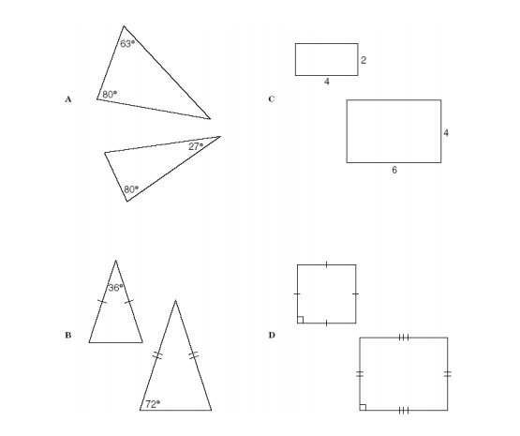Example 1: Use the information in each diagram to determine which pairs of polygons are similar.

Example 2: Find the missing sides: (Hint: use three proportions)
