REFRACTION IN ACTION!

STATION 1: Refraction Contraption
- In the space below place a plastic block on its large flat side. Trace the block.
- Shine a single ray of light straight at the block to create a normal. Trace your light ray.
- Adjust the ray box so that the light ray hits the block at an angle. Trace the incident and refracted light rays.

Q: What happens? Why?

Q: As you increase the angle of incidence, what happens to the angle of refraction?

BLOCK

STATION 2: Convex Hex
In the space below, place a convex lens. Trace the lens.
Shine a 5-slit ray box at the lens. Line up the middle light ray with the middle of the lens.
Add to your diagram below: Trace all 5 incident and refracted rays.

Q: How is a convex lens different from a convex mirror?

STATION 3: Oh Behave, Concave!

In the space below, place a concave lens. Trace the lens.
Shine a 5-slit ray box at the lens. Line up the middle light ray with the middle of the lens.
Add to your diagram below: Trace all 5 incident and refracted rays.

Q: How is a concave lens different from a concave mirror?

Q: How is a concave lens different from a concave lens? Include a picture of both!

STATION 4: Simulation!
Take out your computers and navigate to the following cite: https://phet.colorado.edu/sims/html/bending-light/latest/bending-light_en.html
Click the simulation and then Prisms.
Select the 5- beam light source (see picture) and place the various lenses listed below and place them in front of the light source.
Draw how light interacts/refracts with the various lenses (see next page).

Trapezoid
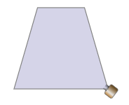
Spherical
Convex
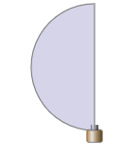
Concave
