Science 8  Worksheet: Refraction | Name:  Date:  Block:

- Use the diagram to answer the following questions:  - Draw the normal (as a dotted line).  - Identify which material (air or water) is more dense.  - Explain what happens when the ray of light moves from the fish to the eye. | 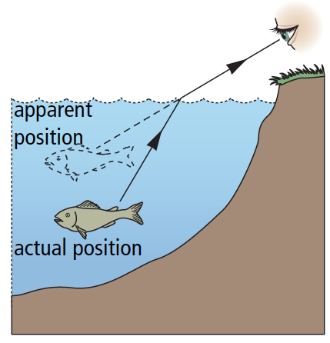

Draw a sketch of how light behaves as it passes from left to right through the following materials. Remember there is a NORMAL at every boundary!

Water |  | Air |  | Glass |  | Air |  | Water
 | Material more or less dense?  Light will bend toward or away from normal? |  | Material more or less dense?  Light will bend toward or away from normal? |  | Material more or less dense?  Light will bend toward or away from normal? |  | Material more or less dense?  Light will bend toward or away from normal?

