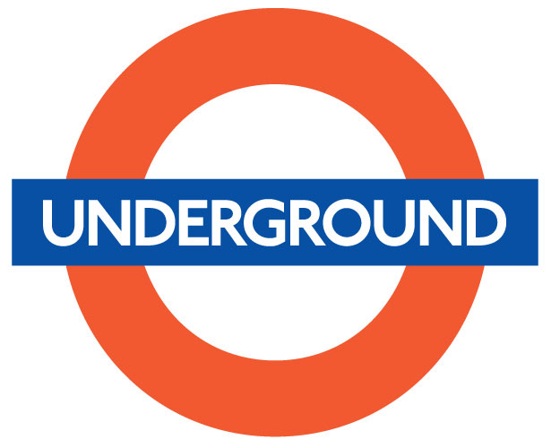
CHAPTER PROJECT ­ CIRCLE GEOMETRY

Name: ____________________________

A new company (insert a company here) _________________________ is looking for a circular logo for their new line of (insert a product here) ____________________________.
- Decide on a company name and the new product the company hopes to promote.

- Design a circular logo for the company that applies the geometric properties of a circle. The diameter of the circle cannot be greater than 8 cm.

- Draw the outline of a circular logo on a Cartesian plane on graph paper (found at the front of the room). Be sure to use a protractor or some circular object to draw the circle. DO NOT DRAW FREEHAND.

The logo must contain at least one central angle, two inscribed angles and two chords.

- Determine the length of each chord, the radius and the diameter (use the distance formula).

- Measure the central angle(s).

- Use the measure of the central angle(s) to find the measures of each inscribed angle.

- Calculate the area of the circle.

- Calculate the circumference of the circle.

- Trace the logo on unlined paper. Choose your colour scheme and colour the logo. Calculate
the area of each coloured sector.

Make sure to show your work on a separate piece of paper.

Example: Volkswagen

