- Sketch a graph of the following function, and label the vertex. ( /3 )
f(x) = –2(x + 3)² + 4
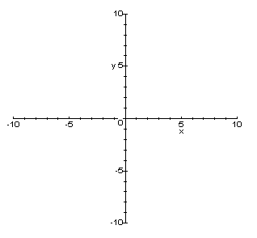

- What is the equation of the following graph? ( /2 )

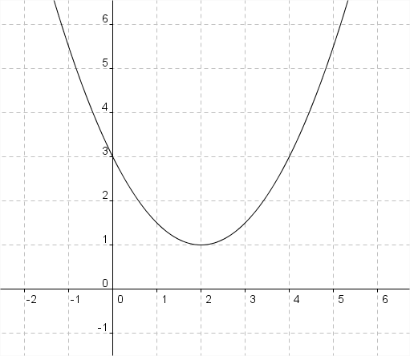

- Consider the quadratic function f(x) = (x +1)² – 9.
  - Graph the function on the axes below. ( /1 )
  - Identify the following:
    - the coordinates of the vertex ( /1 )
    - the x- and y- intercepts ( /1 )

- Consider the quadratic function f(x) = 2(x-1)² + 1.

  - What is the vertex of the function? ( /1 )

  - Sketch the function on the given set of axes. ( /1 )

