Remember:
- we call any equation with a squared variable (x², for example) a quadratic equation
- quadratic equations can be written in the following way: y = a(x – p)² + q
  - where a, p, and q are called parameters

Parameters ‘a’ and ‘q’
What does ‘q’ do?
What does ‘a’ do?

Parameters ‘p’
- to determine what the parameter ‘p’ does, graph the following on the same set of axes:
Table of Values |  | Table of Values |  | Table of Values |  | Table of Values
x | y = x² | x | y = (x + 1)² | x | y = (x – 3)² | x | y = ½(x + 2)²
-2 |  | -2 |  | -2 |  | -2
-1 |  | -1 |  | -1 |  | -1
0 |  | 0 |  | 0 |  | 0
1 |  | 1 |  | 1 |  | 1
2 |  | 2 |  | 2 |  | 2

What does ‘p’ do?

Vertex Form:
- any parabola or quadratic equations can be written in the following way: y = a(x – p)² + q
  - a, p, and q are called parameters
  - this is called the vertex form of a quadratic equation
  - the vertex will be determined by (p, q)
  - the equation of the axis of symmetry will be x = p
  - if a is positive, the graph will open up; if a is negative, the graph will open downward

Example 1: Complete the following table:

Equation | Vertex Form | p | q | Vertex | Axis of Symm.
y = x²
y = x² + 5
y = (x – 2)²
y = (x + 3)² - 4

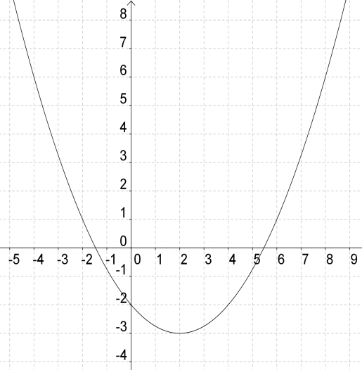
Example 2: What is the equation of the following graph?

Example 3: Graph the equation y = 2(x + 1)² + 4. Describe in terms of the direction of the opening, the vertex, the axis of symmetry, the domain and range, and the maximum or minimum value. Calculate any intercepts.

Example 4: Describe how you would obtain a graph of of y = ½(x + 1)² – 4.5 from a graph of y = x². What are the x- and y-intercepts of the graph?

