What is a Quadratic Equation?
A quadratic equation is any equation that can be written in the form:
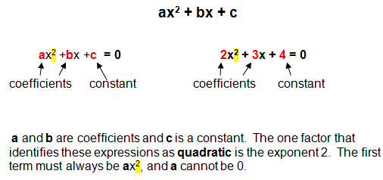

Which of the Following Equations are Quadratic?
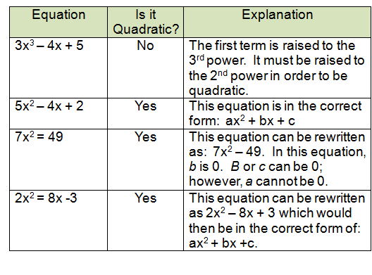
Which of the following are Quadratics?
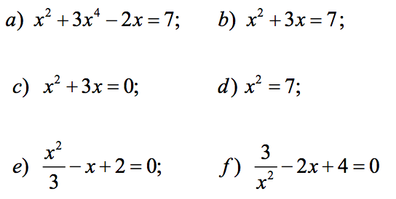
Complete the following table by filling in the missing information
 | y = ax² +bx + c form | Factorized Form (Grade 10) | Co-ordinates of x intercept (from factorized form) | Co-ordinates of y intercept (from factorized form)
Example | y = x² + x – 6 | y = (x+3)(x-2) | (-3,0) and (2,0) | (0,-6)
 | y = x²
 | y = 2x²
 | y = x² + 3
 | y = x² + 2x – 8
 |  | y = (2x+3)(x-4)
 |  |  | (5,0) (-1,0) | (0,10)

