7.8 Application of Trig with Two or More Triangles Assignment

1. From the top of a 200 m-tall office building, the angle of elevation to the top of another building is 40°. The angle of depression to the bottom of the second building is 25°. How tall is the second building?
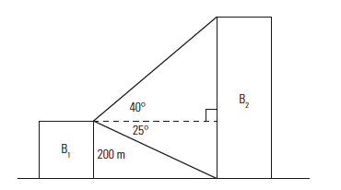

2. A roller coaster has a track that drops at an angle of depression of 25° from a height of 14.9 m. When it reaches the ground, in travels horizontally for 8 m. It then rises at an angle of elevation of 47° to a height of 26.8 m.

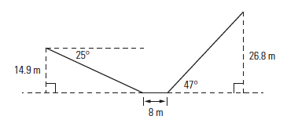

a) What is the total horizontal distance covered by this portion of track?

b) What is the total distance travelled by a car on this portion of the roller coaster track?
3. Sylvie and Mathieu are bird-watching. They both spot a nest at the top of a tree. Mathieu is 89 m from the tree. The angle between Sylvie’s line of sight and Mathieu is 73°. The angle of elevation from Sylvie to the top of the tree is 35°. What is the height of the nest?

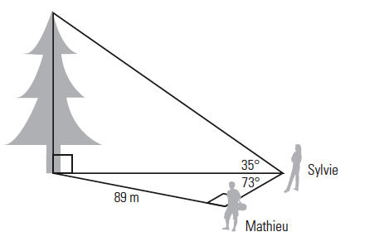
4. Justin is laying out a ramp to go up a 30° slope in a park. Because the ramp may not have a slope greater than 1:20 so that it can be used comfortably by wheelchairs and motorized scooters, he must angle it across the slope. The total change in elevation is 4 ft.
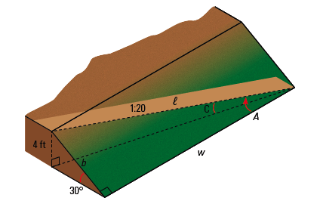

- a) What is the angle that the ramp must make with the base of the hill?

- b) What width of hill is needed to build the ramp without using a switchback?

