7.6 Trigonometric Ratios in Complex Situation Assignment

1. What is the length of x?

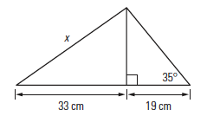

2. Calculate the measure of angle θ.

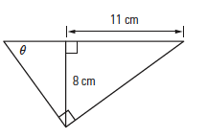

3. Find each of the indicated sides.

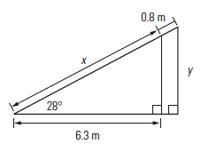

4. Find the angle of offset between the two pipes. How long is the travel pipe?

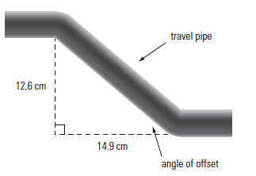

5. A surveyor must determine the distance, AB, across a river. He stands at point C, downriver 500 m from B, and using his theodolite, measures the angle of vision to A as 28°. How wide is the river?

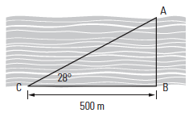

6. Pauline is building a fence around her vegetable garden, shown below. What length of fence will she need to build?

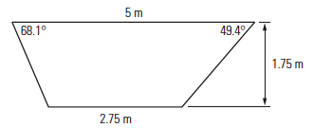

7. Soo-Jin is building a fence around his patio. Using the diagram below, calculate the amount of fencing he will need to buy.

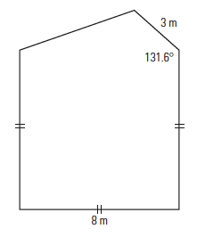
House is here (no fence necessary)

