Similar Triangle Worksheet

1. State whether or not the following triangles are similar and support your answer.

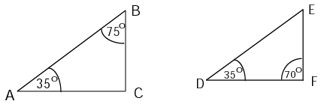

1. (i) Determine if the triangles below are similar, and explain how you know.
2. Find the lengths of the missing sides. All measures are centimeters unless otherwise stated.

a) b)

 

c)



1. Assuming the two triangles are similar, find the tower's height from the given measurements below.

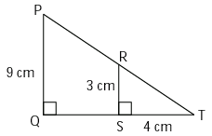 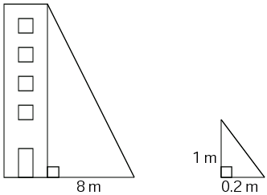

1. Looking at the triangles in the figure on the right:
   1. Are the two triangles similar?
   2. What is the length of *QT*?
   3. If *PT* is 15 cm, what is the length of *RT*?

1. Tonya is 1.3 meters tall.  She stands 7 meters in front of a tree and casts a shadow 1.8 meters long.  How tall is the tree?

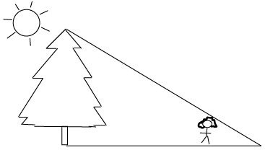

1. Stephanie casts a shadow of 1.2 m and she is 1.8 m tall. A wind turbine casts a shadow of 10 m at the same time that Stephanie measured her shadow. Draw a diagram of this situation and then calculate how tall the wind turbine is.