Science 8 – EARTHQUAKES!
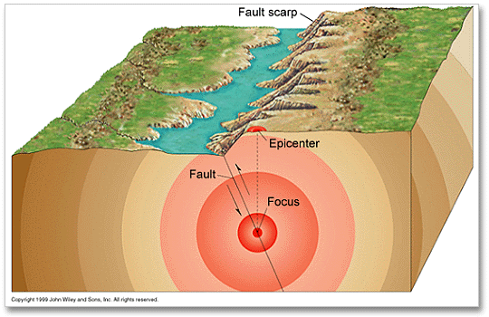
Describing Earthquakes:
- The ________________ of the earthquake is where the pressure is finally released.
- The ________________ is the point on the surface directly above the focus
- Earthquakes occur at different __________________, depending on the _____________________________.
- Earthquakes at the ______________________ usually cause more damage.
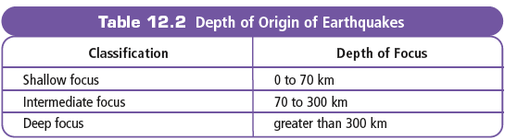

Earthquakes produce __________________________________.
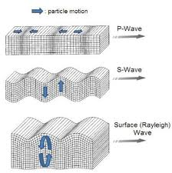
Types of Earthquake Waves:
- There are three types of seismic waves;
  - ______________________________
  - ______________________________
  - ______________________________

Seismic Waves:
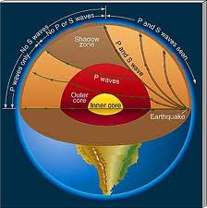
Comparing how __________________ travel through the Earth can tell us if the Earth is ________________, or _________________

The Richter Scale
- 1 increase in magnitude = ____________________________
- A magnitude 6 earthquake is ___________________ more powerful than a 4.

- Since seismic waves travel at _____________________________, a distance-time graph can ___________ where the focus was.
