Example 1:
Change the following information into inequalities and graph them below.

Jack has to buy pop for family movie night. They need at least 3 litres of cola. They need at least 6 litres of Dr. Pooper. Jack has enough money to buy a maximum of 12 litres total.

Step 1 - Define your variables.

_____ = # of litres of cola.

_____ = # of litres of Dr. Pooper.

Step 2 - Make inequalities from the paragraph.
They need at least 3 litres of cola.

They need at least 6 litres of Dr. Pooper.

Jack has enough money to buy a maximum of 12 litres total.

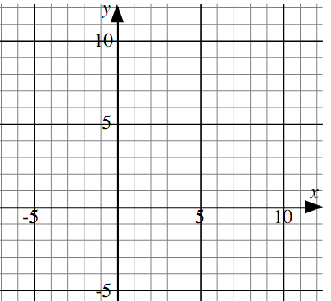
Step 3 - Graph the inequalities.

Every point inside the triangle represents
a possible combination of cola and
Dr. Pooper that jack can buy.
Example 2:
Change the following into inequalities and graph them.

Buffy the farmer is going to plant corn and beans. Buffy has enough seed to plant 4 acres of corn. She has enough seed to plant 6 acres of beans. Buffy only has 8 acres of land. Hint: Buffy can't plant negative acres of corn or beans.

Step 1 - Define your variables.

_____ = _________________________________
_____ = _________________________________

Step 2 - Make inequalities from the paragraph.
Buffy has enough seed to plant 4 acres of corn.

She has enough seed to plant 6 acres of beans

Buffy only has 8 acres of land.

Buffy can't plant negative acres of corn or beans. (2 inequalities)

Step 3 - Graph the inequalities.

What does the shaded area represent?

