**Multi-Variable Inequalities:**

1. What does it mean to solve ?
2. Show the solution to on the number line below.

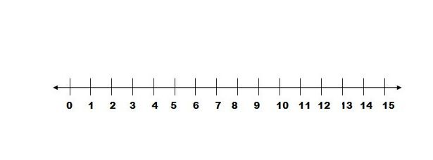

Check 2 points in your solution in .

1. Show the solution to on the number line below.

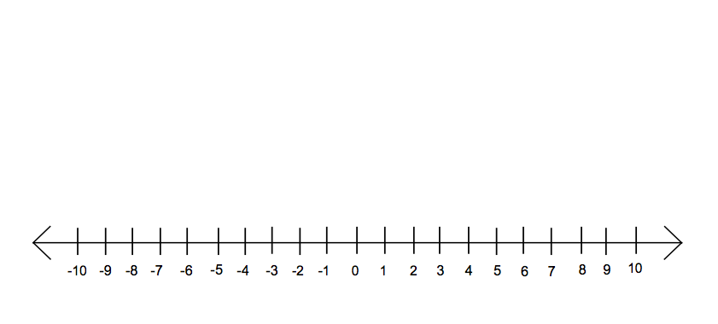

1. What does it mean to solve ?
2. Graph the solution to  below.

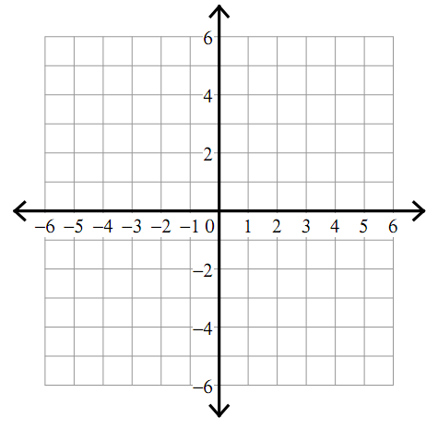

1. Show that 3 points in your solution make both true.
2. Graph the solution to 



1. Graph the solution to 