**Multi-Variable Inequalities:**

1. What does it mean to solve?
2. Show the solution to  on the graph.

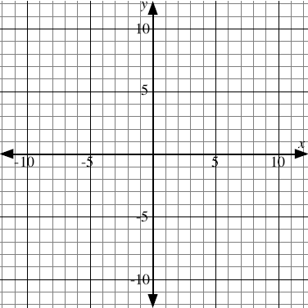

* Hint 1: will be part of the solution.
* Hint 2: Guess and check.

1. Show the solution to  on the graph.

Now show the solution to .

1. Show the solution to  on the graph.



* There is a ">" instead of ""
* Is part of the solution?
* How can we represent this difference?