**MiniQuiz:** Solve the following system by graphing. Don’t forget to check your solution algebraically.

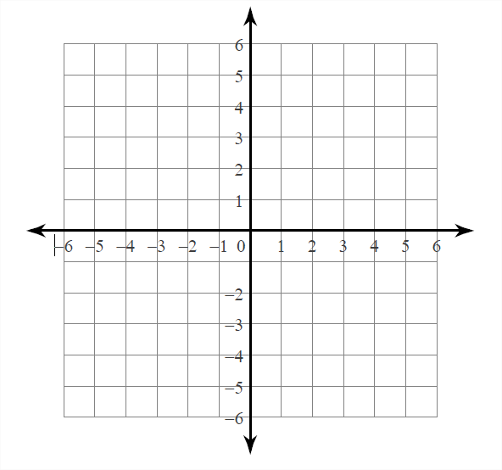

$y=\frac{1}{3}x+2$

$y=-x-2$

**Solving Systems of Linear Equations by Graphing**

1. What does it mean to solve ?
2. Show the solution to on a number line.

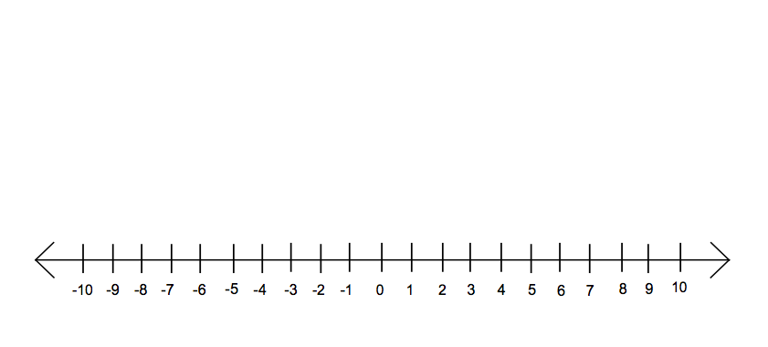

1. Check 3 values from your solution in .
2. Solve and show your solution on a number line



1. Check 3 values from your solution in 
2. Takeand multiply both sides by -2.
3. What happens to the “<” sign.
4. Take and divide both sides by -3.
5. What happens to the “>” sign?
6. Solve and show your solution on a number line.



1. Check 3 values from your solution in .
2. Solve and show your solution on a number line.



1. Check 3 points from your solution in .