**Solving Systems of Linear Equations by Graphing**

1. What does it mean to solve?
2. Show the solutions toand on the same graph.

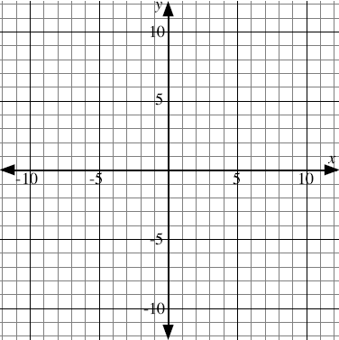

1. Where is the solution to ?
2. Check your solution to .
3.  Solve by graphing
4. Check your solutions in 



1. Solve  by graphing.
2. Check your solutions in .