**Example #1:**

* What does it mean to solve?
* Find a solution to.
* Is that the only solution to?
* 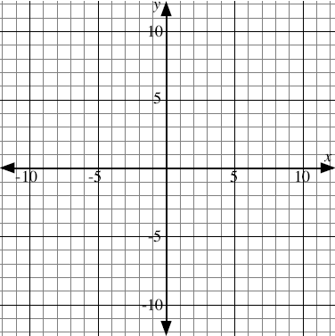Write down some solutions to  in this table.

|  |  |
| --- | --- |
| *x* | *y* |
|  |  |
|  |  |
|  |  |
|  |  |
|  |  |
|  |  |
|  |  |
|  |  |

* Is it possible to write down all of the solutions to?
* Plot your solutions to  on this graph.
* Where do you think the other solutions to would go on the graph?

**Example #2:**

* Do a table of values and graph the solution to 



|  |  |
| --- | --- |
| *x* | *y* |
|  |  |
|  |  |
|  |  |
|  |  |
|  |  |
|  |  |
|  |  |
|  |  |

**Example #3:**

* Do a table of values and graph the solution to 

|  |  |
| --- | --- |
| ***x*** | ***y*** |
|  |  |
|  |  |
|  |  |
|  |  |
|  |  |
|  |  |
|  |  |
|  |  |



|  |  |
| --- | --- |
| *x* | *y* |
|  |  |
|  |  |
|  |  |
|  |  |
|  |  |
|  |  |
|  |  |
|  |  |

**Example #4:**

* Is the point (4, 3) on the graph of 3x + y = 15?
* Is the point (–4, 1) on the graph of 2x – y = 10?

**Examples #5:**

* Where does the graph of y = 3x – 9 cross the y-axis?
* Where does the graph of y = 3x – 9 cross the x-axis?