Lesson 10.3 Exploring Tangents To A Circle

Tangent Line:

Point of tangency:

Properties of a circle

Tangent to a Circle
A tangent to a circle is perpendicular to the radius at the point of tangency

Tangent Chord Relationship
A chord drawn perpendicular to a tangent at the point of tangency contains the center of the circle, and is a diameter.

Examples:

In the diagram, EF is tangent to the circle at F, and the radius is OF.
What is the measure of ∠OEF?

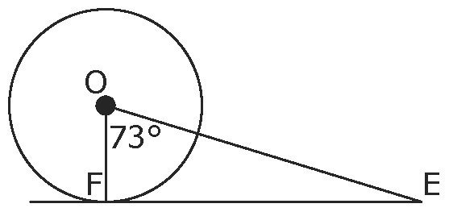

In the diagram, SP is tangent to the circle at P. SX is tangent to the circle at X. SP = 6 cm, SA = 10 cm, and A is the centre of the circle. What is the length of AX?
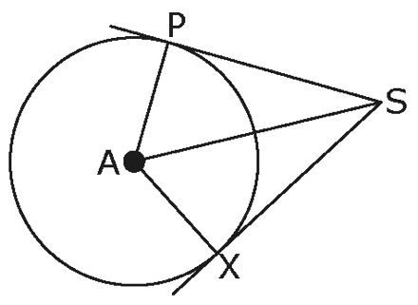

In the diagram, MN is tangent to the circle at T, the radius is 5 cm, TN is 12 cm, and ∠RCT = 120˚.

a) What type of triangle is RCT? Explain your answer.
b) What is the measure of ∠TRC?
c) What is the length of PN? Show your calculations.
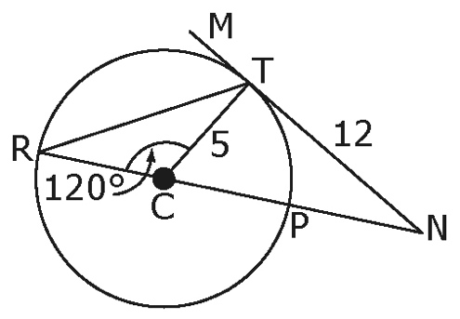

On the map, DB is tangent to the circle at B, the diameter is BE,
DB = 5 km, and ABC is an equilateral triangle. The radius of the circle is 6 km.
a) What is the length of BE?
b) What is the length of DE?
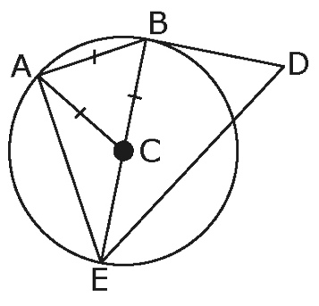

Two concentric circles have radii of 24 cm and 26 cm. What is the length of the chord that is tangent to the inner circle? Include a sketch with your answer.

RT is tangent to each circle at S and R. If OR = 9 m, PS = 3 m, ST = 6 m, and RT = 10m, how far apart are the centers? Round your answer to the nearest tenth of a metre.

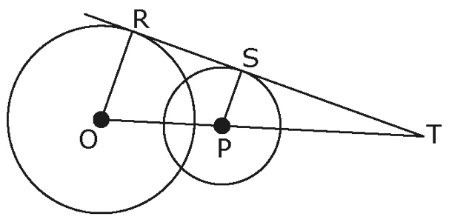

HWK. Pg. 399 #3-9 (draw diagrams to show work)

