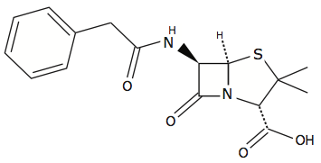 |  | Functional Groups-1 |  | Name:  Date:
There are two isomers of C₃H₇OH that are alcohols. One of them is 2-propanol. Draw the other isomer and name it.

1. | 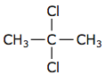
2. | 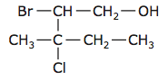
3. | 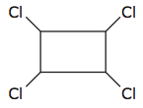
4. | 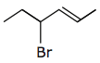
5. | 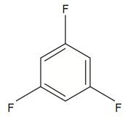
6. | 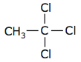

Draw the condensed structural formula for the following organic compounds:

- 1,1-dichloroethene
- 2-methyl-3-pentanol
- 2-chloropropane
- 1,1-dichloro-3,3dimethyl-2-hexanol
- 2,3,5-tribromocyclohexanol

