The Montreal Protocol – How can we create meaningful change? By NATACHA PISARENKO – The Montreal Gazette 2017
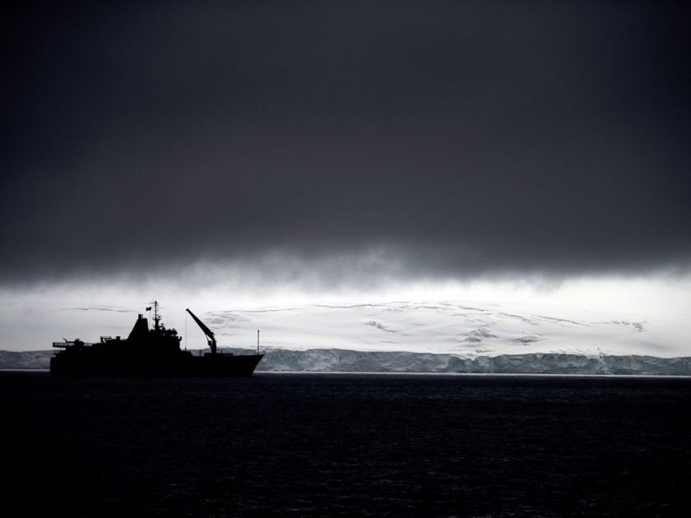
Chile's Navy ship Aquiles moves alongside the Hurd Peninsula, seen from Livingston Islands, part of the South Shetland Islands archipelago in Antarctica. Antarctica's ozone hole is finally starting to heal, a new study finds. In a study showing that the world can fix man-made environmental problems when it gets together, research from the U.S. and the United Kingdom show that the September-October ozone hole over Antarctica is getting smaller and forming later in the year. And the study in the journal Science also shows other indications that the ozone layer is improving after it was being eaten away from chemicals in aerosols and refrigerants. Ozone is a combination of three oxygen atoms that high in the atmosphere shields Earth from much of the sun's ultraviolet rays.
Thirty years ago this week, the world’s nations took action to address a growing hole in the ozone layer by adopting the Montreal Protocol. Generally considered the most successful international environmental agreement in history, the protocol has succeeded in phasing-out 98 per cent of ozone-depleting substances and the remaining “hole” above Antarctica is expected to close in the next few decades.
As the world continues to wrestle with climate change, the anniversary of the protocol provides an opportunity to take stock of why it worked and what lessons can be drawn for global climate action.
Incremental progress is still progress: The Montreal Protocol did not achieve binding national commitments overnight. The 1985 Vienna Convention set global objectives and facilitated research and policy discussions. This eventually led governments to adopt binding targets through the Montreal Protocol two years later. The protocol continues to evolve and impose progressively more ambitious obligations upon its signatories.
Hence, while prominent critics like former NASA scientist James Hansen have decried the Paris Climate Agreement’s incremental approach as “just worthless words,” Montreal reminds us that stringent agreements sometimes come from humble beginnings.
The rich must help the poor: Initially, Mexico was the only developing country to ratify the Montreal Protocol. The lack of developing country participation posed an enormous risk to its overall effectiveness. In response, governments created a fund to provide financial assistance for participation. As of 2013, 147 of the 196 parties to the protocol have received financial assistance from the fund and all developing countries have complied with their obligations.
Bring industry on board: Many U.S. chlorofluorocarbon (CFC) manufacturers were originally opposed to the Montreal Protocol. Industry asserted that the scientific evidence on ozone depletion was too uncertain to justify regulation and that alternatives to CFCs were limited and costly. After the adoption of the protocol, the U.S. CFC industry radically altered its position. Faced with the prospect of domestic regulation and seeking a competitive advantage, producers like DuPont supported the Montreal Protocol and lobbied the Bush White House to ratify it.
Industries that rely on fossil fuels have thus far proven more recalcitrant. Governments should move to create coalitions of actors that benefit from robust climate action. This means increasing subsidies for renewables, setting a fair price on carbon and ending fossil fuel subsidies.
A cohesive and compelling narrative is key: In the late 1980s, scientists and activists developed a compelling narrative about the depletion of the ozone layer that resonated with the public and led to the signing of the Montreal Protocol. This narrative was comprised of two elements: the metaphor of an “ozone hole” and the accompanying risk of skin cancers.
While scientists have provided a deluge of evidence on the impacts of climate change, research tells us that humans are less likely to be moved by graphs and statistics than by a compelling narrative. Hence, further emphasis might be placed on highlighting the images and narratives of those affected by climate change. Climate change deniers might not be swayed by more data, but they may be convinced by narratives that elicit empathy.
To be sure, ozone depletion is not as complex a problem as climate change. Fossil fuels are far more locked-into the global economy than CFCs were. Nonetheless, the Montreal Protocol reminds us that global environmental challenges can be overcome.

