Expansion of an Ideal Gas into a Vacuum

The expansion and compression of gases is one of the most important topics in thermodynamics, because of its relevance to combustion engines, refrigerators, heat pumps, hot air balloons, gas storage, fire extinguishers, and a host of other practical applications. It is also one of the problems that very nicely links the macroscopic reasoning of thermodynamics to the microscopic picture of the kinetic molecular theory. Let’s consider an apparatus that consists of two bulbs connected by a stopcock. On one side, initially, there is an ideal gas and on the other side there is a vacuum. The apparatus is also in thermal equilibrium with its surroundings, meaning that the temperature is the same inside and out:

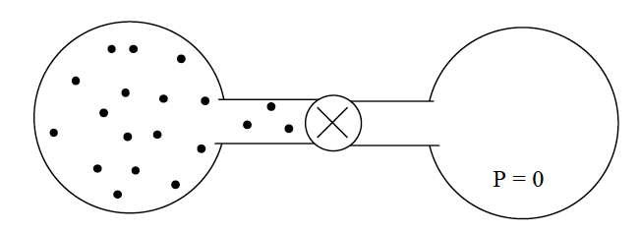

What we want to know is, what happens when we open the stopcock? Part of the answer is obvious. Gas molecules will rush from the left side to the right, until the pressure, the number of moles of gas, and temperature are the same on both sides. We also know that the ideal gas law (PV = nRT) will apply before, during and after the expansion, and that the volume V will double during the process. But how do we know what the final values of P and T will be? The ideal gas law will only give us one of these if we know the other.
To solve this problem, let’s first do a thought experiment, which is to insulate the system thermally from the outside world. Now when we open the stopcock it looks something like this:

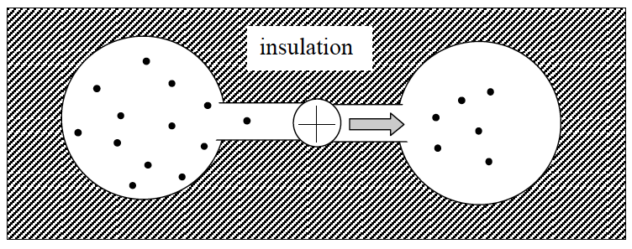

We know that Q = 0 for the expansion because the system is insulated. We also know that W = 0, because the gas is expanding into a vacuum (W = PexternalΔV = 0 because Pexternal = 0). This leads us to the conclusion that the change in internal energy ΔU = Q + W = 0 + 0 = 0.

OK, so the energy of the gas does not change in the process. Does that help us understand what happens to P and T? Yes, but first we need to reflect on what we mean by ΔE = 0.

The internal energy (U) of the system is the sum of the of its potential energy (E_{p}) and kinetic energy (E_{k}).

If U = E_{p} + E_{k}, then ΔE = ΔE_{p} + ΔE_{k}.

For ΔU to be zero, the sum ΔE_{p} + ΔE_{k} must be zero too. In other words, the changes in E_{k} and E_{p} must be equal and opposite of each other.

But, for an ideal gas (and this is the key point), the potential energy is always zero. Potential energy is the energy of atoms interacting with other atoms, e.g., to make a chemical bond, or to attract or repel each other through non-covalent interactions. But in an ideal gas the molecules are non-interacting. This means ΔE_{p} is always zero for an ideal gas. Note that this is not true for a real gas. Real gases have attractions and repulsions between molecules that make ΔE_{p} ≠ 0.

Back to our problem:

ΔU = 0 = ΔE_{p} + ΔE_{k} = 0 + ΔE_{k}, which means ΔE_{k} = 0.

But we know from the kinetic-molecular theory for a monatomic ideal gas that…

For a polyatomic ideal gas, E_{k} is still proportional to T, and ΔT = 0.

This means that the temperature does not change in the expansion, and, if that is the case, we can now remove the insulation without changing the result, since Q = 0 for an isothermal system.

The solution then, is: Q, W, ΔE, ΔE_{p}, ΔE_{k}, and ΔT are all zero.
T_{final} = T_{initial}
V_{final} = 2 V_{initial}
P_{final} = 1/2P_{initial}
Question:

- If the expansion is not driven by changes in energy, what makes it go?

