Science 8  Plate Tectonics and Boundaries | Name:  Date:  Block:

The story so far…
- Name the four layers of the Earth, in order from the inside out:

- What was the name of the last super continent?

- What evidence do we have that a super continent formed?

Mid-Atlantic Ridge

- In 1872, a British vessel HMS Challenger set out to map the ocean floor.
- The ______________________________ discovered a long mountain range running north and south down the length of the ____________________________ ocean.
- They called this the _______________________________________________________.
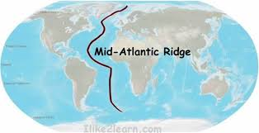
- Oceanographers found that the _______________________________________ rocks were found _____________________________ to the ridge… Why?
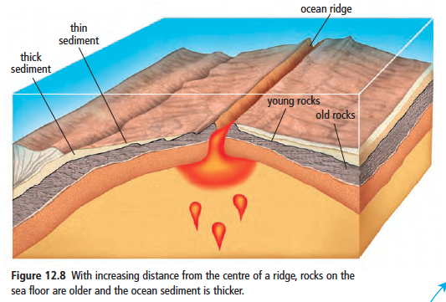
Sea-floor spreading

- In 1960, Harry Hess proposed an explanation:
  - _________________________ rises from __________________________ the Earth’s surface
  - When it breaks through the Earth’s surface, it hardens and forms _____________________________

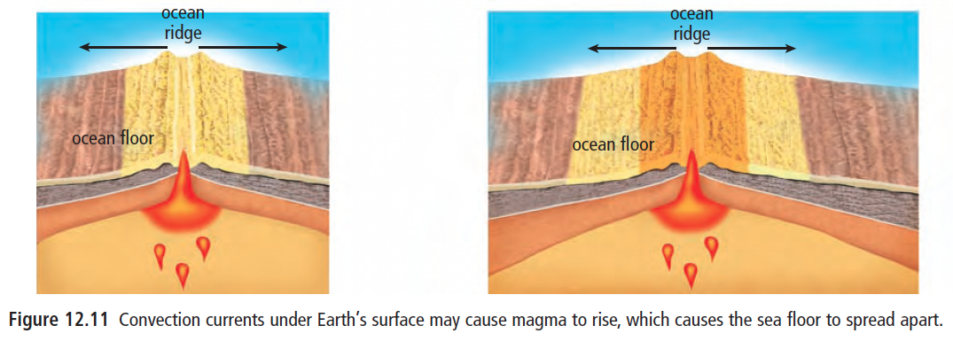
Plate Boundaries

- A plate boundary is a region where _____________________ tectonic plates are _____________________________

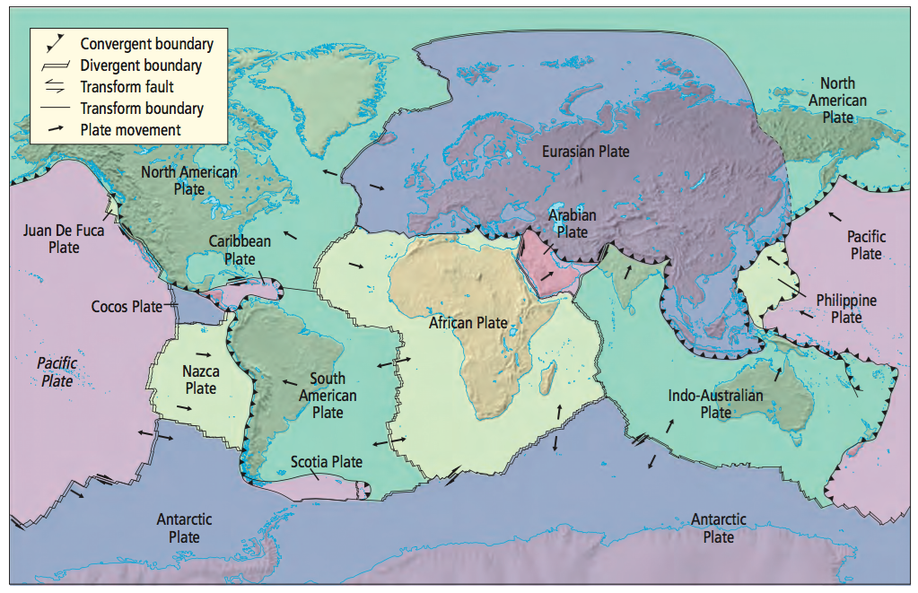

- The way in which tectonic plates interact depends on…

Push and Pull
- Ridge Push | - Slab Pull

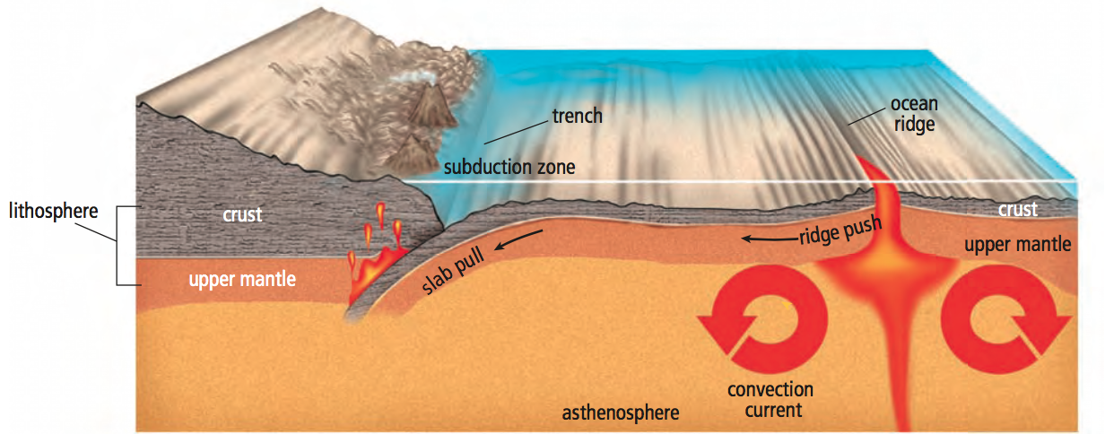

Types of Plate Interaction

DIVERGENCE
- Divergent plate boundaries mark the areas where ________________________ plates are ___________________________ apart.
- In the ocean, sea floor spreading causes plates to _______________________________
- Ex.
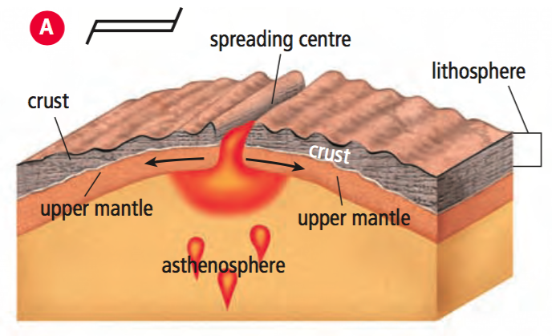

CONVERGENCE
- Convergent plate boundaries occur where _________________________ plates _________________________.
- Three types:
- Continent plate + continent plate
- Plates have similar _________________________
- As the plates _________________________, their edges __________________ and ____________________, forming great ___________________________________ ranges
- Ex.
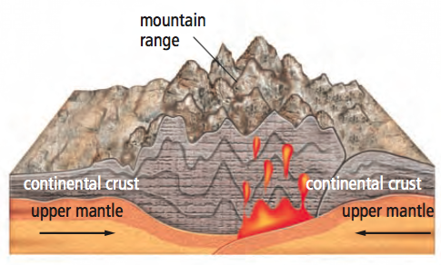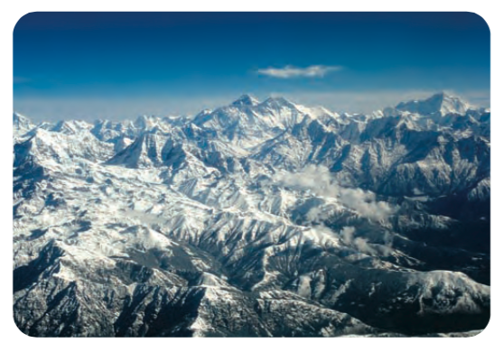
- Ocean plate + ocean plate
- __________________________ occurs where the ______________ dense plate will slide __________________ the ______________________ dense plate and deep into the mantle

- A deep underwater valley called a ______________________________ is formed
- Can produce a ________________________________________________
- Ex.
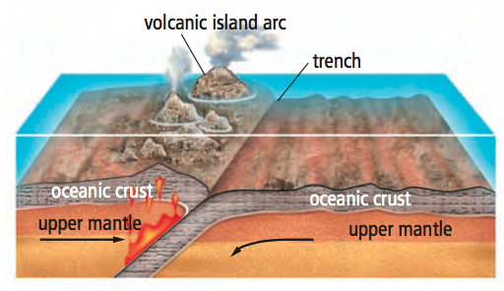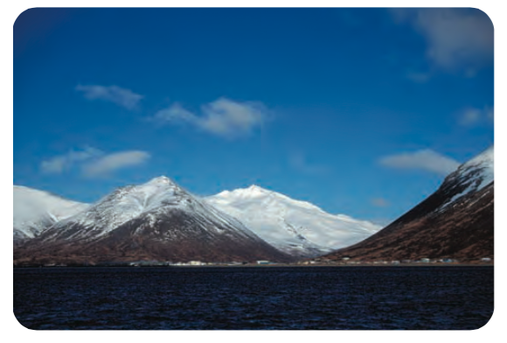
- Ocean plate + continental plate
- Ocean plate is _______________________________ and is forced to slide ______________________________ the continental plate
- Also produces an ______________________________________________
- Ex.

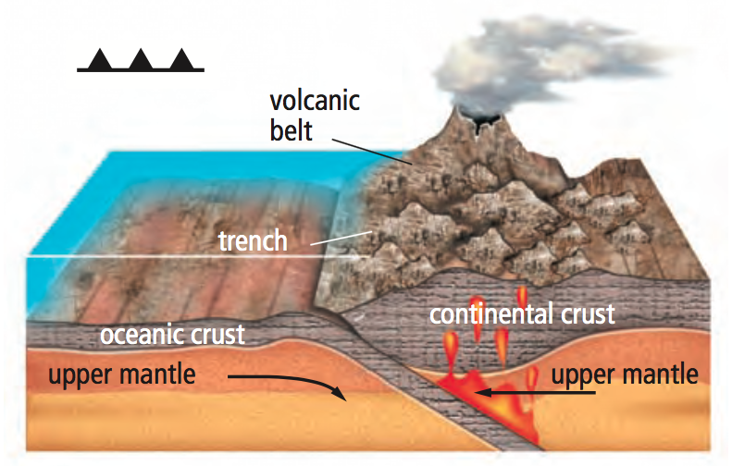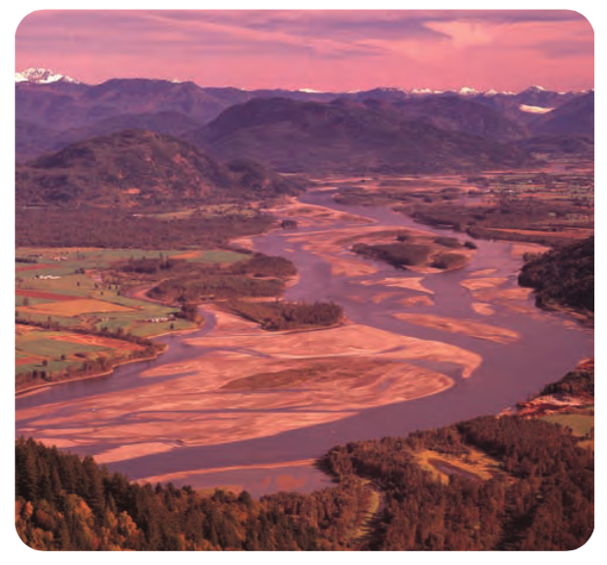
TRANSFORM
- Transform plate boundary occurs when ____________________________ plates __________________________ past one another.
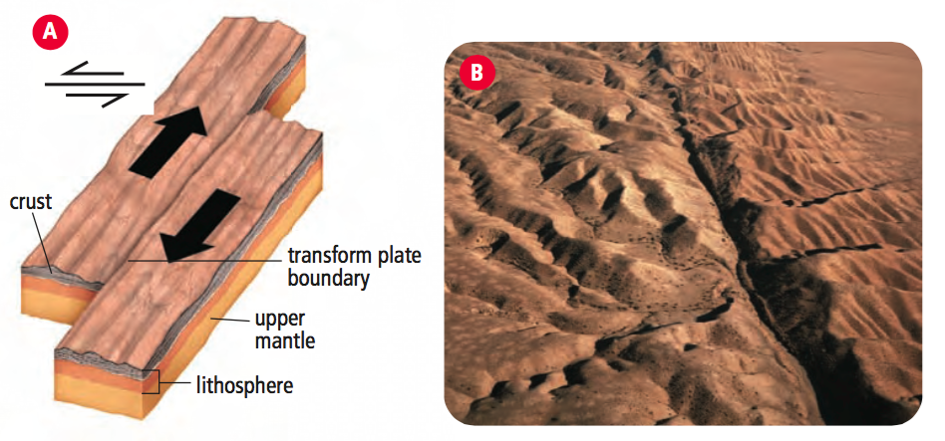

- Ex.

