|  |  |
| --- | --- |
| **Empirical and Molecular Formula’s**  **The Mole** | Name: __________________________ Date: _________________ |

**Chemical Formula**:

**Write the chemical formula of the following:**

1. Sodium chloride ____________
2. Lithium oxide ____________
3. Iron (II) bromide ____________
4. Ammonium sulphide ____________

**Molecular Formula**

Identifies the number of each type of atom

Example: Hexane: C6H14

**Empirical Formula**

Simplest whole number ratio of atoms of each element

Example: Hexane: C3H7

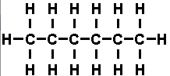

**Structural Formula**

Shows the structure of the molecule

**Finding Empirical Formula’s**

|  |  |  |
| --- | --- | --- |
| **Substance** | **Molecular Formula** | **Empirical Formula** |
| **Water** | **H2O** |  |
| **Methane** | **CH4** |  |
| **Benzene** | **C6H6** |  |
| **Sulfur** | **S8** |  |
| **Glucose** | **C6H12O6** |  |

**Finding Molecular and Empirical Formula’s**

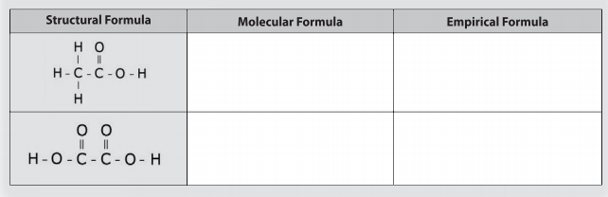

1. A sample of compound contains 5.723 g Ag, 0.852 g S, and 1.695 g O. Determine its empirical formula.
2. A sample of compound contains 18.7% Li, 16.3% C and 65.0% O by mass. Determine its empirical formula.

**Molecular Formula:**

To find the Molecular Formula we use the following relationship



Where Molar Mass is the mass of the Molecular Formula

*Where N = ______________________________________________________________________________________*

1. A compound has an empirical formula of NH2 and a molar mass of 32.1 g/mol.

List 3 possible molecular formulae.

What is the compound’s molecular formula?

1. A compound containing 40.0% carbon, 6.7% hydrogen and 53.3% oxygen has an molar mass of 180.2 g/mol. What is the molecular formula?