Math 9  Surface Area – 3 Dimensional | Name:  Date:  Block:

Determine the surface area of each 3-D shape below.

*Look for symmetry as this will cut down on the number of calculations you have to do.
*Some students find it helpful to draw a net. In other words they “unfold” a 3D object into 2D pieces.

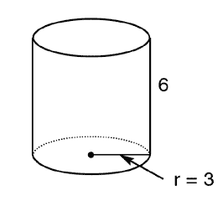 | Length = 4cm  Width = 6cm  Height = 5cm

.

3D Composite Shapes: Two or more 3D shapes put together.
*With composite shapes it is important to determine which faces will be included/ excluded from the total surface area.

Find the surface area of each composite shape below.
Length=4
Width=6
Height=5

Height=2
Radius=6

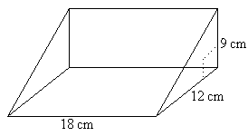(*hint – you have to use Pythagorus equation)

