Science 8  How does light interact? | Name:  Date:  Block:

Line up your ray box and each of your given materials with the diagram below.

Ray Box | Material

- Identify each of your materials.

- How does each object interact with the light? Record some QUALITATIVE observations below:

Note: a qualitative observation is an observation with NO numbers.

Material #1 is… | Material #2 is… | Material #3 is…
An object that does not let any light pass through is called OPAQUE.

- Which of your materials is opaque? ______________________________

An object that allows some light to pass through is called TRANSLUCENT.

- Which of your materials is translucent? ____________________________

An object that allows all light to pass through is called TRANSPARENT.

- Which of your materials is transparent? ____________________________

Can you think of other materials that are opaque, translucent and transparent?

Opaque | Translucent | Transparent

The Ray Model of Light:

- Light is represented as a straight line, or ray that shows the direction the light wave is travelling.

- You can use this model to show what happens when light strikes different materials.

Three things can happen when light strikes a material!

Light may be… | Material | Examples:
Transmitted | Transparent | 1.  2.
Reflected | Translucent | 1.  2.
Absorbed | Opaque | 1.  2.

Shadows  The ray model of light helps us predict:  1. Where shadows will form.  2. How large they will be. | 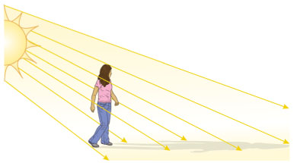

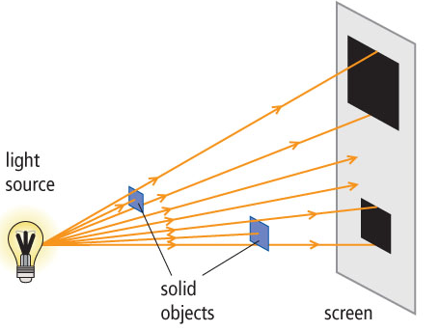 | - A ray diagram can be used to show how the size of shadows is related to the distance of the object from the light source.  - The closer the object….  - The larger the shadow.

