Lesson 10.2 Exploring Chord Properties

1.) Draw two different chords.

2.) Construct the perpendicular bisector of each chord.

3.) Where do the perpendicular bisectors intersect?

Properties of a circle

Perpendicular Bisector of a Chord
If you are given any two of the following three statements you can imply the third.

- The line goes through the center.
- The line bisects a chord
- The line is perpendicular to the chord.

Example #1
In the diagram, diameter EF bisects chord AB at D. If
EF = 24 units and AB = 16 units, find the lengths of
CF, CB, BD, CD, and DE to the nearest tenth.

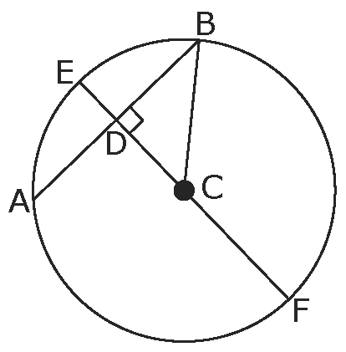

Example #2

In the diagram, D is the midpoint of AB. AB is 8 units in
length. Find the length of CD to the nearest tenth.
Justify your answer.

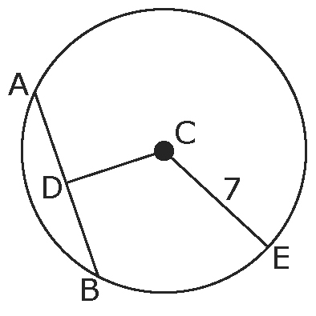

Example #3

Bob is building a toy truck out of wood for his son. He has measured and cut out the wheels but he is having difficulty determining the center where he needs to put the bolt through. How can he determine where the center of each wheel is?

HWK. Pg 386 #4-12, 15-18

