Math 9  Enlargements & Reductions | Name:  Date:  Block:
Warm-up: Review from last class:

A proportion is a relationship that says that two ratios are equal.
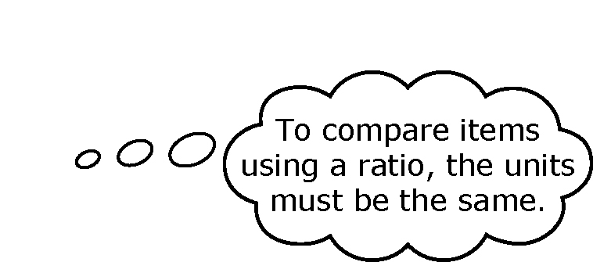A proportion can be expressed in fraction form.
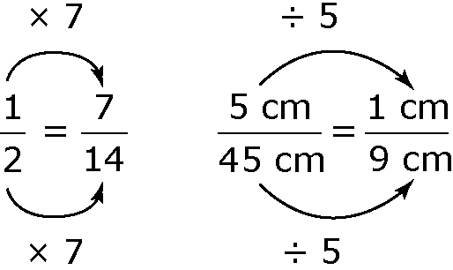
- Identify the missing value to make an equivalent fraction.
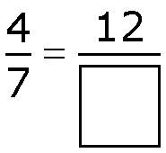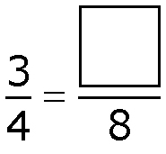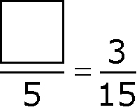
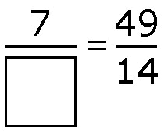a) b) c) d)

- 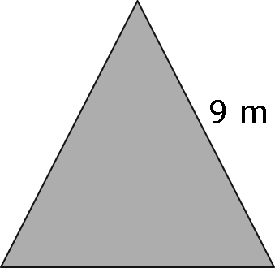For each regular polygon, what is the ratio of one side length to the perimeter? Use ratio notation.
a) b)

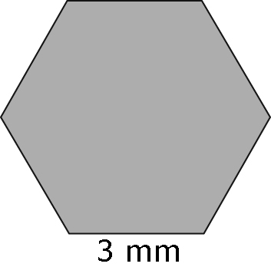c)

- The distance between Town B and Town C is 56 km. The distance shown on the map is 7 cm in length. What is the actual distance between Town A and Town C if it is represented on the same map by a length of 12.5 cm?
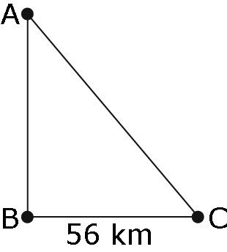
Introduction: In this session, we want to discover how to make a shape bigger (Enlargement), or smaller (Reduction) by multiplying it by a “constant factor”.
3 Key ideas:
- An Enlargement results in an image that is the same shape but proportionally larger than the original.
- A Reduction results in an image that is the same shape but proportionally smaller than the original.
- The Scale factor is a constant amount that ALL Dimensions of an object are multiplied by to create an enlargement or reduction.

Example 1: For each case below, use your ruler and measure the length of each line segment. Write the measurements dwo Then determine the scale factor.

Scale factor: _____________

Scale factor: __________
Example 2: For the letter “H” below:

- Use a scale factor of 1.5 to enlarge the letter.
H
- Use a scale factor of ¼ to reduce the letter.
H

Summary:

A scale factor less than 1 indicates a _______________ and a scale factor grater than 1 indicates a __________________________

