Science 8  Bohr Models | Name:  Date:  Block:

Bohr models show all electrons in each electron shell.

Electrons are distributed in the following way:
- The first electron shell holds a maximum of ______ electrons.
- Each of the next shells holds a maximum of ______ electrons.
- Shells cannot be created until the lower shell is __________________ filled.

In the Bohr model diagram, make sure to:
- Write the number of _________ and _________ in the center of the diagram.
- Place electrons one at a time before they are paired up.

Example: Sodium
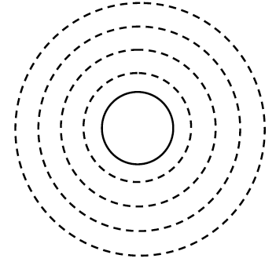

1. Carbon | 2. Hydrogen | 3. Oxygen
4. Chlorine | 5. Potassium | 6. Neon
7. Aluminum | 8. Magnesium | 9. Helium
10. Boron | 11. Silicon | 12. Beryllium
13. Calcium | 14. Phosphorus | 15. Argon
16. Sulfur | 17. Nitrogen | 18. Fluorine

