Science 8  Plate Tectonics and Boundaries Worksheet | Name:  Date:  Block:

- Match the term with the descriptor:
Term | Descriptor
D Continental drift theory | A. The region where magma breaks through Earth’s surface, continually forcing apart old rock and forming sea floor
E Plate tectonic theory | B. The large slabs or rock that form Earth’s surface and move over a layer of partly molten rock
C Pangaea | C. The original super continent
L Magma | D. The theory that the crust is broken up into large plats that move and then rejoin
F Mid-Atlantic Ridge | E. A process that provides an explanation for continental drift
A Sea floor spreading | F. A long mountain range running north to south down the length of the Atlantic Ocean
J Convergent plate boundary | G. The most inner layer of the Earth
H Divergent plate boundary | H. An area where tectonic plates are spreading apart
N Transform plate boundary | I. The most outer layer of the Earth
I Crust | J. An area where tectonic plates collide
M Mantle | K. The second most inner layer of the Earth
G Inner Core | L. Hot fluid below or within the Earth’s crust
K Outer Core | M. The layer of the Earth where convection currents occur
B Tectonic plates | N. An area where tectonic plates slide past one another

- What is a tectonic plate?

The large slabs or rock that form Earth’s surface and move over a layer of partly molten rock

- What is the Mid-Atlantic Ridge and how was it formed?

A ridge system situated in the middle of an ocean basin. It is formed by the upwelling of magma associated with seafloor spreading due to divergent plate boundaries.

- Identify the Mid-Atlantic Ridge on the map below.

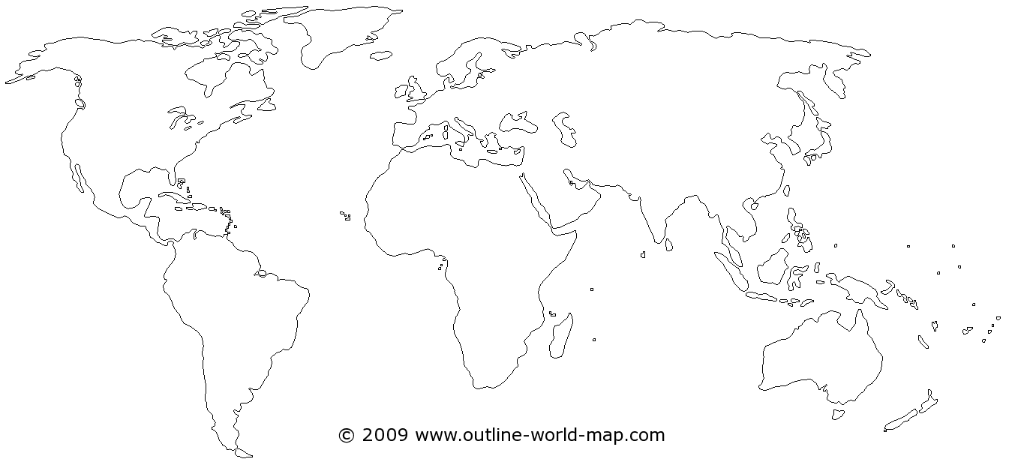

- Using your plate tectonic handout, describe the type of plate interactions that have occurred at the following geographic locations.
Geographic Location | Plate Interaction
1. East African Rift | Divergent
2. Juan de Fuca plate | Convergent/Transform
3. Islands of Japan | Convergent
4. Himalayan mountains | Convergent
5. San Andreas Fault | Transform

- When two continental plates collide, does subduction occur? Explain your answer.

No! Their densities are two low. We end up seeing folding, leading to Mtn. formation.

- What geological feature is formed at subduction zones?

Volcanoes!

