**3.4: Volume and Capacity of Spheres, Cones and Pyramids Name: _____________**

Calculating the volume of spheres, cones and pyramids is not as straight forward as it was for prisms. We will rely on the following 3 formulas:







Ex. 1 A tennis ball has a diameter of 6.7 cm.



(a) What is the volume of the tennis ball?

(b) Tennis balls are sold in a cylindrical tube in packs of 3. What is the volume of the container?

(c) What is the ratio of the volume of the 3 balls in the container to the volume of the container?

Ex 2: A spherical exercise ball has a diameter of 1.2 m.

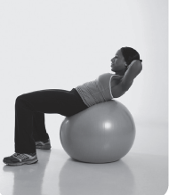a) What is its volume?

b) What is its capacity?

Ex 3: A sphere with a radius of 46 cm is centred inside a sphere with a radius of 76 cm. What is the volume of the space between the two spheres?

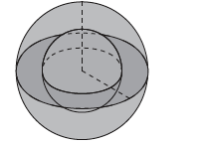

Ex 4: Calculate the volume and capacity of this pyramid.

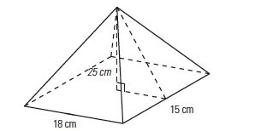

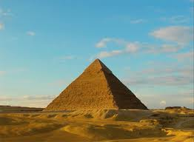Ex 5: The great pyramid of Giza in Egypt measures 440 m along each side of its base and 280 m from its center height.

(a) What is the volume in m?

(b) If the pyramid was filled with water, how many liters would it hold?

(hint: 1 cubic meter =1000 liters)

(c) One US gallon contains 3.785 liters. How many US gallons does the pyramid hold?

Ex 6:

A paper cup in the shape of a cone has a radius of 3.2 cm and a height of 6 cm. How much water can the cup hold?

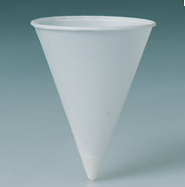

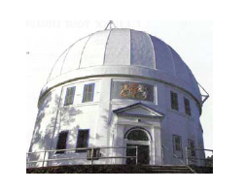

Ex. 3 Calculate the volume of the Dominion Astrophysical Observatory. It has a cylindrical base with a diameter of 20.1 m and a height of 9.8 m. The dome is half of a sphere with the same diameter as the base.