**3.3: Volume and Capacity of Prisms and Cylinders Name: _________________**

**Volume** is the measure of the space _______________ a 3-D object.

**Capacity** is the amount a 3-D object can _______________.

* Volume is measured in _______________ units, such as ______, ______, or ______.
* Capacity is measured in _____________ or _________________.

Ex 1: Safeway sells different sizes of milk cartons.

8 cm

8 cm

8 cm

8 cm

8 cm

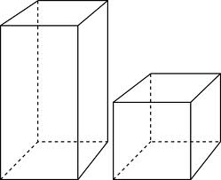

16

cm

(a) How much milk is contained in each container ( in cubic cm).

Carton 1:

Carton 2:

(b) What is different between the containers dimensions? How do the volumes compare?

(c) 1 Liter equals 1000 cubic centimeters. Convert the volumes of the milk cartons to capacity in liters.

Note: 1 ml = 1 cm3 and 1 L = 1000 cm3

For ALL **prisms**:

**VOLUME = Area of Base x Height**

Ex 2) A rectangular prism that has a base that is 15 cm by 12 cm and a height of 20 cm.

a) Label the diagram and calculate the volume of the prism.

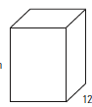

b) Calculate the capacity of the prism.

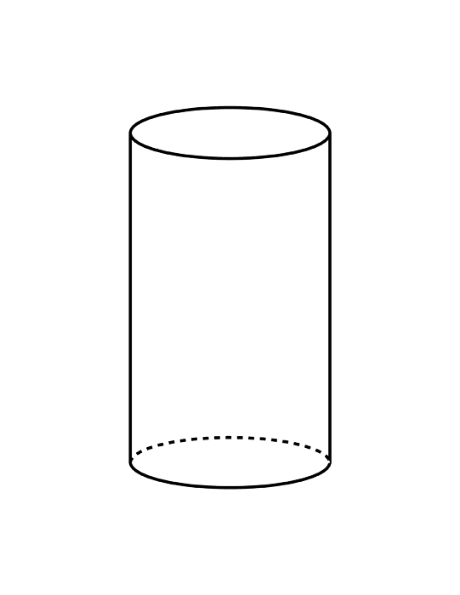

Ex. 3) The radius of a cylinder is 1.5 inches and the height is 3

inches. What is the volume of the cylinder, in cubic in.?

**Solution**

**A.** Find the area of the base.

Area (Circle) = 

A =  x ________  = ____________ sq. in.

**B.** Use the formula: Volume = Area of Base x Height

V = ________________ sq in. x _______________ in.

V = ________________ cub. in.

Ex 4) A can of tomato sauce has a radius of 3 cm and a height of 8 cm.

a) What is the volume of the can?

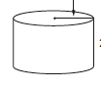

b) How much tomato sauce (in litres) does the can hold?