AP Physics – Second Law of Thermodynamics

Sadi Carnot showed that even though energy was conserved in a thermodynamic process, not all the energy appears in forms that are useful. Some of the energy is always converted to heat, even in a perfect machine. This was the heat that was exhausted to the low temperature heat sink

The first law is all about how energy is conserved throughout the universe. It wasn’t long before a second law of thermodynamics was needed. This had to do with the idea that there would always be energy converted into non-useful forms.

In 1865 a German physicist, Rudolf Clausius, found that the ratio of the heat content of a system to its absolute temperature would always increase. He called this ratio entropy. Entropy increases in all natural processes.

The entropy of an isolated system, system A, can decrease, but it can do this only at the expense of some other system, system B, whose entropy will do the increasing for both. In all cases the increase in entropy for system B will be greater than the decrease in entropy for system A so that the net entropy has increased.

Entropy is an important concept and if you were to become a mechanical engineer, you would do all sorts of wonderful things with it. We in AP Physics will just have a nice discussion about it.

This has been formalized into the second law of thermodynamics:

Second law of thermodynamics ≡ It is impossible to build a heat engine that can produce work equivalent to the input heat.

There are several ways to look at the second law and define it. Here is another way to write the thing out:

Heat will never flow from a cold object to a hot object, but only from a hot object to a cold object.

Heat flows downhill all the way. But this is just one way to look at the second law. Another way to approach the thing is to look at it from the perspective of a heat engine.

Heat Engines and The Second Law: Heat engines convert heat to work. The first law tells us that we can never get a greater amount of work out of an engine than the heat we put into it. The second law tells us that we can't even get back what we put into the system. The output work will always be less than the input.

Universal Implications: The second law is important to thermodynamics but it also has huge implications for the universe itself. If we look at the universe as a closed system, we realize that entropy must increase as time passes. Clausius speculated that the universe was in a state where energy was constantly being converted to heat. This meant that the amount of energy available in the universe to do useful work is constantly growing smaller.
Eventually, all the energy in the universe will be converted to heat and none will be left over to do any work. This is a frightening thought.

Order and Disorder: The first law of thermodynamics says that energy can neither be created nor destroyed, but that it can be transformed from one type of energy to another. We have learned that in any energy transformation some of the energy is converted to heat, which, of course, is often not very useful. Useful energy is energy that can do work. A compressed spring stores potential energy that can be used to do work so we think of the compressed spring as being a form of useful energy. Another way to look at useful work is to think of it as organized energy. Gasoline is organized energy - all those hydrocarbon molecules with their carbon-hydrogen bonds just waiting to be burned in an engine. The fuel is organized because the atoms are arranged in complicated molecules whose bonds store energy. The same atoms, broken loose from the molecules, are disorganized and cannot be called upon to do near the work that they can do when they are organized.

We can define the second law of thermodynamics in terms of order and disorder.

Second law of thermodynamics ≡ A natural processes takes place in a direction that increases the disorder of the universe.

When we harvest the energy from some organized system, it becomes disorganized and can no longer do useful work. A candle is highly organized - all those nice carbon, oxygen, and hydrogen atoms bonded together to form the wax, the cellulose in the wick, &tc. When the candle is lit, it produces heat and light. You can read your Action Comic by candlelight – a very useful thing. Once the candle is used up, it can no longer perform useful tasks for us like it once did. All we have left is some wax, a bit of burnt wick, and some combustion gases. Most of the candle’s atoms have been chemically rearranged into gas molecules that are busy flitting about randomly in the atmosphere.

The second law is not limited to thermal systems. It actually affects everything in the universe.

Everything in the universe seems to be going from an ordered state to a disordered state. A child builds a sandcastle at the beach - the child arranges the grains of sand with great care and effort (i.e., work) into a highly ordered state. But then what happens? The tide comes in and the sea rises. Waves break the sandcastle apart and turn it into just so much beach sand. The sand has gone from a state of wonderful order to a non-wonderful state of ordinariness.

How can we say that all things go from order to disorder? Well, ask yourself this question, “What is the likelihood that the waves will roll onto the beach and push the sand around so that it ends up piled into the shape of a sandcastle?”

Would that ever happen?

A raw egg is highly ordered. One can crack the thing open, deposit the contents in a frying pan and scramble the thing. The cooked egg is less organized than the raw egg. Remember the nursery rhyme "Humpty Dumpty"?

Humpty Dumpty sat on a wall,
Humpty Dumpty had a great fall.
All the king’s horses and all the king’s men
Couldn’t put Humpty together again.

This is the story of the universe.

Disorderd things can become ordered, but only at the expense of energy and the disorder of something else. A brand new deck of cards comes in a highly ordered state. Each suite is separate and ordered from the ace up to the king.

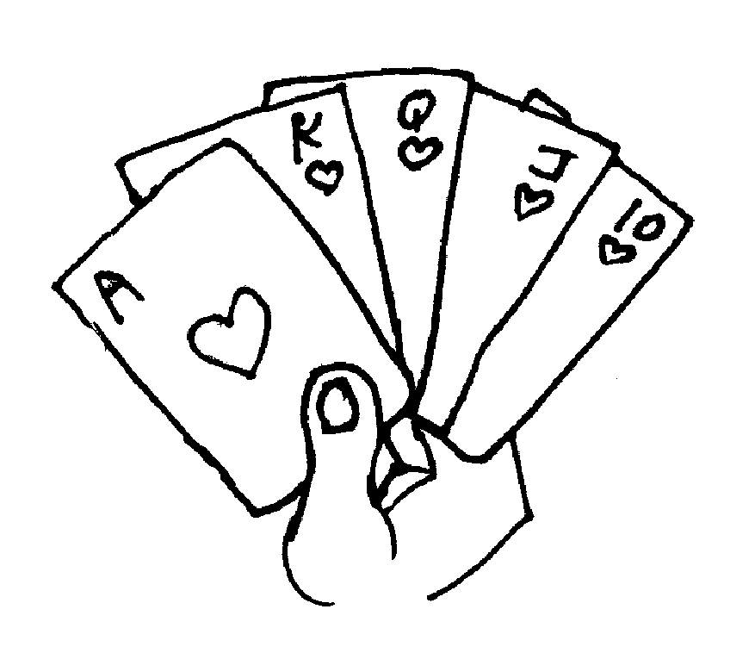
One can take the cards and toss them in the air. But, what are the odds that the cards will fall down in any kind of intelligent order? Pretty low. In fact, the probability is that the cards will fall down in complete disorder - some sort of random arrangement. There is a slim probability that the cards could land in some intelligent order - hey, it could happen! But it is not very likely. So how could the cards be placed back in order? Well, someone would have to pick them up and sort them back into the suites and get the cards in the correct order. That would take energy. The use of that energy will create its own disorder and this disorder will be greater than the order of the cards. The disorder will come about from the respiration of the person – pumping out CO₂ and H₂O and breaking apart complicated organic molecules to do this.

It has been said that in an infinite universe, all things are possible. The classic example of this is the old monkey/Hamlet deal. You know; if an infinite number of monkeys were given an infinite number of typewriters to bang away on for an infinite amount of time, one of them would have to end up writing Hamlet.

We can see the increase in disorder all around us. Do this experiment. Buy a house and fill it up with wonderful furniture, rugs, and accessories. Now walk away from the house and leave it to sit by itself for twenty-five years. Then go back and look at it. Will is still be a nice, neat house full of lovely furniture and nice things? Or will it be a wreck?

Perpetual Motion Machines: A perpetual motion machine is a device that is perfectly efficient. Once placed in motion, it will continue to operate forever with no additional energy input.

All sorts of hopeful inventors have brought out devices that they claim will operate as a perpetual motion machine. But none of them has ever worked. Usually there’s some sort of hidden source of power.

Such devices are clearly prohibited by the second law. To continue running after energy is initially added, but with no additional input would mean that the machine produces more work than the energy that went into it and this cannot happen. The machine must produce less work. Remember, the laws of physics are not optional.

Physics laws must be obeyed!

Dear Doctor Science,
Is there any promise in answering the world's energy needs with perpetual motion machines, like the toy rooster that - despite not having a battery - will dip his beak in a vodka tonic for an infinite amount of time?
-- T.J. Murphy, Brooklyn from Brookyn, NY

Dr. Science responds:
Perpetual motion is a fact, but one hidden from the public by the big energy companies, who keep the working prototype in a vault in the basement of the Vatican. Currently, only Henry Kissinger, the Illuminati, certain high ranking Masons and Kathy Lee Gifford have access to this machine, which produces unlimited amounts of energy at the touch of a button. Don't waste your time looking for one at Wal-Mart. Even if one appears with the alluring "As Seen on TV" logo, it's not the real McCoy. Save your money and wait until Oprah demonstrates one on her show. Then you'll know it's legit.

Entropy and Evolution: Modern biology has at its core the idea of evolution. No if ands or buts. No respectable scientist questions it.

Evolution is very controversial, however. Mainly because it is at odds with the religious beliefs of some people. Many of these people have developed a pseudoscientific alternative, which is called “creation science”. Sometimes it is called ‘creation by intelligent design”. Creation science is basically the book of Genesis dressed up with scientific terms.

Anyway, a very popular argument used by the creationists to try and undermine the concept of evolution involves the second law.

The argument goes like this: the universe must go from an ordered state to a disordered state according to the second law of thermodynamics. Yet for life to have evolved as Darwin said it has would require that life have gone from a low state of order to a higher state of order. This is clearly prohibited by the second law of thermodynamics, QED.

Actually, a fertilized human ovum coming to term, being born, and then growing to become an adult humanoid would also seem to violate the second law – right? How can one cell manage to undergo all these cell divisions and then somehow turn itself into a fully functioning human being, like an AP Physics student? I mean how can you get more organized than that?

An AP Physics student attending good old CCHS is, in fact, a really good example of the flouting of the second law. Typically the student comes in as a totally disorganized wreck as a sophomore. Yet that same student will, upon completing AP Physics, be a highly ordered human being. A true credit to his or her ethnic group.

So how can the second law be violated in such a regular manner? Well, it's simple. The second law has to do with natural random events and actions. A child coming of age is not a random event. The child is an isolated system - its order certainly does increase, but it does so at the expense of the entropy of its surroundings. It takes a great deal of energy to turn a newborn baby into a functioning adult. Remember the example of the playing cards? When they landed on the deck, they were disordered. But it is not impossible to put them back into order, it just takes energy. Same deal with babies - it just takes energy to increase their order. The parents have the privilege of paying for all this energy. No doubt you have heard mom and dad complain about the outrageous cost of supporting a high school student. Obtaining all this energy that is used up increases disorder all over the world.

What happens with an individual - energy being used to increase its order - can also happen with a species. Energy can increase the order in this as well. Evolution does not violate the second law, it is merely a result of the first law, energy being converted from one form to another.

Of course the life form may decrease entropy for itself, but its use of energy in such a manner will increase the entropy in the creature's vicinity. We see the effects of this with the large number of humans on the planet. We call the increase in entropy in the area surrounding large numbers of humans "pollution".

Once an organism dies and is not capable of expending energy to maintain its order, it soon becomes disordered. It undergoes decay and returns to a simpler state.

Summing Up: The second law of thermodynamics turns out to be far more powerful than one would be lead to expect. It does not apply merely to thermal systems, but to everything in the universe. The news it brings is not good.

The cruel message, which we must accept, is this: we are engaged in a game, a game we call life. In this entertainment we are struggling with, we can never get more out of the endeavor than we pony up. The very best that we can hope for, according to the first law, is to break even. But even that solace ("At least I didn't lose anything!") is denied us. The hardhearted second law says this: you can't even win your money back. In every transaction, you will lose some of your energy to disorder.

Perhaps the cruelest part of the lesson is this: you can't even quit the game. It's the only one in town. (Actually, you can quit the game, but when you do this, you have really quit the game.)

So here's the beastly message:

You can't win.

You can't break even.

You can't even quit the game.

You can only lose.

Perhaps, if you are lucky, you will manage to make your chips last for a good 75 – 85 years or so. Maybe a little longer. But that’s the best outcome you can hope for.

Modern medicine has made much progress. People today can expect to live much longer than they did, oh, say, a hundred years ago. Back then the average man could expect to live to the ripe old age of maybe 50, a woman had about the same life expectancy. Today those numbers are much bigger. Men live to around 74, women to around 78. So how come?

Well, it turns out that people would die at very young ages back a century or so. Men would be killed in work accidents and by disease. (three out of ten infants would die during their first year of life). Women died from disease and childbirth.

Jobs today are much safer, so the chances of being killed in a work accident are much smaller. Diseases cause fewer deaths as well and childbirth is pretty safe as well.

The interesting thing is that people really don’t live longer today than they did in the past. The maximum age has remained the same. Most people will die in their 70’s, a significant number make it into their 80’s, there are quite a few people who live into their 90’s, and there are some who live to be over 100. But very few people live much beyond 105. The oldest living person, according to available records, is 111 years old. A French woman died about three years ago who had lived for 117 years.

That’s about the maximum age and modern medicine has not been able to change it. Do you think that this has anything to do with entropy?

Entropy
Humans using energy to take them near and far
They're burning up the fossil fuels in airplanes, trucks and cars
They think that they're the masters at creating entropy
But they are only amateurs, next to my friends and me
Let me introduce myself I'm Streptomyces flocculus
Underneath the microscope I seem quite innocuous
But with my other pals like Pseudomonas borealis
We take the world apart
But we do so without malice
Entropy
Things are going down hill
Entropy
Always have and always will
Entropy
We think our job is great
We won't stop till we reach a steady state
Huh!
Every leaf and every branch that's lying on the ground
Is just potential energy waiting to be found
We digest the matter, turn it into energy
When the stuff is all used up
We've got more entropy!
Entropy
There's nothing we can do
Entropy
It's the end of me and you
Entropy
Don't get into a panic
It's just the second law of thermodynamics
Huh!

---- A song by Bill Harley of Seekonk, Massachusetts

Dear Cecil:
OK, I know the answer to this, I just want to hear some reasons. Why isn't fire alive? It breathes oxygen. It eats wood. It reproduces (sort of). What defines life? How do we know it's not an advanced non-carbon-based life-form? On that same note, why isn't a rock alive? If a rock grew at a nanometer every million years, how could we possibly study something like that? --Gwidion15, via AOL

Cecil replies:
You know, Gwidion, a lot of people reading this are thinking, that's what you get for riding a motorcycle without a helmet. Not me. Truth be told, though everybody thinks he knows it when he sees it, there is no widely agreed upon definition of life. In fact fire is sometimes used as an example of something that obviously isn't alive but nonetheless exhibits many functional characteristics of living things, e.g., metabolism, growth, reproduction, and so on. But if the functional definition (it's alive if it acts like it's alive) won't cut it, what will? Here are a few other definitions of life:

- It's the name of a magazine. I'm allowed one inane joke per column, and this is it.

- Living things contain reproducible hereditary information. This is the genetic definition. You'll notice I avoided mentioning DNA, nucleic acids, chromosomes, and such, so as not to limit this definition to life as we know it on earth. Yet this definition is still open to criticism. Some people argue that a machine could contain reproducible hereditary information but we wouldn't consider it alive. Most scientists would counter: why not? If we accept the possibility of artificial intelligence, why not artificial life? A more serious objection is that by this definition a virus is alive. A lot of biologist types don't buy this. A virus is basically a chunk of DNA or RNA (or computer code, for that matter) that succeeds in reproducing itself. But it's not a cell, which many consider the fundamental unit of life, and it doesn't do the things cells do, such as metabolize, react to their environment, etc.

- Life is an illusion. Now I'm really starting to feel that six-pack. Let's set aside the question of sentient life to avoid arguments about the soul. It seems obvious that at some level all we see about us, living or otherwise, is merely a manifestation of chemical reactions and the laws of physics. Chemists implicitly accept this mechanistic idea, defining "organic chemistry" (whose nominal subject is the chemical reactions underlying life) as anything having to do with carbon. In short, life is an arbitrary distinction.

- Life reverses local entropy. Popularized by Isaac Asimov. In lay terms, life reverses the default trend toward ever-greater disorganization. Your initial reaction may be: Asimov must never have had children. Still, this one's got a certain appeal. In contrast to, say, fire, which in its uncontrolled form is one of your more basic entropic phenomena, life is a creative force. On the other hand ... well, think about it. At the low end of the entropic (i.e., organizational) scale we have the primordial hydrogen soup whence arose the universe we know; at the other end we have the Microsoft Corporation. No one would describe the chemical reactions occurring for the universe's first few billion years as life, yet somehow we wound up with Bill Gates. This suggests two things. First, it may be hopeless to define life in a nontrivial way. Second, there seems to be a powerful antientropic force in the universe (at a certain level of organization, some call it natural selection), of which we are merely the latest--and so far the coolest--manifestation. (Actually, I am the coolest manifestation. I just mentioned Bill Gates to be polite.)

One more thing. When this question came up on the Straight Dope message board the other day, one confused philosopher attempted to settle the issue by saying, "Cogito ergo sum [I think, therefore I am]; fire no cogito." Another wit replied, "If [cogito]'s the litmus test, we're going to lose most of California."
--CECIL ADAMS
Dear Doctor Science,
What's this "death" thing about? It sounds really stupid...
-- Richard Clark from Hollywood, CA

Dr. Science responds:
All entropic processes have an endpoint, including human life. Fortunately, the reaction is cyclical, and we are reincarnated the instant we die, usually as a noteworthy historical figure, or a minor celebrity. In my last life, I was Andy Clyde, the silent movie star. Before that I was John Wilkes Booth, and before that Benjamin Franklin. So you see, there really is no "death" but the notion is an important plot device in dramas of all kinds. How else can you end most stories?
It's either "happily ever after" or "death."

Dear Doctor Science,
For millions of years now living things have evolved via the survival of the fittest. Has this process stopped now that even the weak survive?
-- Leon Martell from Manila, Phillippines

Dr. Science replies:
The process stopped long before that. Evolution began to work backward, in what scientists call "de-evolution" in the year 1066. With the first recorded visit by Haley's comet, everything began its downward slide, culminating in movies made for television starring over-the-hill TV actors and the music of John Tesh. Sure, there have been some steadily diminishing high points along the way, like Little Richard and the Beatles, but eventually the peaks and the valleys all look the same and you realize that with no standard of excellence to compare things to, who's to notice? Nowadays we become fat and lethargic with age, like Wilford Brimley, instead of thin, grizzled and peppy, like Gabby Hayes.

