Science 8 – Earth Science
Evidence and Mechanism of Continental Drift and Plate tectonics
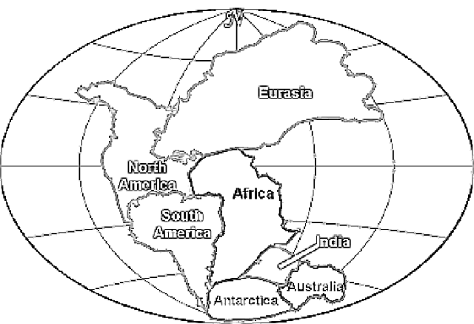
Continental Drift Theory
- Initially the theory was not well accepted.
- Alfred Wenger needed evidence to support his theory!

List the evidence for continental drift and Pangaea, make sure to explain how each supports Wenger’s theory!:

Question: What is the difference between the Theory of Continental Drift and the Theory of Plate Tectonics? _______________________________
________________________________________________________________________________________________________________________
________________________________________________________________________________________________________________________
Evidence  What evidence do we now have that confirms Plate tectonics? | Mechanism  What actually makes the plates move? How does it work?
Mantle Convection – _________________________________________
__________________________________________________________
__________________________________________________________
Slab Pull - __________________________________________________
__________________________________________________________
Ridge Push – _______________________________________________
__________________________________________________________

