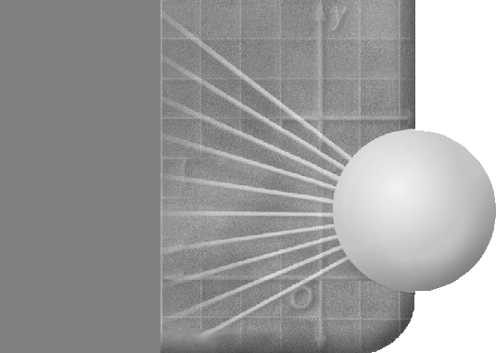
NAME ______________________________________________ DATE ____________ PERIOD _____

Surface Area of a Robot

This robot is made of common three-dimensional figures.

The hat is a square pyramid. Each side of the base is 6 inches long, and the height of the pyramid is 8 inches. What is the Surface of the hat?
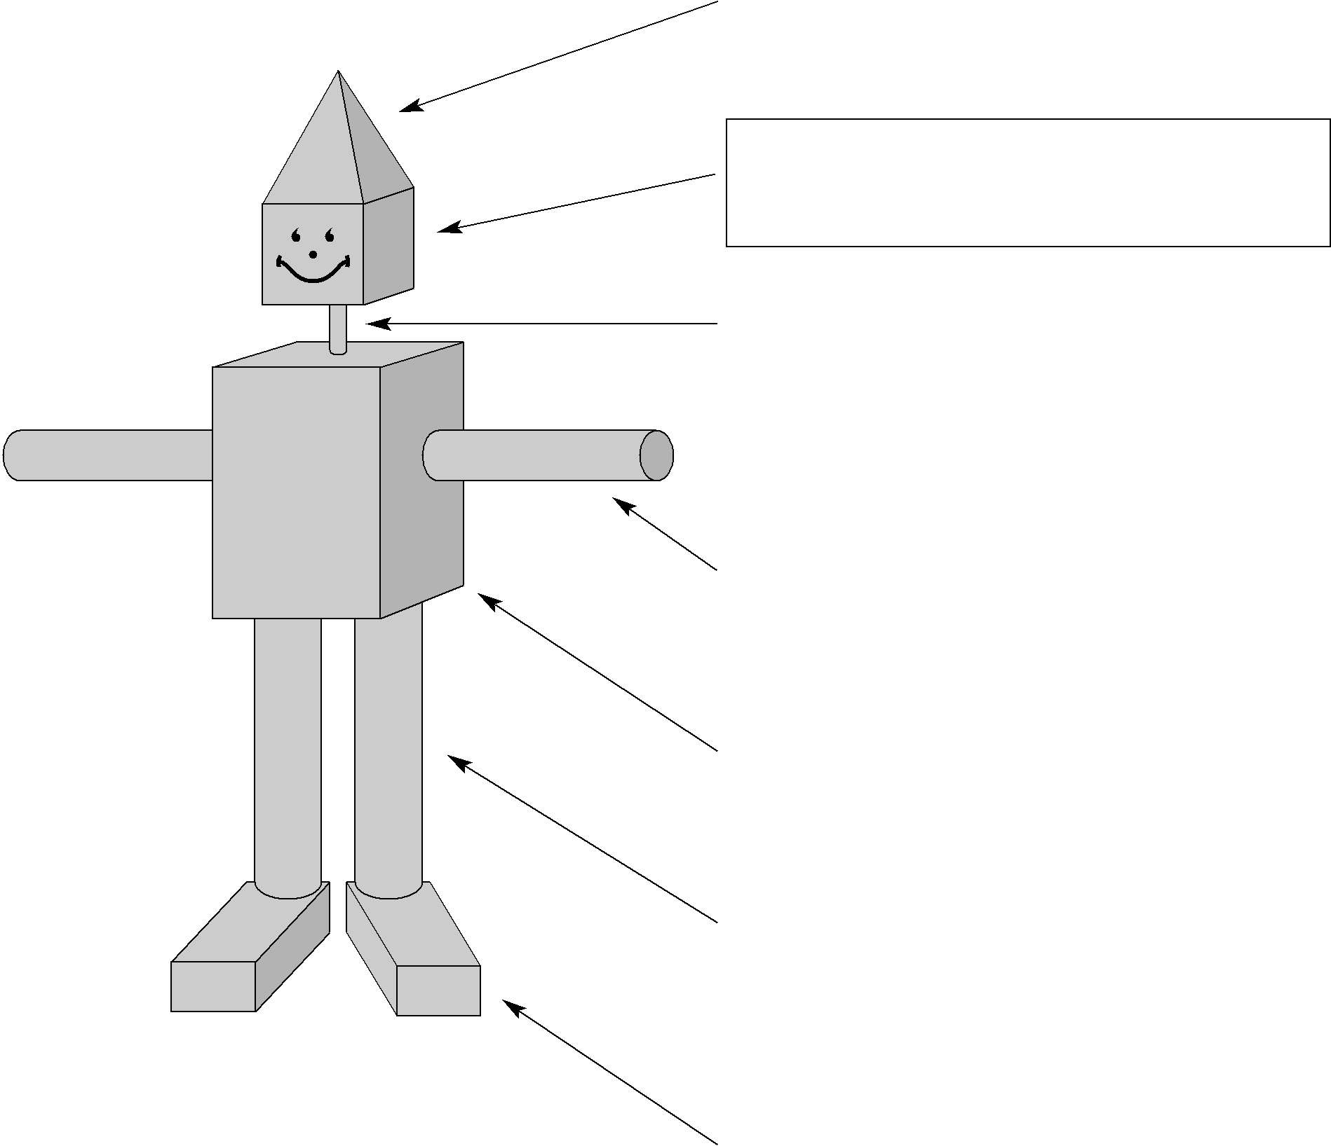
The head is a cube. Each side of the cube is 6 inches long. Find the Surface Area of the head.

The neck is a cylinder. The radius of the base is 1 inch and the height of the cylinder is 3 inches. What is the Surface Area of the neck to the nearest whole number.

Cylinders are used for the arms. The diameter of each arm is 3 inches and the length of each arm is 15 inches.

Find the Surface Area of one arm to the nearest whole number.

The torso is a rectangular prism. The dimensions of the body are 10 inches by 10 inches by 15 inches. What is the Surface Area of the torso?

Cylinders are used for the legs. Each leg is 4 inches in diameter and 18 inches long. Find the Surface Area of one leg to the nearest whole number.

Rectangular prisms are used for feet.

Each foot is 5 feet by 3 feet by 6 feet.

What is the Surface Area of each foot?

What is the total Surface Area of the robot?

