Math 10 A&W  Surface Area – 3 Dimensional Composites | Name:  Date:  Block:
SA of 3D Composite Shapes: Two or more 3D shapes put together.

*With composite shapes it is important to determine which faces will be included/ excluded from the total surface area.

Find the surface area of each composite shape below.
Length=4
Width=6
Height=5

Height=2
Radius=6

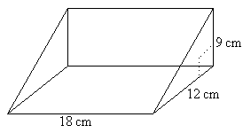(*hint – you have to use Pythagorus equation)

