**3,2 Area of Parallelograms Name: __________________**

Parallelograms are squares that are ***slanted***

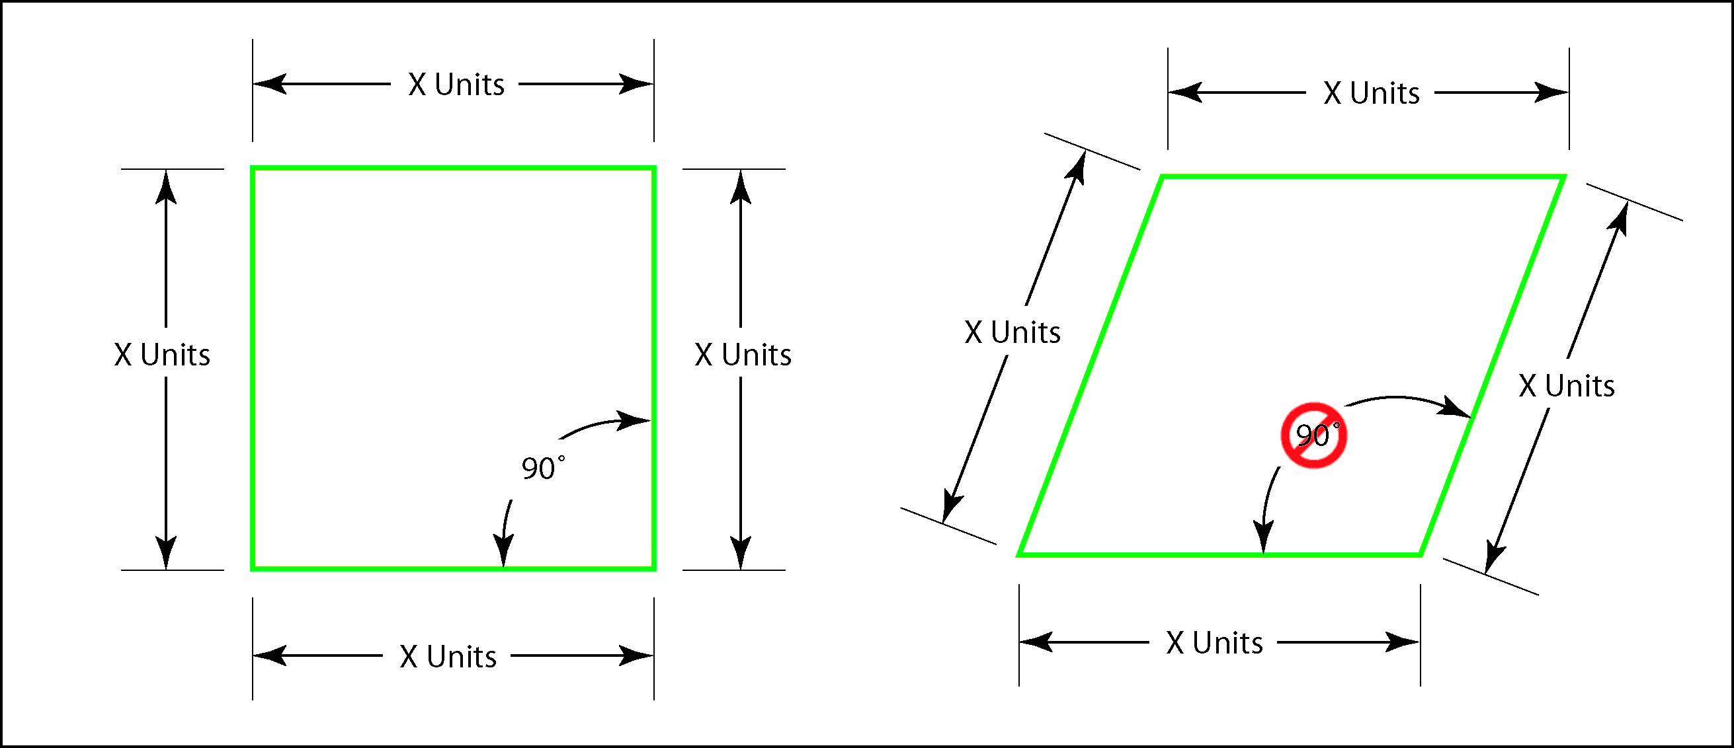

For a Rectangle Area = L x W

For a Parallelogram Area = B x H

Find the Area of the following structures

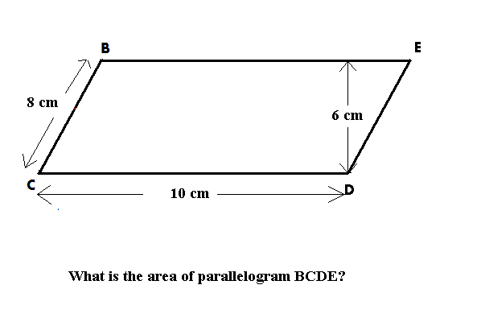

|  |  |
| --- | --- |
|  |  |

**3,2 Area of Irregular Objects Name: __________________**

Unfortunately not all objects fall into the categories of circles, triangles, rectangles and parallelograms

Use your notes from the previous class to calculate the area of the objects below:

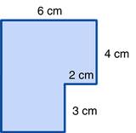

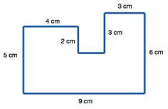

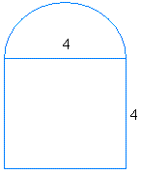

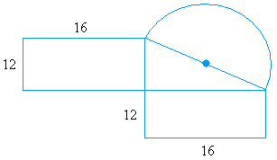

|  |  |
| --- | --- |
|  |  |
|  |  |
|  |  |
|  |  |
|  |  |

Find the area of the SHADED regions:

|  |  |
| --- | --- |
|  |  |
|  |  |