Working with 2D Objects: Notes Name: __________________

- Perimeter (P): ________________________________________________________________________

Find the perimeter of the following objects:

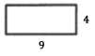 | 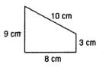 | 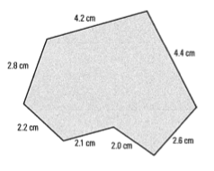

Find the missing side lengths (E and F):

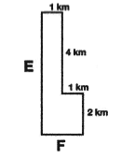

- Circumference (C): ____________________________________________________________________
- Need the radius (half the distance across a circle) or diameter (full distance across a circle)
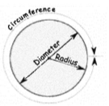
Find the circumference (perimeter) of the circles shown below.

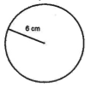 | 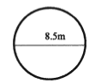

- Area: __________________________________________________________________________

Area Formula’s

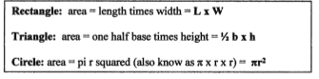

Find the area of the objects below:

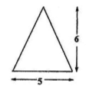 | 