Science 8  Elements of the Periodic Table | Name:  Date:  Block:
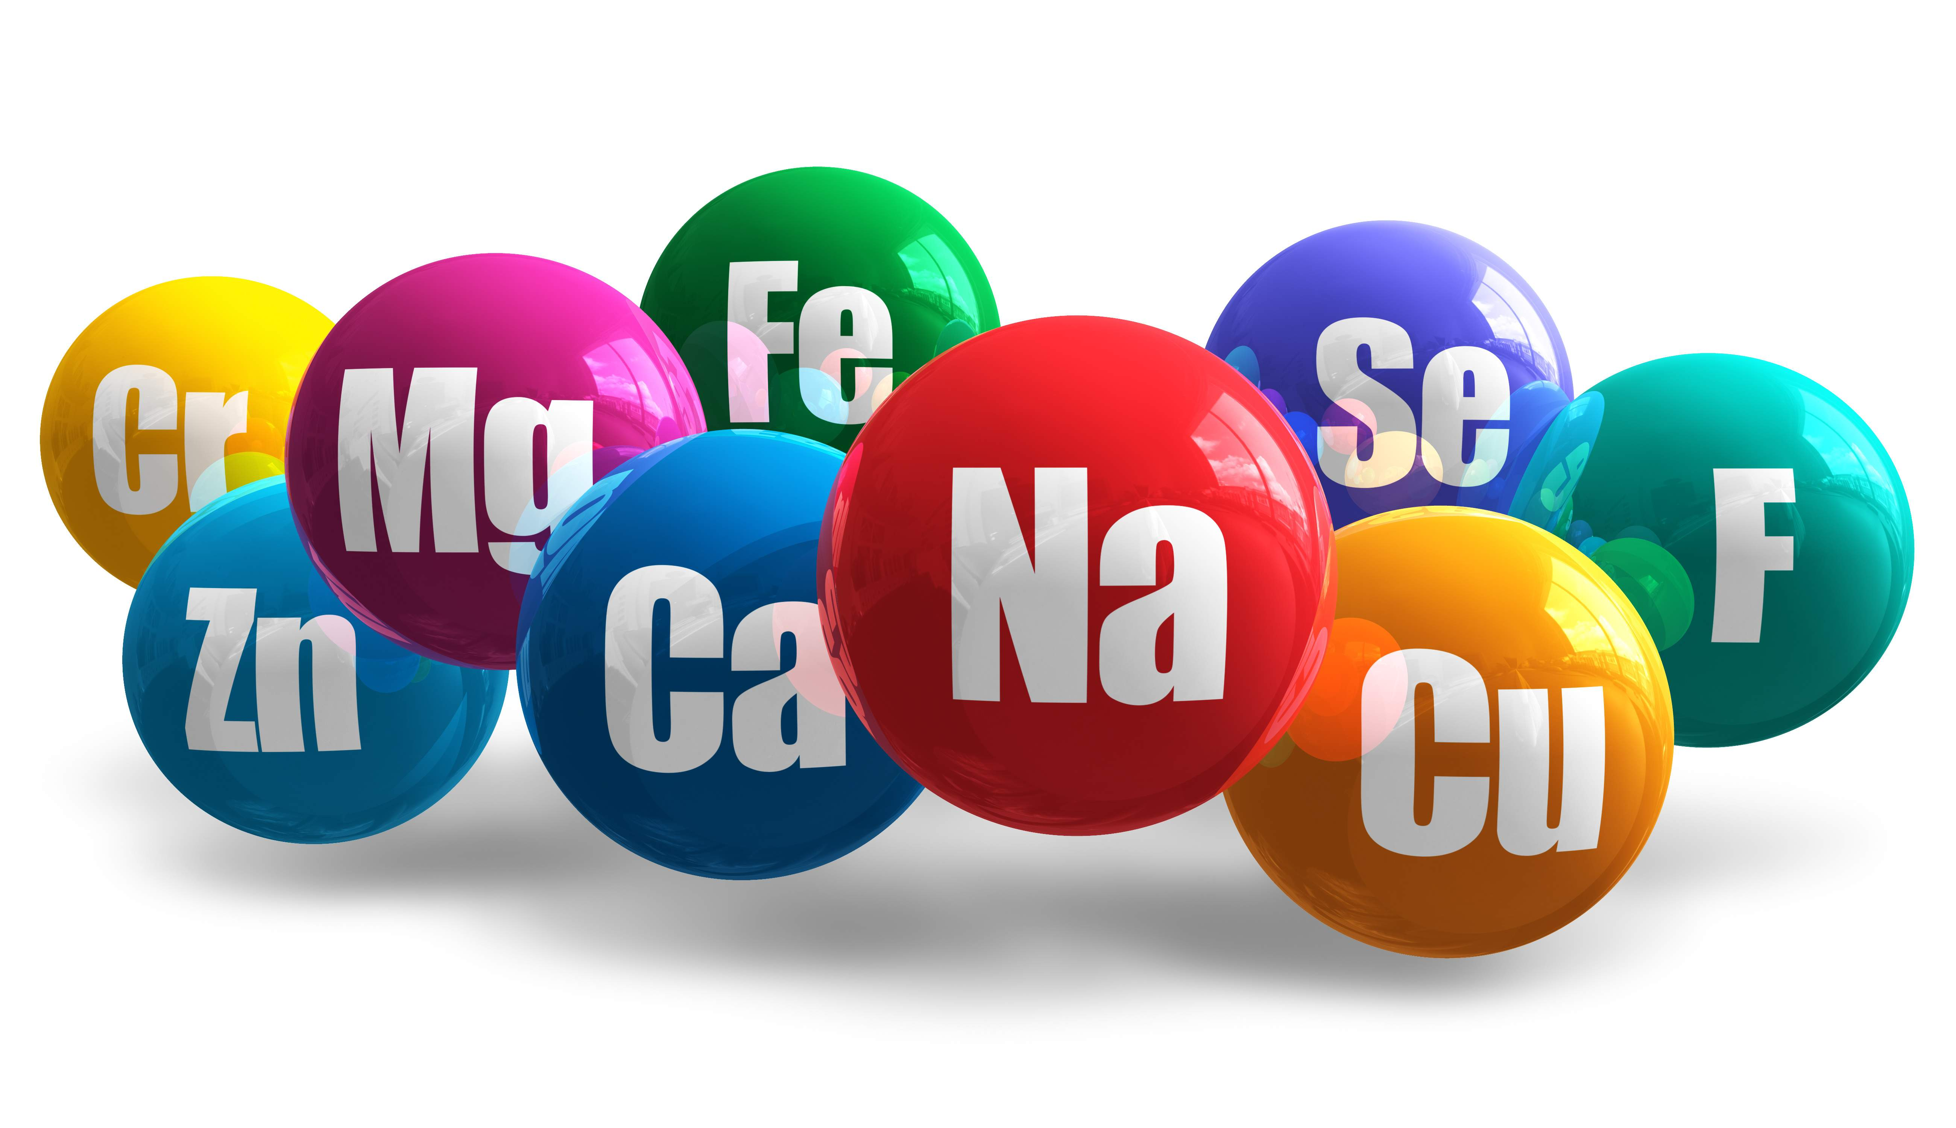
Each element is different and has different properties/characteristics.
It is often said that an element in the flavor of the atom!
Name 5 different elements: EXAMPLES
(1) Copper (Cu) (2) Oxygen (O) (3) Helium (He) (4) Iron (Fe) (5) Mercury (Hg)
A few properties/characteristics are:
- State (Solid, Liquid or Gas) at room Temperature
- Melting point - Temperature at which the element melts – Ex: Solid Liquid
- Boiling point - Temperature at which the element boils – Ex; Liquid Gas
- Density - the amount of matter in a given space
- Reactivity – tendency for an element to react with another element

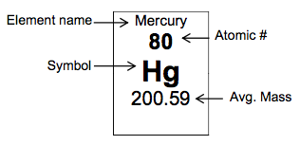
See the back for the Periodic Table Scavenger Hunt!

Periodic Table Scavenger Hunt!
- What is the chemical name for Ga? Gallium
- What is the symbol for Palladium? Pd
- What is the atomic number for Yttrium? Y
- What is the atomic number for Helium? 4.00
- What is the chemical name for W? Tungsten
- What is the atomic number for Gold? 79
- What is the atomic mass for Platinum? 195.08
- What is the symbol for Copper? Cu
- What is the chemical name for Ba? Barium
- What is the atomic mass for Cerium? 140.12
- What is the chemical name for Rh? Rhodium
- What is the atomic mass for Samarium? 150.36
- Who was the element Einsteinium named after? Albert Einstein
And now for the… ELEMENT JOKES!
- What do you do with a dead scientist? Barium (that is if they couldn’t Helium/Curium first!)
- Hey want to hear a joke about Potassium? K
Ok so the last joke was BAD…
- Want to hear a joke about Sodium and Hydrogen? NaH….
- What do you say when Oxygen, Hydrogen, Sulpher, Sodium and Phosphorous walk into a bad?
OH SNaP!
- Oxygen and Potassium went on a date… did you hear how it went? Just OK….
- I was going to tell you another chemistry joke but all the good ones…. ARGON
Ok Ok Mr. Lawson! Stop with the puns…. We've all sulfured enough.

