**Lesson10.1 Exploring Angles in a Circle**

**Circle Terminology**

|  |  |
| --- | --- |
| **Term/Description** | **Example** |
| **Radius** |  |
| **Diameter** |  |
| **Chord** |  |
| **Tangent** |  |
| **Central Angle** |  |
| **Inscribed Angle** |  |
| **Arc** |  |
| **Perpendicular Bisector** |  |

**Relationships between angles in a circle**

Label the centre of the circle C.

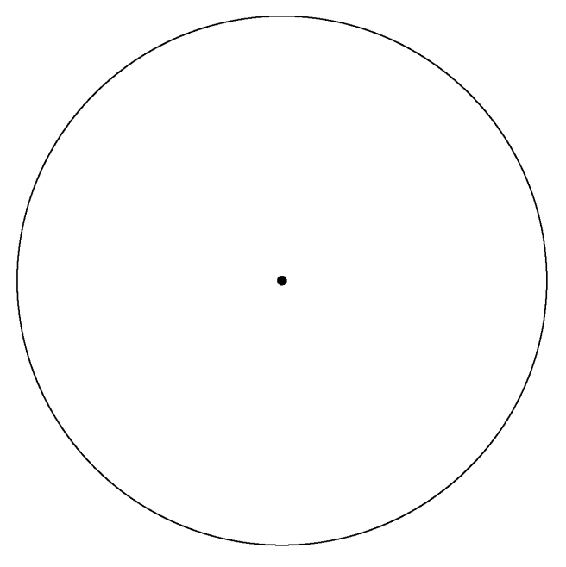

Construct a chord AB and a central angle 

Create the inscribed angle 

What is the measure of ?

How do the measures of  and compare?

Create a second inscribed angle 

What is the measure of angle ?