2-4 Notes: Circle Graphs

Circle Graph – is used to display how a ____________ is divided.

- The _____________ of the circle represent parts of the data.

- A circle graph can provide a very good ___________ representation of a set of data because the size of the slices varies visibly compared to the whole.

- More readily see _______________ amounts.

- Circles graphs are _______ likely to be used to display misrepresenting data unless important data is omitted.

Example 1) The following circle graph shows how many people in Maxine’s office building get to work. There are 350 people working in the building.
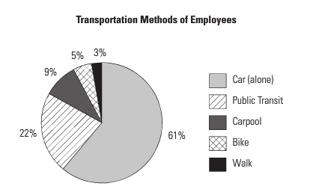

a) What percentage of the people walk to work? How many people does this represent?

b) What percentage of people come to work in a car? How many people is this?

c) Consider those who carpool, walk, or bike. Is this more or less than the number who take public transit? How many more or less?

Example 2) Jasmine surveyed students at her college to find out how they commute to school. The results are shown in the table below. Create a circle graph of the data. 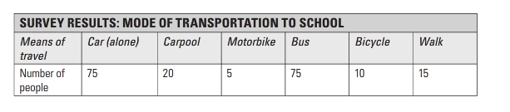
STEP 1: Calculate what proportion of the total data is represented by each category:

Total:
Car Alone:
Carpool:
Motor Bike:
Bus:
Bicycle:
Walking:

STEP 2: Calculate how many degrees of a circle are presented by each category:

Car Alone:
Carpool:
Motor Bike:
Bus:
Bicycle:
Walking:

STEP 3: Draw a circle and a radius. Use your protractor to measure the degrees of each section.

